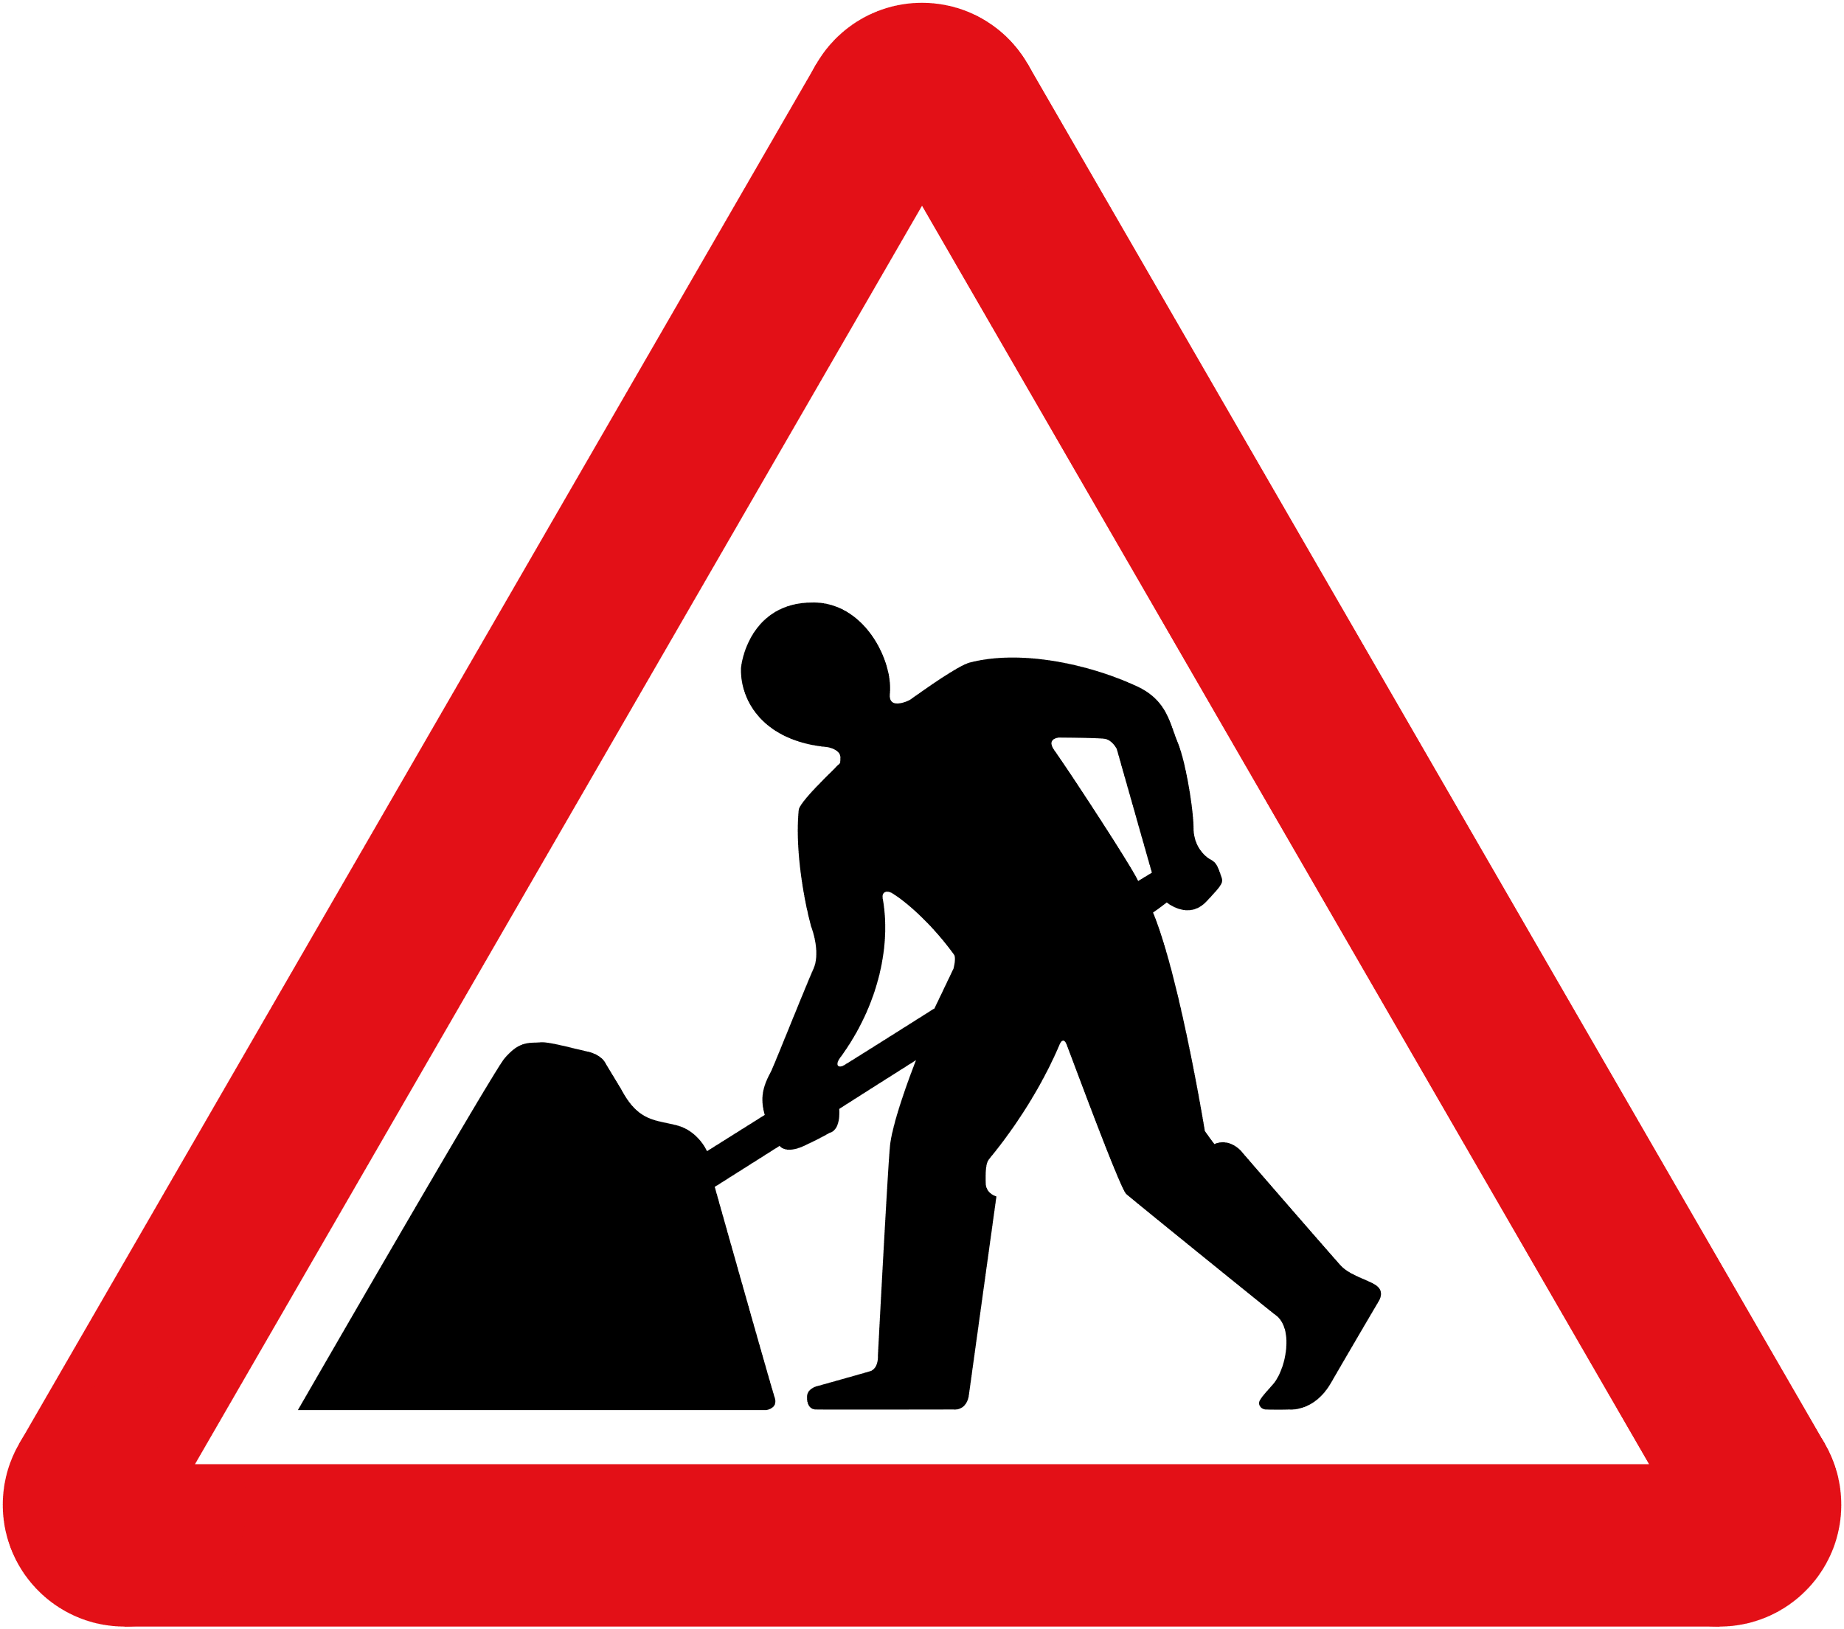

ROAD WORKS PERFORMANCE REPORT
01 April 2022 to 31 March 2023

Contents
1. Introduction 3
2. Executive Summary 5
3. The Organisation 10
4. Monitoring 11
5. Trends from Indicator Reports 15
6. Quality of Utility Company Reinstatements 27
7. Commissioner Penalties 29
8. Promotion of Compliance and Good Practice 30
9. Consultations and Research 34
10. Scottish Road Works Register 36
11. Legislation 44
12. Annual Report and Accounts 46
13. Reflection and Forward Planning 47
Appendix A. List of Acronyms and Terms 49
Appendix B. List of Roads Authorities and Utilities 51
Appendix C. Extent of Engagement 54
Appendix D. Additional Indicator Reports 56

Authorising Context
This Report has been produced in accordance with the requirements set out in Schedule 2 of the Transport (Scotland) Act 2005 and covers the 12 month period from April 2022 to March 2023.
Appointment
Kevin Hamilton was appointed in November 2020 as the 4th Scottish Road Works Commissioner for a period of 5 years. He brings a wealth of experience having worked in the roads sector for some 30 years.
The Scottish Road Works Commissioner’s Role
The Scottish Road Works Commissioner is an independent public official, appointed by Scottish Ministers. The Office was established following enactment of the Transport (Scotland) Act 2005.
The Act states:
“[The Commissioner] will oversee improvements to the planning, co-ordination and quality of road works in Scotland.”
The general functions of the 2005 Act are to:
- monitor the carrying out of road works in Scotland
- promote compliance with the New Roads and Street Works Act 1991
- promote the pursuit of good practice
The specific functions of the 2005 Act are to:
- publish an annual report
- prepare an annual account
- keep a register to be known as the Scottish Road Works Register
Disclaimer
The views offered by the Commissioner within this document are his own and do not necessarily reflect the approach taken by previous Commissioners.

Introduction
I am delighted to present my fourth sector monitoring report since taking up office in November 2020, covering the period 1 April 2022 to 31 March 2023.
This reporting period is the first full period since the end of restrictions due to the Covid-19 pandemic. Many changes in working practices introduced through the pandemic have continued and there has also been a continued increase in road works activity, up 6.4% overall compared to 2021/22. The continued roll-out of fibre broadband has been a major factor in this increase although there are now signs that it may have reached a peak. However, other emerging utility sectors, for example electric vehicle charging and heat networks may lead to continued high levels of works on the ground in years to come.
A key indicator of good planning and co-ordination of works is the proportion of so-called ‘noticing failures’. I am concerned that utilities remain stubbornly above the target of 4%.
2022/23 saw the introduction of Reinstatement Quality Plans (RQP). It became a legal requirement for utilities to have agreed RQP’s in place by 1 April 2023. By the deadline, agreed RQP’s were in place covering 99% of all utility works undertaken in Scotland. My team dedicated a considerable amount of time and resource to work with utilities in order to have plans approved by the deadlines. However, despite this effort, there was a small number of utilities who either did not engage in the process or left it too late. As a result, 2 utilities had their overall rating downgraded from either well managed or satisfactory to unsatisfactory due to not having an agreed RQP in place in time.
I am very concerned that there has been a drop in the pass rate for category A sample inspections in 2022/23. This, combined with the increase in the number of reported sub-standard traffic management layouts suggests that there may have been a decline in overall safety compliance. This is a safety critical issue and the whole industry needs to work harder to improve. This will be a key focus of activity for compliance officers in 2024.
I am also concerned that roads authorities are not fully utilising the powers available to them to ensure proper co-ordination of works. In particular, there are very few authorities using their powers to issue undue delay directions under Section 125 of NRSWA. Also, there are several authorities who do not issue fixed penalty notices and I would encourage all authorities to make full use of the powers available to ensure that works are properly co-ordinated.
A significant amount of work was undertaken in 2022/23 to revise the Specification for the Reinstatement of Roads (SROR). The working group met fortnightly through the whole year and worked efficiently and co-operatively to achieve a revised draft. This was subsequently endorsed and approved by Ministers in June 2023. I would like to formally thank the members of the working group and my team for their considerable efforts.
Finally, I would like to thank my team and everyone in the road works community for their support and co-operation through the year.
Kevin Hamilton
Scottish Road Works Commissioner

Executive Summary

The Organisation
The only change to staffing within the reporting period was, as mentioned in last year’s report, I employed a replacement Policy and Quality Manager in June 2022.
This staffing establishment remains well placed to deliver the requirements of the Transport (Scotland) Act 2005 and to address the governance required of a public office.

Monitoring
The main sources of data available to the Scottish Road Works Commissioner’s monitoring regime are:
- performance data from a suite of indicator reports in the Scottish Road Works Register (SRWR)
- statutory sample inspections of utility company road works by roads authorities, and
- Periodic national coring programmes of the bound layers in utility company reinstatements.
The Scottish Road Works Register (SRWR) suite of indicators, which benchmarks roads authority and utility company road works performance across Scotland, and facilitates benchmarking against the rest of the UK, is regularly reviewed to enable organisations and the Commissioner to demonstrate continuous improvement.
My team now monitors key aspects of road works noticing activity on a monthly basis which allows early discussion with organisations before performance becomes a major issue.
The national coring programme results were delayed due to resourcing problems in one of the local areas. The results will be published in 2023/24.

Performance Indicator Trends
The 5 year rolling period has again been utilised with a number of the graphics within appendix D, continuing to display a short gap in data associated with the onset of the pandemic in March/April 2020. As per the 2022-23 reporting year the assumed trend across the reporting period can reduce the impact of any data loss, with a true reflection of the actual operations on the ground be presented. In October 2022 the register had additional reports included, detailing the non-compliance around Roads Authority and Utility Company inspection processes. In February 2023, organisations were given 6 months to improve their individual performance.
Several areas remain in need of continuing improvement including:
- noticing failures in the utilities sector
- percentage of unplanned works registered by some utility companies
- overall performance of many smaller utility companies
- the delivery of the Roads Authorities inspection process
- utility companies sample inspection pass rates, particularly in relation to the final reinstatements
- the inconsistency of roads authorities to utilise their full range of powers including the issuing of FPNs
Despite the resourcing challenges facing the Scottish road works community, it is important that organisations fully embrace the concept of continuous performance improvement which is key to the delivery of co-ordinated road works.

Performance Reviews
Annual Road Works Performance Reviews covering the period 1 April 2021 to 31 March 2023 were issued to all Roads authorities and Utility companies operating in Scotland on the 26 May 2023.
The rating process of either Well-managed, Satisfactory or Unsatisfactory was again utilised which provides a generic listing for performance. The number of organisations delivering either a well-managed or satisfactory performance improved slightly to 44 against 42 in 2021/22. However the percentage figure for this grouping compared against all organisations slipped to 58.7% from 64.6% in 2021/22. This slippage can be attributed to an additional eight new or returning undertakers who were rated as unsatisfactory, of which, six were new telecoms businesses. A small number of undertakers had had their rating downgraded due to them failing to deliver an agreed reinstatement quality plan by the 1 April deadline.

Safety at Road Works
Safety at utility company road works and at roads authority works for roads purposes remained a key priority of the office.

Utility Company Reinstatements
Improving the quality of utility company reinstatements remains a high office priority. It is not acceptable that utility companies leave legacy defects for roads authorities to repair.
An indication of the quality of reinstatements is found in the results of national coring programmes which sample and test the bituminous bound layers of utility company reinstatements. Programmes are undertaken by RAUC(S) every two to three years. The current national coring programme commenced in March 2022 covering a 2% sample of utility company reinstatements undertaken between 1 January 2021 and 31 December 2021. The full report was delayed due to resource issues in one local area with the report now due to be published in 2023/24.
The sample inspection pass rates for both Category B and Category C inspections rose to an average of >93% in 2022/23. This provides reassurance that the quality of reinstatements is improving.
In addition, the results of a research study into the Service Life of Reinstatements, to be published in 2023/24 has found that quality has improved since the last similar research conducted in around 2012.

Commissioner Penalties
A £10,000 penalty was imposed on Scottish Water for systematic failures to comply with their statutory obligations when carrying out repairs to their water services in the roads.

Promotion of Compliance and Good Practice
The office continued to engage with the road works community at a national, area and local level in addition to membership of various working groups, promoting best practice, encouraging innovation and improved performance monitoring.
A well-attended webinar event on forthcoming legislative changes was held in October 2022.
The Commissioner gave presentations to various events through the year including Highways UK in Birmingham, Street works UK conference in Leicester, a learning event for Virgin Media Group and its build partners in Edinburgh and the Road Expo conference in Glasgow.
The Technical Standards Manager continued his engagement at a local level to improve compliance and communication between utility companies and roads authorities, helping to informally resolve issues before they significantly impacted road works performance.

Consultations and Research
The Commissioner continued his active engagement with various groups but in particular the Mobility Access Committee for Scotland (MACS) and the Society of Chief Officers in Transportation in Scotland (SCOTS).
The Commissioner and staff have continued to actively participate in the Scottish Road Research Board (SRRB) and the Transport Scotland Pavement Forum (TSPF).
The SRRB funded research study into the service life of reinstatements was completed within the year. The main findings were that reinstatements constructed to the specification would be expected to be serviceable after at least 6 years and that reinstatement quality had improved since the last research in 2012.

Scottish Road Works Register
Management and operation of the SRWR continued with the support of the SRWR Steering Group, the SRWR Systems Assurance Team and the RAUC(S) Gazetteer Group.
The SRWR Manager and the Commissioner supported and attended all meetings of the SRWR steering group and the Systems Assurance Team. These forums provide community input into the development and operation of the Scottish Road Works Register.
The service suffered from some service loss during the period, with the system being unavailable for short periods in June, November, December, January and March. All the outages were resolved quickly, and none threatened to breach the Service Levels set out in the contract. Overall availability for the year was 99.77%, which is above the 98% target set out in the service contract.

The Organisation
The Commissioner’s permanent staffing numbers remained unchanged during the reporting period with a new Policy and Quality Manager taking up post in June 2022.

Policy and Quality Manager
Key functions include keeping regulations, codes of practice and advice notes under review, promoting good practice, and media/complaint handling. The role also encompassed the review of Reinstatement Quality Plans (RQP’s).

Performance Manager
This role entails the management of indicators, management of statistical information, working with the community to improve compliance and drafting performance reviews.

SRWR Manager
The key responsibility of this post is to manage the operation of the SRWR. The SRWR Manager is the primary contact with the provider of the register, currently Symology Ltd.

Technical Standards Manager
This post provides the office with engineering support. The main priority is to drive improvements in the overall quality and standard of road works through increased scrutiny of road works sites across Scotland and promoting best practice.

Business and Governance Manager
This key role deals with the general administration of the office, in house accounting, enquiries from the public, statutory returns, invoicing, budget monitoring, managing requests under FOI(S)A and EI(S)R and monitoring compliance with legislation and governance.

Monitoring

Introduction
The duties of the Commissioner include “monitoring the carrying out of works in roads in Scotland” to ensure that roads authorities and utility companies are meeting their statutory obligations.
The Commissioner has been monitoring the performance of organisations since indicators were introduced in 2009. In parallel, roads authorities and utility companies have been improving their own use of management information, available from the SRWR, to monitor their own works. Over recent years, the general trend has been towards improvement, with reduced levels of non-compliance. The provision of better technology and user friendly interfaces for accessing the SRWR, has merited greater organisation engagement, resulting in general improvements.
In May 2023 all roads authority and utility company CEOs respectively received their Annual Performance Review, in respect of performance during 2022/23. Performance reports are also available throughout the year in the SRWR for roads authorities and utility companies to interrogate, allowing individual organisations to monitor their own performance and take remedial action where necessary.
Five key questions are considered when monitoring performance:
- are roads authorities co-ordinating works on their roads?
- are utility companies co-operating with roads authorities?
- are works taking too long to complete?
- are works being carried out safely?
- are reinstatements in roads meeting the required standard?

Performance Indicators
Indicator reports are used to identify trends in the performance of roads authorities and utility companies over time. A suite of indicator reports are available directly to roads authorities and utility companies with access to the SRWR. Organisations are encouraged to regularly interrogate the SRWR to monitor their own performance and take appropriate mitigating action.
The Commissioner indicator reports are continually reviewed and developed to ensure that they are relevant, up to date and transparent. Organisations are required to provide a written response when their performance is poor.
Quarterly performance dashboards capture key indicators and present them in a red/amber/green status report which is provided to all organisations.

Engagement and Improvement
Ongoing engagement is intended to improve performance without the need to take formal enforcement action.
A number of organisations met (virtually) with the Commissioner to discuss their performance during 2022/23. In general terms, 35% of the smaller Utility Companies including the major gas, electricity and water companies and around 82% of roads authorities, performed satisfactorily. Again, however a significant proportion of the telecommunications sector and a number of smaller (all sector) utility companies (approx. 65%), along with 18% of roads authorities, were considered as needing to give greater priority to meeting their road works statutory obligations.
Discussions in relation to performance were held with the following Roads Authorities:
- Aberdeen City Council
- Aberdeenshire Council
- Angus Council
- Argyll & Bute Council
- City of Edinburgh Council
- Comhairle nan Eilean Siar
- East Lothian Council
- Falkirk Council
- Fife Council
- Glasgow City Council
- Inverclyde Council
- North Ayrshire Council
- North Lanarkshire Council
- Perth & Kinross Council
- Renfrewshire Council
- Scottish Borders Council
- Shetland Islands Council
- South Lanarkshire Council
- Stirling Council
- Transport Scotland (on behalf of Scottish Ministers)
- West Dunbartonshire Council
and the following utility companies:
- Axione UK Ltd
- Borderlink Broadband Ltd
- BT
- CityFibre
- Fulcrum Pipeline Ltd
- Gas Transportation Company
- Indigo Gas & Power
- InternetTY Ltd
- Last Mile Electricity Ltd
- Mua Electricty Ltd (formerly Murphy Power)
- Neos Networks
- Network Rail
- Optimal Power Networks
- Scottish Water
- SGN
- Sky UK
- SP Energy Networks
- Virgin Media Group
- Vodafone

Key Facts 2022/23
Road Works started | 150,872 (+6.4% above 2021/22 volumes)
Scotland’s Road Network | 57,077 km*
SRWR Users | 2,300
Potential Noticing Offences | 6,244
Potential FPNs Issued | 43.5%
Commissioner Penalties issued | £10,000
Sample Inspection Pass Rate | 92.6%
Table 1 - Key Facts 2022/23
(*Source: Scottish Transport Statistics 2022)

Trends from Indicator Reports
Roads authorities have a statutory duty to co-ordinate the execution of works of all kinds in roads for which they are responsible, whilst undertakers have a statutory duty to use their best endeavours to co-operate with the road works authority and with other undertakers.
These endeavours are both in terms of section 118(1) and section 119(1) respectively of the New Roads and Street Works Act 1991 (NRSWA) and are to ensure that road works are carried out:
- in the interests of safety;
- to minimise inconvenience to persons using the road; and
- to protect the structure of the road and integrity of apparatus in it.
Since the transition after the pandemic restrictions, road works delivery has returned to near normal for the majority of both roads authorities and utility companies. In some cases the pandemic has meant an acceleration of works during 2021/22 to recover any of the lost ground and in the particular the Telecoms sector has driven this increase in activity. This is largely due to the roll-out of super-fast fibre broadband across Scotland.
Note: In some instances the comparison of performance continues to reference 2019/20 delivery due to the effect caused by the pandemic in 2020/21. This is referenced at the start of each relevant section.

Improvement Plans
The Commissioner Improvement Plans were first introduced in 2017/18. The following organisations met with the Commissioner and were required to develop a plan to improve their performance:
Authorities:-
No Roads Authorities were included in the process and the following utility companies were:
- Axione Uk Ltd
- Energy Asset Pipelines
- ES Pipelines Ltd
- Fulcrum Pipelines Ltd
- Lothian Broadband
- mua Electricity Ltd
- SGN
- Virgin Media Group
Following review meetings, the following organisations were subsequently removed from the Improvement Plan process within the reporting period:
- Energy Asset Pipelines
- ES Pipelines Ltd
- Fulcrum Pipelines Ltd
- mua Electricity Ltd
- Virgin Media Group

Performance Rating
The following rating was introduced for the individual organisation Performance Reviews in 2021/22 and continues in the reporting year 2022/23, the following is a general description of performance;
Well-managed – good performance across all indicators with minor non-compliance associated with one metric,
Satisfactory – between 1 and 3 non-compliant metrics with either near or slightly out with the respective targets, and
Unsatisfactory – more than 3 non-compliant metrics and/or 1 metric delivering consistently poor performance across 2 quarters or more.
Performance rating of Roads Authorities and Utility Companies – see Table 7.
The following summarises and highlights the notable performances and failings of individual organisations for each of the individual indicators:

Noticing Failures
It is expected that all roads authorities and utility companies achieve a failure rate of 4% or less, as noticing of road works is largely an administrative function.

Roads Authorities
The noticing failure percentage for Roads Authorities (including all Transport Scotland (TS) operators) continued to reduce, recording an average figure of 3.04% (3.33% in 2021/22). In particular:- East Dunbartonshire Council; Highland Council; Midlothian Council; Renfrewshire Council; South Lanarkshire Council; TS operators (A90 AWPR DBFO; M80 DBFO; NW Unit; SE Unit & SW Unit) all achieved a rate of less than 2.0%.
Unacceptable performance was delivered by:- Aberdeenshire Council; Angus Council; City of Edinburgh Council; Clackmannanshire Council; Moray Council; Orkney Islands Council; Shetland Islands Council; Tay Road Bridge Board and Transport Scotland – M77 DBFO, all having a rate, greater than 7.0%.

Utility Companies
In 2022/23, the rate of utility company noticing failures reduced to 5.6% (6.5% in 2021/22). This still remains above the target of 4% and the delivered decrease in failures is welcomed.
The following organisations had noticing failure rates of greater than 10%:- Arqiva; Broadway Partners Ltd; Converged Communications Solutions Ltd; ESP Electricity; Energy Assets Network; Fulcrum Pipelines Ltd; Hutchison 3G; Hyperoptic Ltd; InternetTY Ltd; Lothian Broadband; Last Mile Electricity Ltd; Last Mile Gas Ltd; National Gas; Optimal Power Networks Ltd; Persimmons Homes Ltd; Royal Mail; Vodafone Ltd and Zayo. It should be noted that high % failures in some cases are against low work volumes.
Good performance was delivered by:- GTC Pipelines Ltd; Lumen Technologies UK Ltd; mua Gas Ltd; Neos Networks; Sky UK and Verizon who had rates of less than 2.0%.
Full details for Roads Authorities and Utility Companies see Figure 7.

Actual starts (road works commenced)
Roads Authorities increased their noticing volumes by 8.3% to 38,837 (35,869 in 21/22). Significant increase in work volumes were delivered by:- Dumfries & Galloway Council; East Ayrshire Council; Fife Council; Highland Council; North Ayrshire Council and Transport Scotland M80 DBFO and SW OC Unit. Utility Companies also delivered an increase in work volumes, however the Telecoms sector was wholly responsible for the 5.8% increase with 67,618 works delivered in comparison to 59,618 in 2021/22. This continues the 28% Telecom increase on 2020/21 levels, all associated with the roll-out of superfast broadband.
Full details for Roads Authorities and Utility Companies see Figure 8.

Early and late starts as a percentage of actual starts
Roads authorities continued the downward trend for early starts from a Q1 figure of 9.7% they delivered an end of year figure of 5.2%. The Utility Companies also delivered an improving performance during the year, before rising sharply to finish at 7.8% (7.26% in 2021/22).
For full details of early starts see Figure 9.
Late starts delivered by the Roads Authorities continued to be erratic, similar to the previous 2 years with significant levels of non-compliance during Q1 and Q2 (peaking at 1.3%) before reducing to a year end figure of 0.6%.
Utility Companies again continue to deliver a very good performance with an average throughout the reporting year of 0.5%.
For full details of late starts see Figure 10

Unplanned works as a percentage of actual starts
Roads Authorities continue to deliver a consistent level of unplanned works with an slight increase in the average to 2.7% (2.5% in 2021/22), against a target of 4%.
The large-scale utility companies delivering emergency response continue to undertake high percentages of unplanned works with Scottish Hydro Electric Power Distribution plc (44.1%); Scottish Water (54.6%); SGN (44.9%) and SP Energy Networks (43.1%) all delivering above target performance. Weather factors have been cited as the main reason for increases in unplanned works and whilst the commissioner is content that this category is not being systematically abused, he is concerned that the increases are making co-ordination difficult. He is therefore encouraging utilities to aim to reduce their use of unplanned works.
For full details of unplanned works for Roads Authorities and Utility Companies see Figure 11.

Works extensions as a percentage of actual starts
Both Roads Authorities (6.75%) and Utility Companies (9.21%) delivered a compliant performance against a target of <15%, with a small decrease in performance by the Utility Companies from 7.9% in 2021/22. The following individual organisations delivered a performance in excess of 20%:- Energy Assets Pipelines; Indigo Pipelines; Last Mile Gas Ltd and SP Energy Networks.
For full details of works extensions for Roads Authorities and Utility Companies see Figure 12.

Overrunning Works as a percentage of actual starts (Major, Minor & Standard Works)
Roads Authorities in general delivered a near compliant performance across all organisations at around 0.3%. The utility companies delivered a performance around 2.7%, a figure similar to the 2021/22 performance. Organisations delivering a non-compliant performance, in excess of 5% against a target of 0% were:- Lothian Broadband (9.3%); National Gas (7.1%); SGN (6.5%) and SP Energy Networks (6.2%).
For full details of overrunning works for Roads Authorities and Utility Companies see Figure 13.

Works awaiting closure and/or registration of final site reinstatement details
The Roads Authorities continue to deliver good compliance with 2022/23 levels similar to 2020/21 levels with just 20 notices awaiting closure. The Utility companies have delivered a significant improvement from 142 in 2021/22 to a low of 52 notices. It should be noted that the fall in Q4 from 142 was welcomed, however consistency across the reporting year is to be encouraged.
For full details of works awaiting closure for Roads Authorities and Utility Companies see Figure 14.
The number of utility notices awaiting final site registration details has again improved since the year end figure in 2021/22 of 292 to 199 at March 2023.
For full details of Utility works awaiting registration of final site details see Figure 15.

Utility company interim reinstatements
The number of interim, reinstatements being utilised continues to show significant improvement fall with 1045 being installed during the final quarter of the year (1938 in 2021/22). This highlights a decrease in the disruption caused by road works with organisations requiring to return to sites to bring running surfaces to required specification.
The average number of interim reinstatements overdue due to be made permanent over the year increased to 607 (455 in 2021/22).
There was a further increase in the number of reinstatements failing to be made permanent within 6 months at the end of the reporting period 655 (512 in 2021/22). Axione UK Ltd; CityFibre; Scottish Hydro Electric Power Distribution plc and Virgin Media Group delivered improved numbers, whilst BT, Hyperoptic Ltd, Last Mile Electricity Ltd and SP Energy Networks contributed to the above overall increase. The reasoning for the increase in failures could be referenced to the increase in work volumes.
For full details of Utility company interim reinstatements both compliant and failing the 6 month timescale see Figure 16.

Sample Inspections undertaken by roads authorities
A minor increase in completion results was delivered by the Roads Authorities with an average of 94.6% (94.4% in 2021/22). These inspections provide the Commissioner with reliable information on how effectively the utility companies are delivering their works and the quality of their reinstatements. Seventeen authorities:- Aberdeen City Council; Aberdeenshire Council; Argyll & Bute Council; Clackmannanshire Council; Dundee City Council; East Dunbartonshire Council; East Lothian Council, Falkirk Council; Glasgow City Council; Inverclyde Council; Midlothian Council; Moray Council; North Ayrshire Council; North Lanarkshire Council; Perth & Kinross Council; Shetland Islands Council and South Lanarkshire Council all delivered a better than 95% compliance. Three Roads Authorities failed to deliver a 75% compliance – Angus Council (74.9%); Highland Council (69.0%) and Transport Scotland (71.5%).
For full details of sample inspections undertaken by roads authorities see Figure 17.

Sample inspections utility company pass rate
The overall average pass rate for sample inspections was 92.6% (92.4% in 2021/22). However, a significant number of individual organisations failed to achieve the required 90% pass rate within the three sample inspection categories.
The overall pass rate for Category A inspections, which are undertaken whilst the works are in progress, dipped slightly to 90.8% (92.2% in 2021/22). These inspections focus on the safety aspects of ongoing works and this decline in performance requires to be addressed.
The pass rates for Category B and Category C inspections both improved with Category B inspections rising from 91.4% in 2021/22 to 93.2% and are undertaken at the completion of the works. Similarly the pass rate for Category C inspections, which are undertaken at the end of the guarantee period, again rose from 93.1% in 2020/21 to 93.6%. This gives confidence that the quality of the reinstatement is improving.
The inspection category sample numbers undertaken all increased in excess of 12% on the 2021/22 totals, aligning with the increase in work volumes.

There were ten utility companies which failed to achieve the 90% pass rate for Category A inspections. They were: Axione UK Ltd; Borderlink Broadband Ltd; CityFibre; Energy Assets Pipelines; GTC Pipelines Ltd; Hyperoptic Ltd; Last Mile Electricity; Netomnia Ltd; SP Energy Networks and Virgin Media Group.
For full details of category A sample inspections pass rates see Figure 18.
There were 12 utilities which failed to achieve the 90% pass rate for Category B inspections. They were: Broadway Partners Ltd; CityFibre; Energy Asset Networks; Energy Assets Pipelines; EE; Fulcrum Pipelines Ltd; GTC Pipelines Ltd; Hyperoptic Ltd; Last Mile Electricity Ltd; mua Electricity Ltd; Telefonica UK and Vodafone Ltd.
For full details of category B sample inspections pass rates see Figure 19.
There were 11 utilities which failed to achieve the 90% pass rate for Category C inspections. They were:- Arqiva; Axione UK Ltd; Broadway Partners Ltd; CityFibre; Energy Assets Pipelines; Fulcrum Pipelines Ltd; Last Mile Electricity Ltd; Lothian Broadband; Sky UK; Telefonica UK and Vodafone Ltd.
For full details of category C sample inspections pass rates see Figure 20.

Substandard traffic management from inspection results
Failure levels for this indicator for the Utility Companies identified a 20% rise above the previous year results with 1361 incidences of non-compliance against 1072 failures in 2021/22, The increased work volumes could again be a factor, however with a target of 0%, of particular concern are:- Axione Uk Ltd (2.2%); CityFibre (2.2%); Energy Assets Pipelines (4.0%); ESP Electricity (7.1%); Last Mile Electricity Ltd (4.7%); Lothian Broadband (17.8%) and SP Energy Networks (2.9%). These failures account for 41.7% of all the substandard traffic management failures identified during the reporting year.
For full details of sub-standard traffic management from inspection results see Figure 21.

Works registered with missing contact details
Failure levels for this indicator for the Roads Authorities delivered a nearly 50% improvement in non-compliance with 44 incidences compared to the 83 incidences in 2021/22. This improvement is welcomed. The Utility Companies also delivered an improvement of nearly 35% (1009 year total against 1365 in 2021/22) although it must be noted that the average yearly totals for the previous 2 reporting years was 370.
With a target of ‘zero’, the following organisation:- Axione UK Ltd (23); Broadway Partners Ltd (12); BT (673); SGN (77) and Vodafone Ltd (11) delivered significant levels of non-compliance against their respective work volumes,
For full details of Roads Authorities and Utility Company works registered with missing contact details see Figure 22.

Misuse of traffic management type “not yet known”
Roads Authorities achieved a failure rate of less than 0.14% overall. With a target of ‘zero’ failures, combined, both Aberdeen City Council and Argyll & Bute Council were responsible for 40% of the 55 yearly total failures. These inconsistencies have since been investigated and subsequently resolved.
The Utility Companies delivered a very similar performance with the same average failure rate of 0.1%. Similar to the Roads Authority, 2 organisations namely Scottish Hydro Electric Power Distribution plc and SP Energy Networks were responsible for 44% (31 out of 70) of the yearly failures.
In general the incidences of non-compliance continue to decrease across the whole community.
For full details of Roads Authorities and Utility Company works registered with traffic management “not yet known” details see Figure 23.

Fixed Penalty Notices (FPNs) issued to utility companies (Comparison based on 2019/20 performance)
Fixed Penalty Notices (FPNs) were issued by 20 of the 33 roads authorities in 2022/23, any increase of 2 above the previous reporting year. Whilst the issuing of FPNs is discretionary, the improving trend is to be encouraged as it indicates that authorities are undertaking robust management of road works activity and utilising the full range of powers available to them.
The following road authorities failed to issue FPNs at any time during the last five years:- Angus Council; Comhairle nan Eilean Siar; Dumfries & Galloway Council; Dundee City Council; Falkirk Council; Moray Council; Perth & Kinross Council and Shetland Islands Council; and the Commissioner would like to see more authorities utilising these powers in a more consistent way across Scotland.
The number of FPNs issued to utility companies was 2,717 out of a potential 6,244 (43%), a reduction on the 2021/22 reporting year.
For full details of actual and potential fixed penalty notices issued to Utility Companies see Figure 24.
Roads authorities collected at least £217,360 from the issue of FPNs, a significant reduction of nearly 10% on the 2021/22 figure.
For full details of fixed penalty notices issued by roads authorities see Figure 25.
Approximate amounts collected through the issue of FPNs over the last 5 years are:
Year | Amount
2018/19 | £229,200
2019/20 | £162,960
2020/21 | £137,600
2021/22 | £240,080
2022/23 | £217,360
Table 2 – Fixed penalty notice fines collected 2018 to 2022

Undue delay (S125) notices issued by roads authorities and received by utility companies
The overall use of section 125 undue delay directions delivered a significant increase (290%) for 2022/23, 394 notices compared to 101 in 2021/22. East Lothian Council and Midlothian Council combined issued 273 of the total 394 directions and are to be acknowledged for their diligence in managing the delays by Utility Companies. In 2022/23, 17 Roads Authorities issued S125 directions, an increase of 2 on the previous reporting year.
For full details of undue delay (S125) notices issued by roads authorities see Figure 26.

Roads authority works registered per 100km
This indicator scrutinises the number of road works registered on the SRWR by council roads authorities, Transport Scotland trunk road operating companies and Transport Scotland trunk road DBFO companies across Scotland.
Road works are influenced by many factors such as geographic location, political priorities, population, weather, available resources (numbers of operatives), structural and routine budgets, road network lengths, etc. For example, islands and rural authorities register fewer road works than urban authorities. Consequently, for reporting purposes, authorities are grouped with peer organisations and any view on their performance is relative.
Group | Range
Island | 11 to 25 works registered per 100km (3 authorities)
Rural | 17 to 45 works registered per 100km (8 authorities)
Semi Urban | 27 to 108 works registered per 100km (9 authorities)
Urban | 44 to 147 works registered per 100km (8 authorities)
City | 38 to 106 works registered per 100km (4 authorities)
TS OC | 175 to 1,152 works registered per 100km (4 companies)
TS DBFO | 131 to 1,006 works registered per 100km (5 companies)
Table 3 – Roads Authority works/100km

There is a wide range of variation across a number of the SCOTS family groups which continues to indicate an inconsistency in how roads authorities notify their works in the SRWR. The majority of family groups appear to be delivering a mean result weighted slightly towards the lower part of the range which provides some confidence that delivery practices for works are now comparable across the authorities.
The trunk road network managed by the Transport Scotland operating companies have increased their noticing volumes considerably with a mean increase to 423 works per 100km against a figure of 345 works per 100km in 2021/22. SW OC has delivered a near 56% increase on 2021/22 performance.
For full details of the range of works per 100km for authorities in each SCOTS group see Figure 27.

Quality of Utility Company Reinstatements
Utility company reinstatements are required to be undertaken in accordance with the Specification for the Reinstatement of Openings in Roads (SROR).
Since 1997, roads authorities across Scotland have undertaken coring of the bituminous bound layers of utility company reinstatements as part of their investigative regime.
In September 2011, RAUC(S) agreed that a minimum acceptable pass rate of 90% should be introduced for all future National Coring Programmes.
A Commissioner Direction was issued to all organisations on 23 January 2012 requiring all utility companies to achieve a pass rate of 90% during all future National Coring Programmes, so far as reasonably practical.
The most recent National Coring Programme sampled and tested reinstatements completed between 1 April 2018 and 31 March 2019. The associated coring report was published in June 2020.
A full copy of the report can be downloaded here:
National Coring Report 2019-2020 Programme

National Coring Programme 2021 - 22
In 2020 RAUC(S) agreed that a further coring programme would be undertaken. Advice Note 3 was updated in advance of the national coring programme planned for 2022 and the process agreed by RAUC(S).
The current national coring programme commenced in March 2022 covering a 2% sample of utility company reinstatements undertaken between 1 January 2021 and 31 December 2021. The full report was due to be published in March 2023 upon approval by RAUC(S).
However due to resourcing issues in one local area, the results were delayed with an interim report being considered by RAUC(S) in June 2023 and publication of final results due later in the year.

Review of Specification for reinstatement of openings in Roads (SROR)
The SROR working group met throughout 2022/23 and finalised the revised specification in early 2023. The document was subsequently approved by RAUC(S), the Commissioner and the Scottish Ministers and has been published on the Commissioner’s website as the SROR Fifth Edition with an in-force date of 1 October 2023. The key change is the introduction of a 6-year guarantee for most reinstatements.

Commissioner Penalties
Section 119A of NRSWA, as amended by the Transport (Scotland) Act 2005, provides powers to the Commissioner to impose penalties.
Where the Commissioner is satisfied that a roads authority has failed to comply with duties imposed on them under section 118 of NRWSA, or a utility company has failed to comply with duties imposed on them under section 119 of NRSWA, the Commissioner may impose a financial penalty.

Penalties issued during the reporting period
A Commissioner penalty of £10,000 was issued to Scottish Water for systematic failure to comply with their statutory duties under section 119 of NRSWA, during the reporting period.
In the latest five year period, the Scottish Road works Commissioner has issued the following penalties due to individual organisations failing to carry out their duties:
Year | Amount
2018 | £89,000
2019 | £nil
2020 | £122,000
2021 | £nil
2022 | £10,000
Table 4 – Commissioner Penalties issued since 2018

Since the office was established in 2008, the Commissioner has issued penalties to utility companies and roads authorities totalling £548,000 for failures to comply with their statutory obligations.

Promotion of Compliance and Good Practice
The promotion of compliance and good practice is key to driving up standards across the road works community.
The committee and working group structure is long established in Scotland and is central to good practice across all road works undertaken.

Organisational Structure
Roads authorities convene a minimum of 4 local co-ordination meetings which utility companies and other interested parties attend. These local meetings inform area meetings, each of which is represented at RAUC(S). The structure of the area meetings was revised in 2022/23 with 4 areas meeting at 4 monthly intervals a year going forward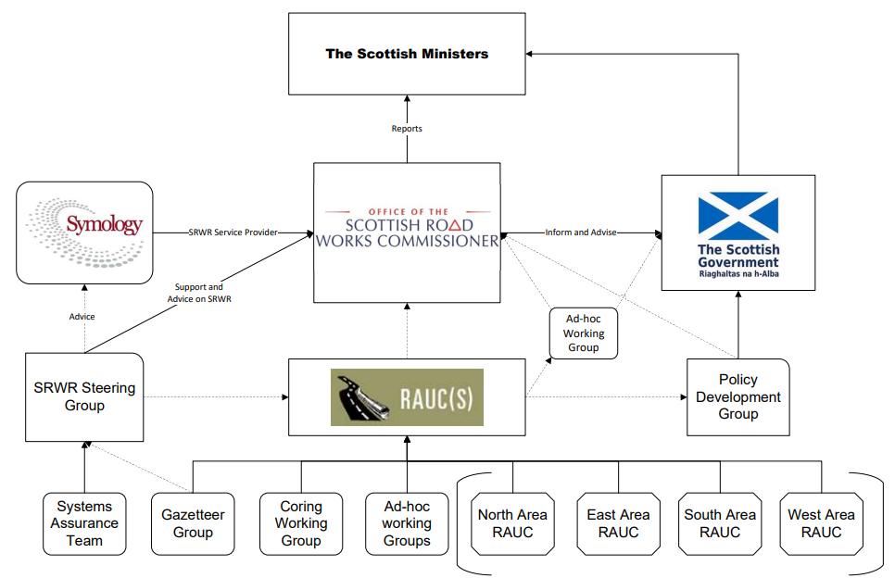
Figure 1 – Scottish road works community structure

The Commissioner has the overarching objective of improving the planning, co-ordination and quality of road works in Scotland.
RAUC(S) consists of representatives from both sectors of the road works community and provides support and advice to the Commissioner.
In addition to the RAUC(S) committee hierarchy, the road works community is represented on a wide range of working groups in Scotland and across the UK. These working groups inform the development of advice on:
- Legislation
- Codes of Practice
- Advice Notes
- Management and development of the SRWR
Working groups generally report directly to RAUC(S) or, where there are legislative or policy implications, to the Scottish Road Works Policy Development Group (PDG) which is chaired by the Scottish Government.

Publication of Codes of Practice and Advice
The continued participation of roads authorities and utility companies in the development of guidance ensures that legislation, codes of practice and advice notes are fit for purpose. The Commissioner appreciates the resourcing challenges facing both the public and the private sectors, and continues to encourage organisations to maintain their support and participation in this vital area of work.
The Commissioner would like to take this opportunity to thank those members of the Scottish road works community and their employing organisations for their continued participation and contribution.
A review of the currency and suitability of codes of practice, advice notes and guidance was undertaken in summer 2022. This resulted in a number of small amendments to existing advice notes, a number of advice notes being withdrawn and a series of recommendations to RAUC(S) to review codes of practice and advice notes. It is intended that a similar exercise will be undertaken annually and reported to RAUC(S) in the October cycle each year.

The following codes and advice note documents were revised in the reporting period:
- Advice Note 21 – Apparatus at Shallow Depth – updated September 2022
- Advice Note 22 - The Use of S109 of the New Road and Street Works Act 1991. Replacing S61 of the Roads (Scotland) Act 1984 – updated October 2022
- Advice Note 24 - Material and Trial Registers – updated September 2022
- Advice Note 26 - Traffic Management in Roads in Advance of Activity Commencing - Rescinded October 2022
- Code of Practice for the Co-Ordination of Works – Two advice notes issued (advice Note 30 – May 2022 and Advice Note 31 – February 2023)

Links to this and other publications can be found at the Legislation & Guidance section of the Commissioner’s website.
The development of legislation and guidance is an ongoing process and updates will be included in future reports.
Appendix C lists committees and working groups which met during the period of this report. The Commissioner was represented at all meetings.

Technical Standards Monitoring Programme
There has been no physical monitoring during the reporting period due to reassignment of the Technical Standards Manager to supporting the review of the SROR and the National Coring Programme.

Training and Accreditation Group (TAG)
Section 126 of NRSWA 1991 introduced a requirement for supervisors and operatives to be qualified as prescribed in regulations. In parallel, the first edition of Safety at Street Works and Road Works: A Code of Practice (“the Red Book”) was introduced in 1992.
TAG was established in 2017 to review the qualifications of supervisors and operatives and to develop question banks for use by accredited training providers. The group is co-chaired by a highway authority and a utility company. It consists of representatives from DfT, Commissioner, Scottish Government, Welsh Government, Northern Ireland RAUC, utility companies, highway authorities and awarding organisations. The Street Works Qualification Register (SWQR) is also represented. There has been no invitation sent to the Commissioner’s representatives since the last meeting held in June 2022. As a result, the Commissioner wrote to HAUC(UK) expressing concerns and to request that TAG was reconstituted to include Scottish representation.

Safety at Street Works and Road Works: A Code of Practice (2013) – (Safety Code)
Whilst, the safety code has been updated several times, most recently in 2013, the associated formal classroom training has remained largely undeveloped. The safety code now applies to roads authorities as well as utility companies working on Scotland’s roads. A review of the safety code has commenced with representation from all the devolved nations split into various groups to work on separate sections of the code. Initial meetings of groups started in May 2023. It is anticipated that a revised code will be completed in 2025.

Consultations and Research
The Commissioner supports and encourages consultations, research and the promotion of good practice.
This section summarises the involvement of the office during 2022/23.

Scottish Road Research Board (SRRB)
SRRB is a partnership between Transport Scotland, SCOTS and the Commissioner.
SRRB commissions research and development to inform improvements in safety, construction, operation and maintenance of the Scottish road network. Objectives include promoting innovation and best practice across roads authorities.
The research programme is jointly funded by Transport Scotland and SCOTS.
The Commissioner submitted a proposal to the SRRB in July 2021 for a project to examine the service life of utility reinstatements and develop a simple set of criteria for assessing reinstatements at the end of a 6-year period. The proposal was approved by the SRRB and undertaken through 2022/23. The results were signed off by the SRRB in early 2023 with publication due sometime in 2023/24. The key results showed that reinstatement quality had improved since the last research in 2012 and that reinstatements constructed in accordance with the specification could be expected to remain serviceable at 6 years old and beyond.

Transport Scotland Pavement Forum (TSPF)
The TSPF was established to promote and develop best practice in the selection and use of paving materials, specifically for use on the Scottish trunk road network. The remit was broadened in 2010 to cover all aspects of road pavement design, construction and maintenance, selection of material types and drainage across both trunk and local road networks.
The Commissioner has continued to have representation on this group through the reporting period.

Mobility and Access Committee Scotland (MACS)
The Mobility and Access Committee for Scotland (MACS) was established in 2002 and is an advisory non departmental public body which is constituted to:
- consider matters about the needs of disabled persons in connection with transport that the committee think are appropriate.
- advise the Scottish Ministers about those matters that the committee think are appropriate.
The Commissioner continued to engage with MACS through the reporting period.

Society of Chief Officers of Transportation in Scotland (SCOTS)
The Society of Chief Officers of Transportation in Scotland (SCOTS) was founded in 1996 following a change in local government. It is a strategic body comprising of transportation professionals from all the 32 councils and the seven regional transport partnerships. The society's work involves improving performance and innovation in the design, delivery and maintenance of transportation systems.
The Commissioner is keen to promote best practice amongst roads authorities and is now a regular participant in the SCOTS Liaison Committee.

Scottish Road Works Register
Under section 112 of NRSWA, the Commissioner has a statutory duty to keep a register of road works. This register is known as the Scottish Road Works Register (SRWR).

The Scottish Road Works Register
The SRWR is a cloud based register used for the transfer, retention and management of data used for the planning of road works across Scotland. Utility companies and roads authorities operating in Scotland have access to the SRWR and are required to give notice of their proposed road works to others who undertake road works allowing roads authorities to co-ordinate these works. It includes a public facing website to inform the travelling public and others affected by works of potential disruptions. It is funded by the user community through a levy of Prescribed Fees and Amounts which are collected annually by the Commissioner.
In summary, the SRWR is the main tool used by roads authorities and utility companies to:
- share information on road works
- assist in the planning and co-ordination of works in roads and
- share the results of inspections carried out for compliance with safety and reinstatement standards
- a source of data for management information to measure the performance of organisations undertaking works in roads and
- a source of information for the public and other interested parties regarding planned, on-going and completed works
There were several short outages to the SRWR service during the 2022/23 reporting period. None breached the service level agreement levels and overall the service was available for 99.79% of the contracted up-time.

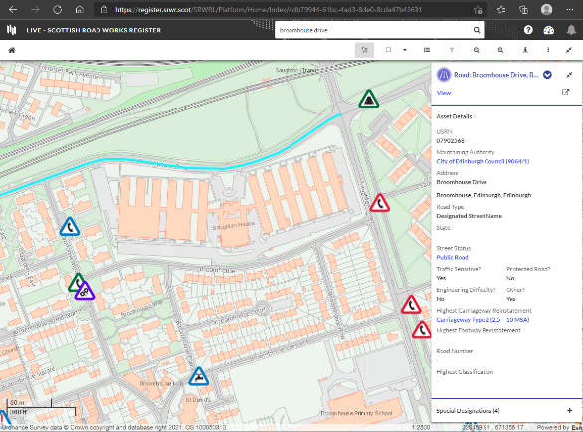
Figure 2 – Screenshot of the Scottish Road Works Register.

The average number of named users of the SRWR over 2022/23 was 2,298.
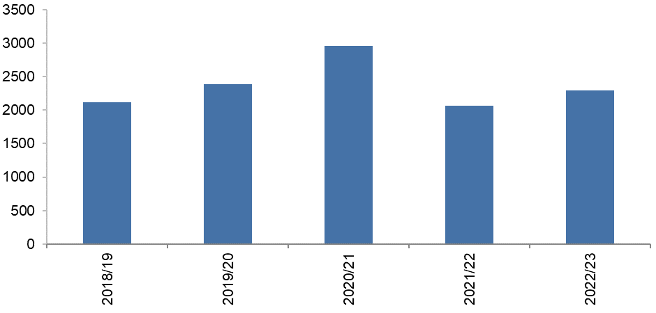
Figure 3 – Number of Named SRWR Users by Year.

Period | Users
2018/19 | 2,117
2019/20 | 2,387
2020/21 | 2,960
2021/22 | 2,065
2022/23 | 2,298
Table 5 – Number of Named SRWR Users by Year.

The contracted maximum number of concurrent users (those logged into the SRWR at any one time) during 2022/23 was 252.
This reporting period was the fifth year of the contract for the provision of the SRWR on behalf of the Commissioner. The contract has a minimum duration of 4 years with the option to extend for an additional 3 years, in 1 year increments.
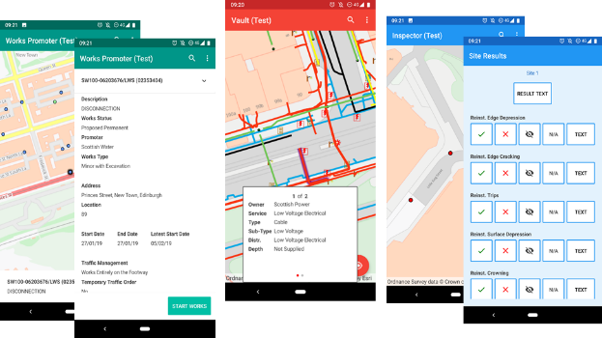
Figure 4 – Screenshots of the three SRWR Apps available.

Also included in the SRWR service are:

Scottish Road Works Online
A cut down version of the SRWR is available on the internet for the travelling public to access information on road works, showing planned and current road works. The site is compatible with a variety of platforms including desktop, tablet and mobile phones.
Scottish Road Works Online can be found here:
Scottish Road Works Online
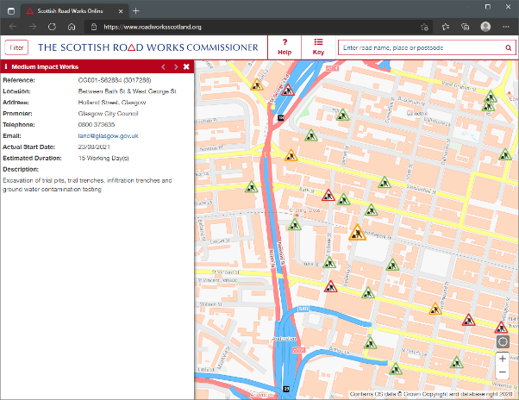
Figure 5 – Screenshot from Scottish Road Works Online

Dial Before You Dig
Whilst the SRWR allows utility companies and roads authorities to exchange details of their apparatus, third parties (those not classed as undertakers or roads authorities) can request information using the Dial Before You Dig Plant Information request facility. This protects operatives carrying out works from harm and protects assets from accidental damage caused by works.
Calls placed to the Dial Before You Dig service are handled by the service provider, Symology Ltd, as part of their contractual obligations for the provision of the SRWR. The provider uses the SRWR to pass details of the request to utility companies and roads authorities, who may have apparatus in the affected area. On receipt of a request utility companies and roads authorities are expected to respond with details of affected assets.
On average 114 requests/month were received during 2022/23.
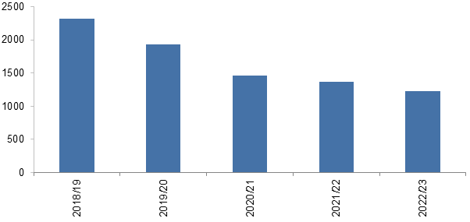
Figure 6 – Number of Dial Before You Dig requests processed

Year | Requests
2018/19 | 2,317
2019/20 | 1,935
2020/21 | 1,468
2021/22 | 1,374
2022/23 | 1,228
Table 6 – Number of Dial Before You Dig requests processed

Further information on this service can be found at:
http://dialbeforeyoudig.scot or by calling 08000 231 251

Community Apparatus Data Vault
RAUC(S) Advice Note 1 – The Sharing of Plant Information requires that records relating to apparatus/plant are made freely available for inspection by any roads authority or utility company. This information is provided using websites showing maps, CDs containing the data, maps by email or printed paper plans sent by post.
The Community Apparatus Data Vault (Vault) is a non-statutory addition to the SRWR introduced in 2011. It is one of the easiest ways available to an organisation to comply with its statutory obligation to share information. Vault displays information from all participating organisations simultaneously on one screen.

SRWR System Training
The training in the use of the SRWR is now provided in a suite of 12 e-learning modules, which can be tailored to the users expected usage of the SRWR. Over the period 1,416 modules were completed by users.

SRWR Open Data
As part of the new contract for the supply of the SRWR, it is a requirement that road works data recorded on SRWR is made available to download as Open Data. Every transaction relating to works is available for download in a set of CSV (Comma Separated Value) files.
Further information can be found here:
Scottish Road Works Register Open Data

SRWR Steering Group and the System Assurance Team
To ensure that SRWR services are fit for purpose, representatives of the SRWR user community meet regularly as members of the SRWR Steering Group and the System Assurance Team. These meetings are attended by representatives of the software contractor.
This engagement helps ensure that the SRWR continues to serve the needs of roads authorities and utility companies. These groups support both the Commissioner and RAUC(S).

Financing of the Scottish Road Works Register
Provision of the SRWR is funded by the user community through a statutory Prescribed Fees and Amounts levy which is collected annually by the Commissioner.
The Parliamentary Regulations supporting the collection of “Fees and Amounts” required for the 2022/23 financial year were:
- The Scottish Road Works Register (Prescribed Fees and Amounts) Regulations 2008 which came into force on 29 February 2008. Whilst the “Fees” element of this legislation has been superseded, the “Amounts” element remains in force.
- The Scottish Road Works Register (Prescribed Fees) Regulations 2021 which came into force on 1 April 2020 prescribes the fee to be collected for 2022/23.
The 2022/23 prescribed fees and amounts collected for the running of the SRWR totalled £882,933. Invoices for the operation of the SRWR were issued to the community on 1 April 2022. Of the 93 invoices issued, 67 were paid before the due date of 1 June 2022. The remaining 26 were all paid by 9 October 2022.
The Scottish Road Works Register (Prescribed Fees) Amendment Regulations 2022 were laid before the Scottish Parliament on 19 January 2022. In conjunction with The Scottish Road Works Register (Prescribed Fees and Amounts) Regulations 2008, these regulations prescribe the £882,933 required to operate the SRWR in 2022/23 and £950,387 required to operate the SRWR in 2023/24. During 2022/23 150,872 works were started, meaning an average cost of around £5.85 for each works started.

Legislation
The legal framework for road works in Scotland are the New Roads and Street Works Act 1991 (as amended by the Transport (Scotland) Act 2005) and the associated secondary legislation, codes of practice and advice notes. In 2019 this was supplemented by the Transport (Scotland) Act 2019. Part 9 of the 2019 Act makes provisions to enhance the role of the Commissioner and to improve the regulation of road works in Scotland.
The Transport (Scotland) Act 2019 received royal ascent in November 2019, and whilst there was a delay due to the Covid pandemic, several provisions contained in Part 9 have been commenced. The remaining provisions are due to be commenced during 2023/24.
Reviewing legislation is an ongoing process which most public sector agencies undertake at some time. Reviews can be driven by sector developments, changes in technology/materials, changes in processes or be policy driven and should benefit stakeholders and the public. Consultation is an essential part of any review and a key part of developing legislation.
Links to this legislation and other publications can be found at the Legislation & Guidance section of the Commissioner’s website.

Specification for the Reinstatement of Openings in Roads (SROR)

Work to develop the Fifth Edition of the SROR has been ongoing throughout 2022/23. This has been a collaborative effort from a working group comprising representatives of roads authorities and utilities, with support from the Commissioner’s staff. This was granted ministerial approval on 25 May 2023 and will come into operation on 1 October 2023.

Policy Development Group (PDG)
The road works PDG meets quarterly and is chaired by the Scottish Government. Membership includes representatives from the Commissioner, RAUC(S), SCOTS, Street Works UK and the SRWR Steering Group. The group considers amendments to road works policy and provides advice on legislation, codes of practice and advice notes.

Regulations
The Transport (Scotland) Act 2019 (Commencement No. 6) Regulations 2022, came into force on 28 November 2022 and introduced: requirements for qualified operatives and supervisors; changes to the noticing requirements for actual works commencement and works completion notices; the legislative requirement for reinstatement quality plans; and some minor amendments and repeals.

Legislation and Future Legislation
The Commissioner will continue to work closely with Scottish Government with this development and any future legislation.

Annual Report and Accounts
Audit Scotland undertook an external audit of the 2022/23 Commissioner Annual Report and Accounts during the summer of 2023.
The Annual Report and Accounts for 2022/23 will be published by 31 December 2023 and be available to download here:
Scottish Road Works Commissioner’s Annual Accounts

Reflection and Forward Planning

Reflection
The number of road works registered continued to increase in 2022/23 compared to the previous year. Most of this increase was in the telecoms sector and appears to be associated with the continuing expansion of fibre broadband. However, the increase was significantly lower than in 2021/22 and this might indicate that the peak is being reached.
Disruption from road works is inevitable but through good co-ordination and co-operation, facilitated by the Scottish Road Works Register, the disruption can be managed and minimised. Roads Authorities have a key role to play in this and have a range of powers available to assist. However, there remains a considerable inconsistency in the use of these powers and the Commissioner feels this needs to improve before any further powers should be considered for Roads Authorities.
There has been a notable rise in the number of substandard traffic management issues recorded and an attendant decrease in the percentage of utility Sample A inspections passed. This is a real concern as good signing, lighting and guarding (SLG) is the fundamental mechanism by which people are protected – both within the site and whilst passing the site whilst walking, wheeling, cycling or in vehicles. There is currently no fixed penalty available for roads authorities to issue in the event of inadequate SLG and this may be one reason for the issue. The Commissioner intends to give particular attention to this when new compliance notice and inspection powers are introduced in 2023/24.
The Commissioner has signed up to the HAUC(UK) Road to Net Zero Charter and will continue to push for action to reduce the carbon impact of road works.
Finally, the results of the delayed National Coring Programme should be released in 2023 and will hopefully show continued improvement. However, it is anticipated that some utilities will still face potential penalties as a result of inadequate performance.

Forward Planning
The Business Plan 2023/24 developed in March 2023, is published on the Commissioner’s website;
Business Plan 2023-24 | Scottish Road Works Commissioner
In addition to addressing the corporate aims of the office, the plan focuses on the overall governance and objective setting by business area. The plan acknowledges the work to assist Transport Scotland, associated with the progression of the Transport (Scotland) Act 2019.
The 2023-26 Corporate Plan, reviewed in 2023, is also published on the Commissioner’s website;
Corporate Plan 2023-26 | Scottish Road Works Commissioner

- List of Terms and Descriptions
The table below proves a list of acronyms and terms used in this report.
Term | Description
Area RAUC | Area sub-group of the Roads Authorities and Utilities Committee
Commissioner | Scottish Road Works Commissioner
DBFO | Transport Scotland contractors engaged to Design, Build, Finance and Operate the road
EI(S)R | Environmental Information (Scotland) Regulations 2004
FOI(S)A | Freedom of Information (Scotland) Act 2002
FPN | Fixed Penalty Notice
Gazetteer | List of all roads maintained by a roads authority
HAUC (UK) | Highway Authorities and Utilities Committee (UK)
Local RAUC | Local Roads Authorities and Utilities Committee
NRSWA | New Roads and Street Works Act 1991, as amended by the Transport (Scotland) Act 2005 and the Transport (Scotland) Act 2019
PDG | Policy Development Group
RAUC(S) | Roads Authorities and Utilities Committee (Scotland)
Register | Scottish Road Works Register
Roads Authority (RA) | The authority responsible for the maintenance of the road and co-ordination of road works taking place on that road.
SCOTS | Society of Chief Officers of Transportation in Scotland
SROR | Specification for the Reinstatement of Openings in Roads
SRRB | Scottish Road Research Board
SRWR | Scottish Road Works Register
Utility Company (U) | Those organisations with the statutory powers to place and maintain apparatus in the road. Referred to “undertakers” in NRSWA.

- List of Roads Authorities and Utilities

Roads Authorities

City Group
Aberdeen City Council
Dundee City Council
City of Edinburgh Council
Glasgow City Council

Island Group
Comhairle nan Eilean Siar
Orkney Islands Council
Shetland Islands Council

Rural Group
Aberdeenshire Council
Angus Council
Argyll & Bute Council
Scottish Borders Council
Dumfries & Galloway Council
Highland Council
Perth & Kinross Council
Moray Council

Semi-Urban Group
East Ayrshire Council
East Lothian Council
Fife Council
Midlothian Council
North Ayrshire Council
South Ayrshire Council
South Lanarkshire Council
Stirling Council
West Lothian Council

Urban Group
Clackmannanshire Council
East Dunbartonshire Council
East Renfrewshire Council
Falkirk Council
Inverclyde Council
North Lanarkshire Council
Renfrewshire Council
West Dunbartonshire Council

Trunk Road
Transport Scotland on behalf of Scottish Ministers

Other
Tay Road Bridge Joint Board

Utility Companies

Electricity
Electricity Network Company Ltd
Energy Asset Networks
ESP Electricity
Fulcrum Electricity Assets Ltd
Indigo Power
Last Mile Electricity Ltd
Moray Offshore Windfarm (West) Ltd
mua Electricity Ltd
NorthConnect
Optimal Power Networks Ltd
Premier Transmission Ltd
Scottish Hydro Electric Power Distribution plc
SP Energy Networks

Gas
Energy Assets Pipelines
ES Pipelines Ltd
Fulcrum Pipelines Ltd
GTC Pipelines Ltd
Indigo Pipelines
Last Mile Gas Ltd
mua Gas Ltd
National Gas
SGN

Pipelines
BP
EnQuest
Exolum Pipeline Systems Ltd
INEOS FPS
INEOS O & P UK
Petroineos Manufacturing Scotland Ltd
Shell

Telecoms
Arqiva
Axione UK Ltd
BorderLink Broadband Ltd
Broadband for the Rural North (B4RN)
Broadway Partners Ltd
BT
CityFibre
Commsworld Ltd
Converged Communications Solutions Ltd
EE
Gamma Telecom
Concept Solutions People Ltd
Grain Communications
Hutchison 3G
Hyperoptic Ltd
InFocus Public Networks Ltd
InternetTY Ltd
Lothian Broadband
Lumen Technologies UK Ltd
Neos Networks
Netomnia
Nexfibre Networks Ltd
Open Fibre UK Ltd
Optify Mediaforce Ltd
Persimmon Homes Ltd
Sky UK
TalkTalk Business
Telefonica UK
Verizon
Virgin Media Group
Vodafone Ltd
Zayo

Water
Scottish Water

Others
Network Rail
Royal Mail

- Extent of Engagement
Committees and working groups which met during the reporting period at which the Commissioner or a representative attended. Due to the pandemic, meetings were held virtually.
Committees | Frequency | Reports to
Highway Authorities and Utilities Committee (UK) | 4 per year | N/A
Roads Authorities and Utilities Committee (Scotland) | 3 per year | N/A
Area RAUC | 3 per year | RAUC(S)
Local RAUC | 4 per year | Area RAUCs

Working Groups | Frequency | Reports to
Policy Development Group | Quarterly | Scottish Government
Specification for the Reinstatement of Openings in Roads Working Group | When required | RAUC(S)
SRWR Steering Group | Quarterly | The Commissioner/RAUC(S)
RAUC(S) Gazetteer Working Group | Quarterly | RAUC(S)
System Assurance Team | Quarterly | SRWR Steering Group
Code of Practice for Inspections Working Group | When required | RAUC(S)
Coring Working Group | When required | RAUC(S)
Co-ordination Code of Practice Working Group | When required | RAUC(S)
Training and Accreditation Group (UK) | Quarterly | HAUC(UK)

In addition to the above specific groups, the following summarises other engagements undertaken during the reporting period by the Commissioner during 2022/23.
Meeting/Engagement | Frequency/Summary
Utility company specific meetings | Meetings include the promotion of good practice, compliance and enforcement.
Roads authority specific meetings | Meetings include the promotion of good practice, compliance and enforcement.
Scottish Government | Specialist technical policy groups to assist in the progress of specialist policies and directives.  Input into significant national events.  Liaison meetings as required.
Continued professional development | Staff development and knowledge exchange to ensure good practice within the industry.
SRWR contract meetings | Quarterly liaison meetings with the software provider.

- 22 Additional Indicator Reports

Performance Review Rating 2022/23
Type | Organisation | Rating
RA | Comhairle nan Eilean Siar | Well Managed
RA | Fife Council | Well Managed
RA | Inverclyde Council | Well Managed
RA | Midlothian Council | Well Managed
RA | North Lanarkshire Council | Well Managed
RA | Scottish Borders Council | Well Managed
RA | South Lanarkshire Council | Well Managed
RA | West Dunbartonshire Council | Well Managed
RA | West Lothian Council | Well Managed
U | ES Pipelines Ltd | Well Managed
U | GTC Pipelines Ltd | Well Managed
U | mua Electricity Ltd | Well Managed
U | Neos Networks | Well Managed
U | Network Rail | Well Managed
RA | Aberdeen City Council | Satisfactory
RA | Angus Council | Satisfactory
RA | Argyll & Bute Council | Satisfactory
RA | Dundee City Council | Satisfactory
RA | East Ayrshire Council | Satisfactory
RA | East Dunbartonshire Council | Satisfactory
RA | East Lothian Council | Satisfactory
RA | East Renfrewshire Council | Satisfactory
RA | Falkirk Council | Satisfactory
RA | Glasgow City Council | Satisfactory
RA | Highland Council | Satisfactory
RA | Moray Council | Satisfactory
RA | North Ayrshire Council | Satisfactory
RA | Perth & Kinross Council | Satisfactory
RA | Renfrewshire Council | Satisfactory
RA | South Ayrshire Council | Satisfactory
RA | Stirling Council | Satisfactory
RA | Tay Road Bridge Joint Board | Satisfactory
RA | Transport Scotland | Satisfactory
U | Borderlink Broadband Ltd | Satisfactory
U | BT | Satisfactory
U | Commsworld Ltd | Satisfactory
U | EE | Satisfactory
U | Nexfibre Networks Ltd | Satisfactory
U | Royal Mail | Satisfactory
U | Scottish Hydro Electric Power Distribution plc | Satisfactory
U | Scottish Water | Satisfactory
U | SGN | Satisfactory
U | Sky UK | Satisfactory
U | Virgin Media Group | Satisfactory
RA | Aberdeenshire Council | Unsatisfactory
RA | City of Edinburgh Council | Unsatisfactory
RA | Clackmannanshire Council | Unsatisfactory
RA | Dumfries & Galloway Council | Unsatisfactory
RA | Orkney Islands Council | Unsatisfactory
RA | Shetland Islands Council | Unsatisfactory
U | Arqiva | Unsatisfactory
U | Axione UK Ltd | Unsatisfactory
U | Broadway Partners Ltd | Unsatisfactory
U | CityFibre | Unsatisfactory
U | Converged Communications Solutions Ltd | Unsatisfactory
U | Energy Assets Pipelines | Unsatisfactory
U | ESP Electricity | Unsatisfactory
U | Fulcrum Pipelines Ltd | Unsatisfactory
U | Hutchison 3G | Unsatisfactory
U | Hyperoptic Ltd | Unsatisfactory
U | Indigo Pipelines | Unsatisfactory
U | InternetTY Ltd | Unsatisfactory
U | Last Mile Electricity Ltd | Unsatisfactory
U | Last Mile Gas Ltd | Unsatisfactory
U | Lothian Broadband | Unsatisfactory
U | Lumen Technologies UK Ltd | Unsatisfactory
U | National Gas | Unsatisfactory
U | Netomnia | Unsatisfactory
U | Optimal Power Networks Ltd | Unsatisfactory
U | Persimmons Homes Ltd | Unsatisfactory
U | SP Energy Networks | Unsatisfactory
U | Telefonica UK | Unsatisfactory
U | Verizon | Unsatisfactory
U | Vodafone Ltd | Unsatisfactory
U | Zayo | Unsatisfactory
Table 7 – Performance review rating 2022/23

Roads authority and utility company noticing failures as a percentage of actual starts
All qualifying road works carried out by utility companies and roads authorities are required to be registered (noticed) on the Scottish Road Works Register (SRWR).
Utility company noticing failures are system generated by the SRWR and referred to as potential noticing offences. Each potential noticing offence is reviewed by a roads authority and may attract a Fixed Penalty Notice (FPN) (not all roads authorities have taken up the option to issue FPNs).
Roads authority noticing failures are also system generated by the SRWR and referred to as potential noticing failures for comparison purposes with utility company performance. They are not subject to FPNs as an authority cannot issue a penalty against themselves.
This indicator compares the average noticing failure rate of all utility companies against the average noticing failure rate of all roads authorities and the individual failure rates of utility companies and roads authorities.
Notices required to be registered on the SRWR include:
- Advance Notice (NRSWA Section 113(5))
- Start Notice (NRSWA Section 114(5))
- Emergency Notice (NRSWA Section 116(4))
- Works Closed Notice (NRSWA Section 129(6))
It is expected that all roads authorities and utility companies achieve a failure rate of 4% or less, as noticing of road works is an administrative function.
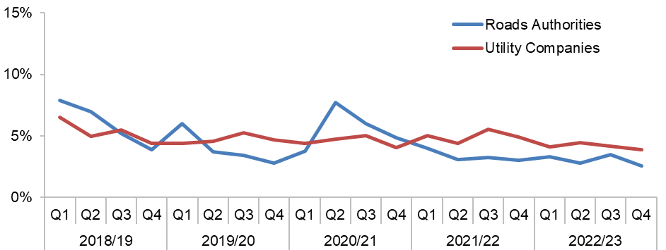
Figure 7 – Roads authority and utility company noticing failures as a percentage of actual starts
(Source: SRWR Reports 2a and 2b)
Roads Authorities | 2018/19 | 2019/20 | 2020/21 | 2021/22 | 2022/23
Aberdeen City Council | 7.0% | 3.9% | 5.5% | 3.8% | 2.6%
Aberdeenshire Council | 13.1% | 4.0% | 6.9% | 6.4% | 8.4%
Angus Council | 4.3% | 1.2% | 3.4% | 1.4% | 9.3%
Argyll & Bute Council | 2.6% | 5.8% | 13.7% | 4.1% | 3.2%
City of Edinburgh Council | 21.1% | 7.8% | 9.4% | 5.5% | 9.7%
Clackmannanshire Council | 2.3% | 0.6% | 6.1% | 8.8% | 11.7%
Comhairle nan Eilean Siar | 1.7% | 0.8% | 1.0% | 1.2% | 2.7%
Dumfries & Galloway Council | 3.7% | 2.5% | 12.0% | 8.6% | 7.0%
Dundee City Council | 15.3% | 14.6% | 17.6% | 9.8% | 5.0%
East Ayrshire Council | 11.6% | 16.7% | 10.5% | 4.1% | 2.8%
East Dunbartonshire Council | 2.5% | 1.6% | 2.5% | 1.6% | 0.8%
East Lothian Council | 5.3% | 10.1% | 19.7% | 2.3% | 2.3%
East Renfrewshire Council | 18.4% | 10.0% | 5.6% | 3.6% | 4.7%
Falkirk Council | 4.7% | 4.2% | 6.8% | 4.6% | 5.9%
Fife Council | 8.6% | 2.9% | 6.9% | 4.5% | 4.5%
Glasgow City Council | 6.7% | 4.1% | 17.9% | 7.8% | 3.0%
Highland Council | 10.0% | 7.8% | 11.4% | 9.0% | 1.4%
Inverclyde Council | 3.0% | 1.7% | 1.4% | 2.4% | 2.9%
Midlothian Council | 1.9% | 0.6% | 4.0% | 0.0% | 0.5%
Moray Council | 0.5% | 2.5% | 12.1% | 5.3% | 7.1%
North Ayrshire Council | 8.3% | 2.8% | 15.2% | 2.0% | 2.8%
North Lanarkshire Council | 4.4% | 1.9% | 3.8% | 2.0% | 2.1%
Orkney Islands Council | 7.1% | 8.7% | 21.5% | 9.7% | 12.0%
Perth & Kinross Council | 4.4% | 1.2% | 3.0% | 5.6% | 5.3%
Renfrewshire Council | 1.1% | 0.9% | 3.7% | 1.2% | 5.2%
Scottish Borders Council | 8.0% | 3.2% | 7.3% | 4.1% | 3.2%
Shetland Islands Council | 2.5% | 4.3% | 10.4% | 7.9% | 7.8%
South Ayrshire Council | 6.3% | 6.3% | 5.8% | 3.6% | 2.2%
South Lanarkshire Council | 5.0% | 2.6% | 6.1% | 5.2% | 1.6%
Stirling Council | 4.3% | 4.6% | 14.8% | 2.8% | 3.9%
Tay Road Bridge Joint Board | 0.0% | 9.1% | 200.0% | 0.0% | 16.7%
Transport Scotland | 3.9% | 3.1% | 3.1% | 1.3% | 1.5%
West Dunbartonshire Council | 70.7% | 35.8% | 5.2% | 3.8% | 2.3%
West Lothian Council | 4.7% | 3.0% | 4.3% | 1.8% | 3.8%
Table 8 – Roads authority noticing failures as a percentage of actual starts
(Source: SRWR Report 2a and SRWR Report 9a)
Organisation | 2018/19 | 2019/20 | 2021/22 | 2021/22 | 2022/23
Arqiva | 14.2% | 2.9% | 0.0% | 66.7% | 66.7%
Axione UK Ltd | N/A | 0.0% | 7.1% | 28.0% | 9.2%
Borderlink Broadband Ltd | N/A | N/A | N/A | 42.5% | 2.7%
Broadway Partners Ltd | N/A | N/A | N/A | N/A | 14.4%
BT | 4.3% | 3.4% | 3.7% | 4.2% | 6.1%
CityFibre | 6.1% | 6.1% | 5.6% | 4.0% | 3.4%
Commsworld Ltd | N/A | N/A | 0.0% | 6.8% | 2.8%
Concept Solutions People Ltd | 30.0% | 66.7% | N/A | N/A | N/A
Converged Communication Solutions Ltd | N/A | N/A | N/A | N/A | 100.0%
EE | 9.5% | 3.5% | 5.6% | 3.3% | 5.1%
Energy Asset Networks | N/A | N/A | N/A | N/A | 11.1%
Energy Assets Pipelines | 13.6% | 16.3% | 14.9% | 10.3% | 8.9%
ES Pipelines Ltd | 8.3% | 9.2% | 50.8% | 42.5% | 2.8%
ESP Electricity | 0.0% | N/A | N/A | 100.0% | 35.7%
Fulcrum Pipeline Ltd | 55.3% | 67.7% | 46.2% | 42.9% | 20.0%
GTC Pipelines Ltd | 24.0% | 24.6% | 7.9% | 3.1% | 1.7%
Hutchison 3G | N/A | N/A | N/A | N/A | 20.4%
Hyperoptic Ltd | 4.5% | 20.0% | 17.0% | 25.1% | 19.0%
Indigo Pipelines | N/A | N/A | N/A | 0.0% | 0.0%
Indigo Power | N/A | N/A | N/A | 50.0% | N/A
INEOS FPS | 25.0% | N/A | 0.0% | N/A% | N/A
INEOS O & P UK | N/A | N/A | N/A | N/A% | N/A
InternetTY Ltd | N/A | N/A | N/A | N/A | 45.5%
Last Mile Electricity Ltd | 30.6% | 16.2% | 8.8% | 10.9% | 11.1%
Last Mile Gas Ltd | N/A | N/A | 4.2% | 6.2% | 15.1%
Lothian Broadband | N/A | 0.0% | 0.0% | 15.7% | 14.2%
Lumen Technologies UK Ltd | 20.0% | 17.6% | 50.0% | N/A | 0.0%
mua Electricity Ltd | N/A | N/A | 65.4% | 36.7% | 4.7%
mua Gas Ltd | N/A | N/A | 100.0% | N/A | N/A
National Gas | 10.5% | N/A | N/A | N/A | 121.4%
Neos Networks | 1.6% | 3.2% | 7.4% | 1.3% | 0.4%
Netomnia | N/A | N/A | N/A | N/A | 8.8%
Network Rail | 6.1% | 2.0% | 3.9% | 3.4% | 3.1%
Nexfibre Networks Ltd | N/A | N/A | N/A | N/A | 6.0%
Optimal Power Networks Ltd | N/A | N/A | N/A | N/A | 50.0%
Persimmon Homes Ltd | N/A | N/A | N/A | N/A | 33.3%
Petroineos Manufacturing Scotland Ltd | N/A | 66.7% | N/A | N/A | N/A
Royal Mail | 25.3% | 4.1% | 25.3% | 0.0% | 10.9%
Scottish Hydro Electric Power Distribution plc | 4.7% | 13.5% | 8.2% | 9.6% | 6.8%
Scottish Water | 3.1% | 3.1% | 3.4% | 4.5% | 3.6%
SGN | 7.3% | 5.6% | 7.9% | 6.6% | 6.0%
Sky UK | 58.3% | 0.0% | 0.0% | N/A | 0.0%
SP Energy Networks | 7.1% | 6.2% | 5.8% | 8.1% | 8.1%
Telefonica UK | 6.2% | 5.3% | 11.6% | 4.1% | 2.2%
Verizon | 22.2% | 0.0% | 50.0% | 10.0% | 0.0%
Virgin Media Group | 8.1% | 6.9% | 13.6% | 19.3% | 3.9%
Vodafone Ltd | 6.0% | 3.2% | 4.1% | 2.3% | 12.0%
Zayo | 72.7% | 50.0% | 20.0% | 54.5% | 30.0%
Note: N/A indicates the organisation did not undertake any works in that year.
Table 9 – Utility company noticing failures as a percentage of actual starts
(Source: SRWR Report 2b and SRWR Report 9a)

Actual starts (Roads authority and utility company)
Subject to the scale of the road works, utility companies and roads authorities are required to register 24 hour, 3 day or 7 day advance notifications on the Scottish Road Works Register (SRWR) for all qualifying works.
When road works actually commence on site, organisations are then required to register an actual start notice.
For example, works subject to a 7 day notification require an actual start to be registered between Day 7 and Day 14, and this must be registered by noon the following day.
This indicator shows the number of actual start notices registered on the SRWR by roads authorities and utility companies, including emergency and urgent works.
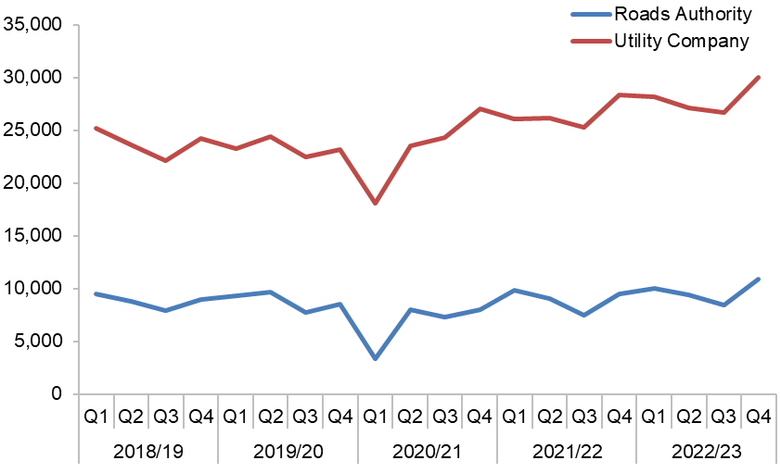
Figure 8 – Roads authority and utility company actual starts
(Source: SRWR Report 9a)

Period | Roads Authorities | Utility Companies
2018/19 Q1 | 9,640 | 25,194
2018/19 Q2 | 8,807 | 23,622
2018/19 Q3 | 7,981 | 22,096
2018/19 Q4 | 9,070 | 24,249
2019/20 Q1 | 9,375 | 23,265
2019/20 Q2 | 9,842 | 24,470
2019/20 Q3 | 7,786 | 22,494
2019/20 Q4 | 8,725 | 23,216
2020/21 Q1 | 3,388 | 18,101
2020/21 Q2 | 7,990 | 23,519
2020/21 Q3 | 7,316 | 24,325
2020/21 Q4 | 8,019 | 27,066
2021/22 Q1 | 9,820 | 26,083
2021/22 Q2 | 9,076 | 26,179
2021/22 Q3 | 7,458 | 25,253
2021/22 Q4 | 9,515 | 28,359
2022/23 Q1 | 10,018 | 28,217
2022/23 Q2 | 9,439 | 27,100
2022/23 Q3 | 8,472 | 26,695
2022/23 Q4 | 10,908 | 30,023
Table 10 – Roads authority and utility company noticing actual starts
(Source: SRWR Report 9a)

Early and late starts as a percentage of actual starts
This indicator records the percentage of works with a registered start date in the SRWR where an early or late start request has subsequently been made.
Early starts with the agreement of utility companies and roads authorities can be a sign of good co-ordination. Where a window of opportunity exists to undertake works, it should be considered. Excessive use suggests poor works planning.
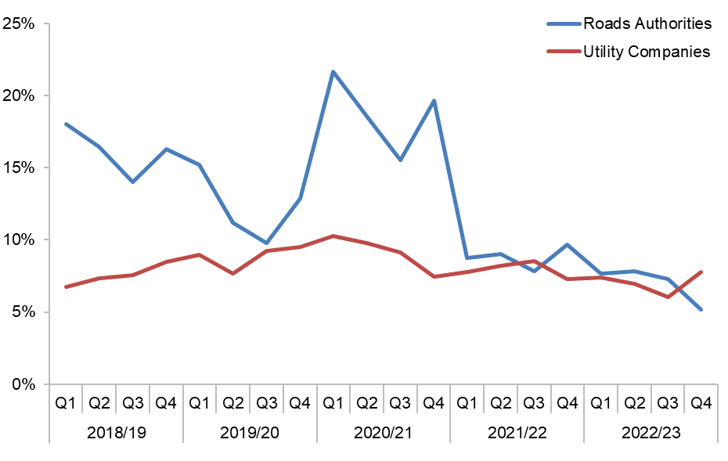
Figure 9 – Early starts as a percentage of actual starts
(Source: SRWR Report 10 and SRWR Report 9a)

Period | Roads Authorities | Utility Companies
2018/19 Q1 | 18.0% | 6.7%
2018/19 Q2 | 16.4% | 7.4%
2018/19 Q3 | 14.0% | 7.5%
2018/19 Q4 | 16.3% | 8.5%
2019/20 Q1 | 15.2% | 9.0%
2019/20 Q2 | 11.2% | 7.7%
2019/20 Q3 | 9.8% | 9.2%
2019/20 Q4 | 12.9% | 9.5%
2020/21 Q1 | 15.1% | 10.2%
2020/21 Q2 | 14.5% | 9.7%
2020/21 Q3 | 11.3% | 9.1%
2020/21 Q4 | 13.5% | 7.4%
2021/22 Q1 | 8.8% | 7.8%
2021/22 Q2 | 9.0% | 8.2%
2021/22 Q3 | 7.8% | 8.5%
2021/22 Q4 | 9.7% | 7.3%
2022/23 Q1 | 7.7% | 7.4%
2022/23 Q2 | 7.8% | 6.9%
2022/23 Q3 | 7.3% | 6.0%
2022/23 Q4 | 5.2% | 7.8%
Table 11 – Early starts as a percentage of actual starts
(Source: SRWR Report 10 and SRWR Report 9a)
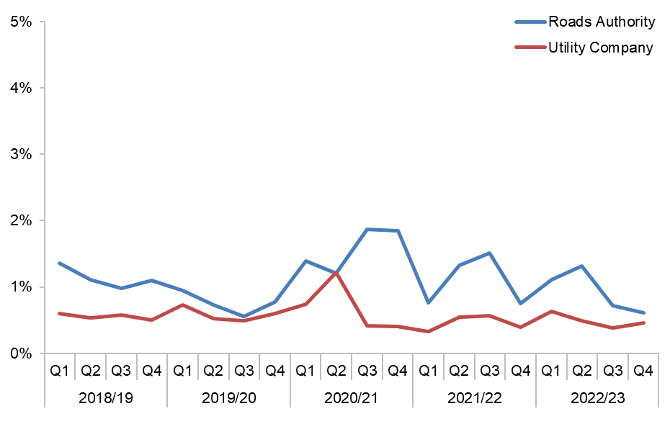
Figure 10 – Late starts as a percentage of actual starts
(Source: SRWR Report 10 and SRWR Report 9a)

Period | Roads Authorities | Utility Companies
2018/19 Q1 | 1.4% | 0.6%
2018/19 Q2 | 1.1% | 0.5%
2018/19 Q3 | 1.0% | 0.6%
2018/19 Q4 | 1.1% | 0.5%
2019/20 Q1 | 1.0% | 0.7%
2019/20 Q2 | 0.7% | 0.5%
2019/20 Q3 | 0.6% | 0.5%
2019/20 Q4 | 0.8% | 0.6%
2020/21 Q1 | 1.4% | 0.7%
2020/21 Q2 | 1.1% | 1.2%
2020/21 Q3 | 1.9% | 0.4%
2020/21 Q4 | 1.8% | 0.4%
2021/22 Q1 | 0.8% | 0.3%
2021/22 Q2 | 1.3% | 0.5%
2021/22 Q3 | 1.5% | 0.6%
2021/22 Q4 | 0.7% | 0.4%
2022/23 Q1 | 1.1% | 0.6%
2022/23 Q2 | 1.3% | 0.5%
2022/23 Q3 | 0.7% | 0.4%
2022/23 Q4 | 0.6% | 0.5%
Table 12 – Late starts as a percentage of actual starts
(Source: SRWR Report 10 and SRWR Report 9a)

Unplanned works as a percentage of actual starts
Where works are considered, by a roads authority or utility company to be emergency, urgent or remedial dangerous they are considered to be unplanned works and there are special noticing procedures which allow works to start as soon as possible.
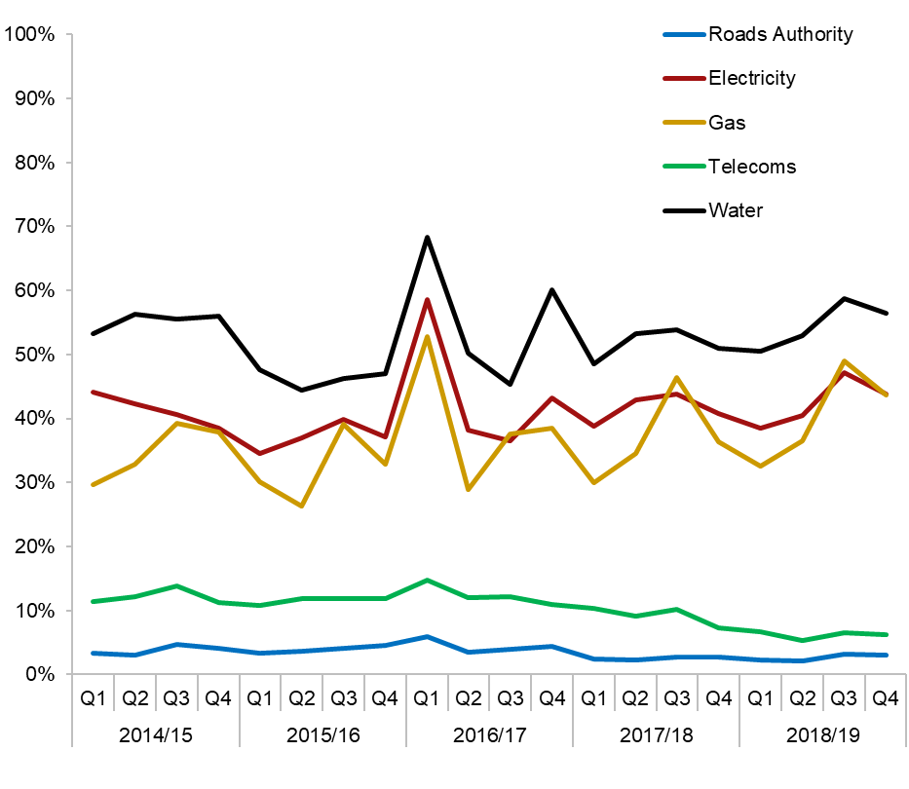
Figure 11 – Unplanned works as a percentage of actual starts
(Source: SRWR Report 9a)

Period | Elec | Gas | RA | Tel | Water | Other
2018/19 Q1 | 44.9% | 29.0% | 3.4% | 9.4% | 53.2% | 5.4%
2018/19 Q2 | 43.2% | 32.0% | 3.1% | 12.2% | 56.2% | 6.7%
2018/19 Q3 | 41.2% | 38.6% | 4.7% | 13.9% | 55.5% | 7.8%
2018/19 Q4 | 39.3% | 36.9% | 4.1% | 11.2% | 55.9% | 8.9%
2019/20 Q1 | 34.6% | 30.2% | 3.3% | 10.8% | 47.6% | 3.6%
2019/20 Q2 | 36.9% | 26.3% | 3.6% | 11.9% | 44.5% | 4.2%
2019/20 Q3 | 39.9% | 39.1% | 4.1% | 11.9% | 46.2% | 3.0%
2019/20 Q4 | 37.2% | 32.8% | 4.6% | 11.9% | 47.0% | 3.0%
2020/21 Q1 | 58.6% | 52.7% | 5.9% | 11.5% | 68.3% | 1.5%
2020/21 Q2 | 38.2% | 29.0% | 3.4% | 10.5% | 50.3% | 2.7%
2020/21 Q3 | 36.5% | 37.6% | 4.0% | 10.6% | 45.3% | 2.4%
2020/21 Q4 | 43.2% | 38.5% | 4.4% | 9.6% | 60.1% | 6.7%
2021/22 Q1 | 38.8% | 29.9% | 2.4% | 10.4% | 48.6% | 1.7%
2021/22 Q2 | 43.0% | 34.5% | 2.3% | 9.1% | 53.3% | 2.0%
2021/22 Q3 | 43.8% | 46.4% | 2.8% | 10.2% | 53.9% | 2.5%
2021/22 Q4 | 40.8% | 36.4% | 2.7% | 7.3% | 51.0% | 1.6%
2022/23 Q1 | 38.5% | 32.5% | 2.2% | 6.7% | 50.5% | 1.9%
2022/23 Q2 | 40.5% | 36.5% | 2.2% | 5.3% | 53.0% | 1.3%
2022/23 Q3 | 47.2% | 49.0% | 3.2% | 6.5% | 58.7% | 7.9%
2022/23 Q4 | 43.8% | 43.7% | 3.1% | 6.3% | 56.4% | 11.2%
Table 13 – Unplanned works as a percentage of actual starts
(Source: SRWR Report 9a)

Work extensions as a percentage of actual starts
Works extensions are granted to a utility company with the agreement of the affected roads authority when an expected completion date is unlikely to be achieved.
This indicator compares the percentage of utility company road works and roads authority works which have been extended beyond their expected end date.
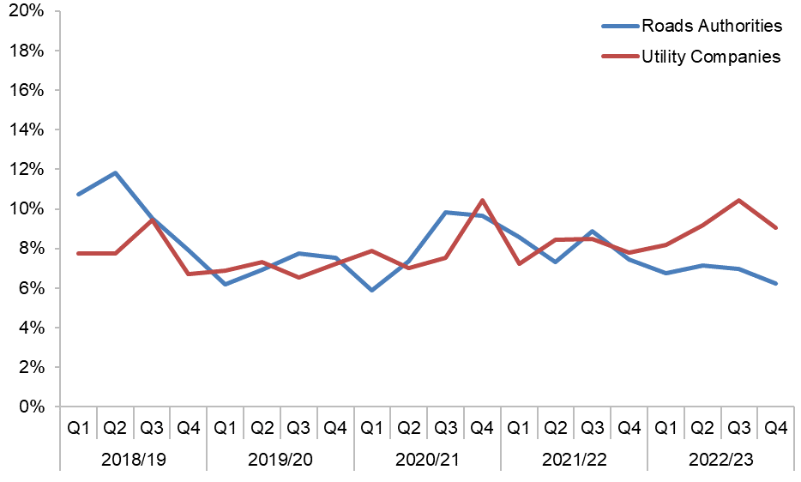
Figure 12 – Works extensions as a percentage of actual starts
(Source: SRWR Report 12 and SRWR Report 9a)

Period | Roads Authorities | Utility Companies
2018/19 Q1 | 10.7% | 7.7%
2018/19 Q2 | 11.8% | 7.7%
2018/19 Q3 | 9.5% | 9.4%
2018/19 Q4 | 7.9% | 6.7%
2019/20 Q1 | 6.2% | 6.9%
2019/20 Q2 | 6.9% | 7.3%
2019/20 Q3 | 7.7% | 6.5%
2019/20 Q4 | 7.6% | 7.2%
2020/21 Q1 | 5.9% | 7.9%
2020/21 Q2 | 7.4% | 7.0%
2020/21 Q3 | 9.8% | 7.6%
2020/21 Q4 | 9.7% | 10.4%
2021/22 Q1 | 8.6% | 7.2%
2021/22 Q2 | 7.3% | 8.4%
2021/22 Q3 | 8.9% | 8.5%
2021/22 Q4 | 7.5% | 7.8%
2022/23 Q1 | 6.7% | 8.2%
2022/23 Q2 | 7.2% | 9.2%
2022/23 Q3 | 7.0% | 10.5%
2022/23 Q4 | 6.2% | 9.1%
Table 14 – Works extensions as a percentage of actual starts
(Source: SRWR Report 12 and SRWR Report 9a)

Works that Overran as a percentage of planned works
Works that overrun occur when a road works completion date goes beyond the expected end date recorded in the Scottish Road Works Register (SRWR).
Note: The term “planned works” include major standard and minor works registered on the SRWR.
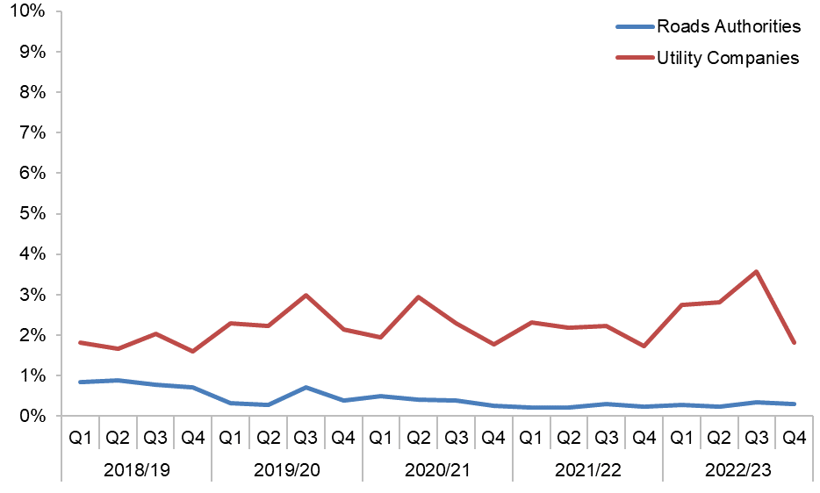
Figure 13 – Works that Overran works as a percentage of planned works
(Source: SRWR Report 6 and SRWR Report 9a)

Period | Roads Authorities | Utility Companies
2018/19 Q1 | 0.9% | 1.8%
2018/19 Q2 | 0.9% | 1.7%
2018/19 Q3 | 0.8% | 2.0%
2018/19 Q4 | 0.7% | 1.6%
2019/20 Q1 | 0.3% | 2.3%
2019/20 Q2 | 0.3% | 2.2%
2019/20 Q3 | 0.7% | 3.0%
2019/20 Q4 | 0.4% | 2.1%
2020/21 Q1 | 0.5% | 1.9%
2020/21 Q2 | 0.4% | 2.9%
2020/21 Q3 | 0.4% | 2.3%
2020/21 Q4 | 0.3% | 1.8%
2021/22 Q1 | 0.2% | 3.1%
2021/22 Q2 | 0.2% | 2.9%
2021/22 Q3 | 0.3% | 3.0%
2021/22 Q4 | 0.3% | 2.2%
2022/23 Q1 | 0.3% | 2.7%
2022/23 Q2 | 0.2% | 2.8%
2022/23 Q3 | 0.3% | 3.6%
2022/23 Q4 | 0.3% | 1.8%
Table 15 – Overrunning works as a percentage of planned works
(Source: SRWR Report 6 and SRWR Report 9a)

Works awaiting closure and/or registration of final site reinstatement details
On completion of road works on site, utility companies are required to place a “works closed” notice in the SRWR by 16:30 the following day. This is followed by a “final site reinstatement details” notice within 5 days.
On completion of road works on site, roads authorities are required to place a “works closed” notice in the SRWR by 16:30 the following day. There is no requirement to record site reinstatement details.
This report compares utility company failures to place “works closed” notices against roads authority failures to place “works closed” notices.
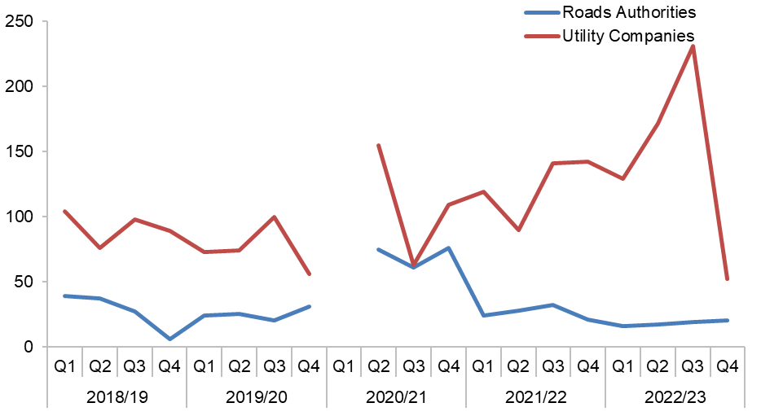
Note: Figures for 2020/21 Q1 were incorrectly inflated due to a problem with a SRWR upgrade. The incorrect figures have been removed.
Figure 14 – Works awaiting closure
(Source: SRWR Report 16)

Period | Roads Authorities | Utility Companies
2018/19 Q1 | 39 | 104
2018/19 Q2 | 37 | 76
2018/19 Q3 | 27 | 98
2018/19 Q4 | 6 | 89
2019/20 Q1 | 24 | 73
2019/20 Q2 | 25 | 74
2019/20 Q3 | 20 | 100
2019/20 Q4 | 31 | 56
2020/21 Q1 | Removed | Removed
2020/21 Q2 | 75 | 155
2020/21 Q3 | 61 | 63
2020/21 Q4 | 76 | 109
2021/22 Q1 | 24 | 119
2021/22 Q2 | 28 | 90
2021/22 Q3 | 32 | 141
2021/22 Q4 | 21 | 142
2022/23 Q1 | 16 | 129
2022/23 Q2 | 17 | 172
2022/23 Q3 | 19 | 231
2022/23 Q4 | 20 | 52
Table 16 – Works awaiting closure
(Source: SRWR Report 16)

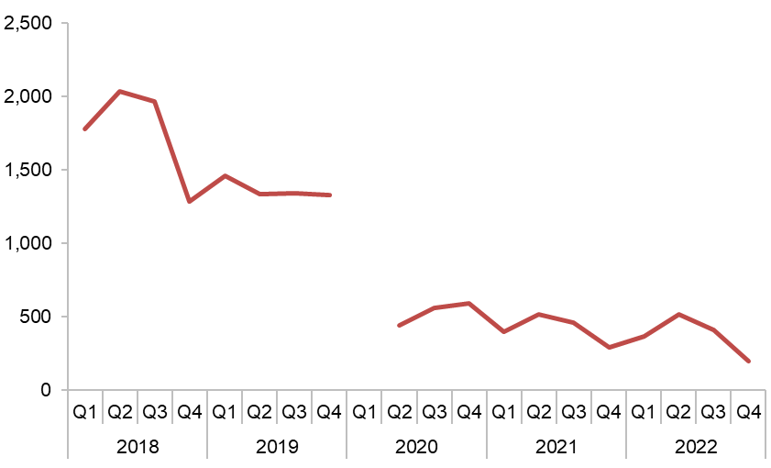
Note: Figures for 2020/21 Q1 were incorrectly inflated due to a problem with a SRWR upgrade. The incorrect figures have been removed.
Figure 15 – Utility company works awaiting registration of final site reinstatement details
(Source: SRWR Report 16)

Period | Utility Companies
2018/19 Q1 | 1,782
2018/19 Q2 | 2,038
2018/19 Q3 | 1,971
2018/19 Q4 | 1,287
2019/20 Q1 | 1,465
2019/20 Q2 | 1,335
2019/20 Q3 | 1,341
2019/20 Q4 | 1,329
2020/21 Q1 | Removed
2020/21 Q2 | 443
2020/21 Q3 | 562
2020/21 Q4 | 591
2021/22 Q1 | 399
2021/22 Q2 | 518
2021/22 Q3 | 462
2021/22 Q4 | 292
2022/23 Q1 | 363
2022/23 Q2 | 513
2022/23 Q3 | 412
2022/23 Q4 | 199
Table 17 – Utility works awaiting registration of final site reinstatement details
(Source: SRWR Report 16)

Utility company interim reinstatements
Utility companies are permitted to use a temporary road surface (interim reinstatement) to allow a road to be reopened to the travelling public. A permanent road surface (permanent reinstatement) must be made within 6 months of the temporary road surface being placed.
This indicator shows the number of interim reinstatements made permanent, against the number of interim reinstatements overdue to be made permanent without agreement from a roads authority at each quarter’s end. Interim reinstatements should be made permanent within 6 months of completion of the interim phase of works. If they are not made permanent in this time without the permission of the local authority they are considered overdue.
The use of interim reinstatements should be minimised to avoid repeat visits and excessive disruption to road users.
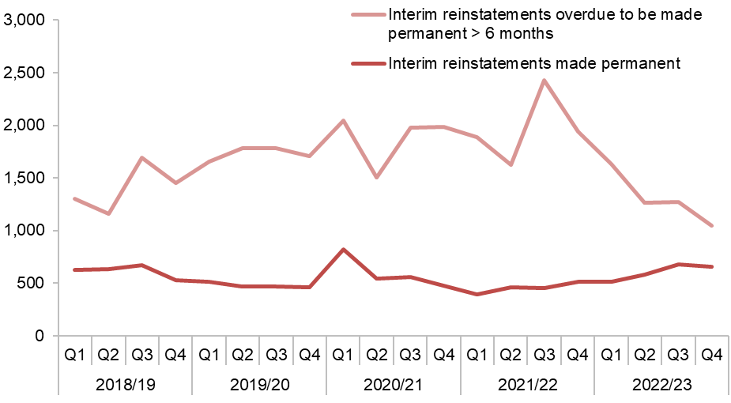
Figure 16 – Utility company interim reinstatements as a number
(Source: SRWR Report 14 and report 18)

Period | Interim reinstatements overdue | Interim reinstatements made permanent
2018/19 Q1 | 628 | 1,302
2018/19 Q2 | 635 | 1,157
2018/19 Q3 | 672 | 1,695
2018/19 Q4 | 532 | 1,454
2019/20 Q1 | 512 | 1,654
2019/20 Q2 | 471 | 1,784
2019/20 Q3 | 465 | 1,782
2019/20 Q4 | 462 | 1,705
2020/21 Q1 | 820 | 2,044
2020/21 Q2 | 543 | 1,508
2020/21 Q3 | 555 | 1,981
2020/21 Q4 | 476 | 1,982
2021/22 Q1 | 392 | 1,888
2021/22 Q2 | 462 | 1,624
2021/22 Q3 | 456 | 2,426
2021/22 Q4 | 512 | 1,938
2022/23 Q1 | 514 | 1,636
2022/23 Q2 | 578 | 1,262
2022/23 Q3 | 679 | 1,273
2022/23 Q4 | 655 | 1,045
Table 18 – Utility company interim reinstatements
(Source: SRWR Report 14 and report 18)

Sample inspections undertaken by roads authorities and utility company failure rate
Sample inspections by the Roads Authorities are undertaken by the Roads Authorities on a 30% randomly generated sample of utility company road works. Inspections are carried out at various stages during the works and the reinstatement guarantee period.
Utility companies are expected to regularly inspect their own works at all stages throughout the works cycle, whilst the roads authorities carry out sample inspections on an agreed percentage, relevant to their total work volume within that local authority area. When a utility company fails in excess of 10% of their sample inspections, under the Code of Practice for Inspections, a roads authority may require a utility company to follow an improvement plan process.

Inspections undertaken by Roads Authorities.
The roads authority are required to undertake 100% of the 3 sample inspections categories (A, B & C) for each utility company. Sample Inspections carried out by roads authorities are shown below:
Authority | Inspections Done | Sample Size | Sample % Done
Aberdeen City Council | 1,328 | 1,305 | 101.8%
Aberdeenshire Council | 921 | 927 | 99.4%
Angus Council | 328 | 438 | 74.9%
Argyll & Bute Council | 448 | 432 | 103.7%
City of Edinburgh Council | 2,710 | 2,877 | 94.2%
Clackmannanshire Council | 235 | 231 | 101.7%
Comhairle nan Eilean Siar | 89 | 96 | 92.7%
Dumfries & Galloway Council | 702 | 798 | 88.0%
Dundee City Council | 736 | 741 | 99.3%
East Ayrshire Council | 549 | 615 | 89.3%
East Dunbartonshire Council | 515 | 492 | 104.7%
East Lothian Council | 581 | 567 | 102.5%
East Renfrewshire Council | 498 | 534 | 93.3%
Falkirk Council | 590 | 594 | 99.3%
Fife Council | 1,326 | 1,470 | 90.2%
Glasgow City Council | 3,034 | 2,967 | 102.3%
Highland Council | 664 | 963 | 69.0%
Inverclyde Council | 282 | 276 | 102.2%
Midlothian Council | 438 | 447 | 98.0%
Moray Council | 443 | 441 | 100.5%
North Ayrshire Council | 521 | 525 | 99.2%
North Lanarkshire Council | 1,341 | 1,347 | 99.6%
Orkney Islands Council | 45 | 51 | 88.2%
Perth & Kinross Council | 657 | 672 | 97.8%
Renfrewshire Council | 965 | 1,149 | 84.0%
Scottish Borders Council | 476 | 570 | 83.5%
Shetland Islands Council | 29 | 30 | 96.7%
South Ayrshire Council | 472 | 555 | 85.0%
South Lanarkshire Council | 1,551 | 1,545 | 100.4%
Stirling Council | 540 | 627 | 86.1%
Tay Road Bridge Joint Board | N/A | N/A | N/A
Transport Scotland | 337 | 471 | 71.5%
West Dunbartonshire Council | 279 | 300 | 93.0%
West Lothian Council | 889 | 993 | 89.5%
Table 19 – Sample inspections undertaken by roads authorities in 2022/23
(Source: SRWR Quarterly Inspection Report and SRWR Inspections Statistics)

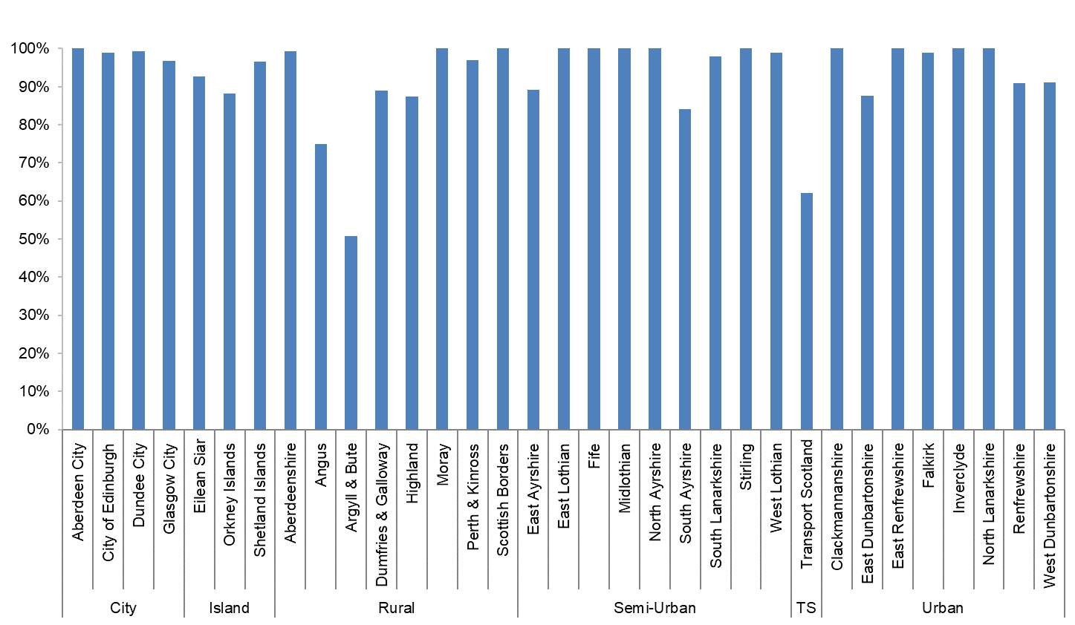
Figure 17 – Sample inspections undertaken by roads authorities in 2022/23
(Source: SRWR Quarterly Inspection Report and SRWR Inspections Statistics)

Inspections Pass Rate for utility companies

Category A (10% sample) – Undertaken while works are in progress.
Inspections check that works are carried out safely and that signs, barriers, safety zones, compaction, layer depth, etc., comply with Safety at Street Works and Road Works : A Code of Practice and the Specification for the Reinstatement for Openings in Roads (SROR).
Type | Organisation | Passed | Inspected | Pass %
Electricity | Energy Asset Networks | 1 | 1 | 100.0%
Electricity | Last Mile Electricity Ltd | 10 | 14 | 71.4%
Electricity | mua Electricity Ltd | 2 | 2 | 100.0%
Electricity | Scottish Hydro Electric Power Distribution plc | 166 | 176 | 94.3%
Electricity | SP Energy Networks | 870 | 971 | 89.6%
Gas | Energy Asset Pipelines | 7 | 8 | 87.5%
Gas | ES Pipelines Ltd | 2 | 2 | 100.0%
Gas | GTC Pipelines Ltd | 9 | 12 | 75.0%
Gas | Indigo Pipelines | 1 | 3 | 33.3%
Gas | Last Mile Gas Ltd | 4 | 4 | 100.0%
Gas | National Gas | 3 | 3 | 100.0%
Gas | SGN | 843 | 926 | 91.0%
Other | Network Rail | 16 | 16 | 100.0%
Telecoms | Axione UK Ltd | 11 | 14 | 78.6%
Telecoms | BorderLink Broadband Ltd | 4 | 5 | 80.0%
Telecoms | Broadway Partners Ltd | 0 | 1 | 0.0%
Telecoms | BT | 1,640 | 1,769 | 92.7%
Telecoms | CityFibre | 906 | 1,047 | 86.5%
Telecoms | Commsworld Ltd | 3 | 3 | 100.0%
Telecoms | EE | 18 | 20 | 90.0%
Telecoms | Hutchison 3G | 1 | 1 | 100.0%
Telecoms | Hyperoptic Ltd | 7 | 9 | 77.8%
Telecoms | InternetTY Ltd | 1 | 1 | 100.0%
Telecoms | Lothian Broadband | 15 | 15 | 100.0%
Telecoms | Neos Networks | 2 | 2 | 100.0%
Telecoms | Netomnia | 11 | 15 | 73.4%
Telecoms | Nexfibre Networks Ltd | 4 | 4 | 100.0%
Telecoms | Telefonica UK | 11 | 11 | 100.0%
Telecoms | Virgin Media Group | 408 | 488 | 86.6%
Telecoms | Vodafone Ltd | 13 | 14 | 92.9%
Telecoms | Zayo | 1 | 1 | 100.0%
Water | Scottish Water | 2,046 | 2,189 | 93.5%
Table 20 –Category A sample inspection pass rates undertaken by utility companies in 2022/23
(Source: SRWR Quarterly Inspection Report and SRWR Inspections Statistics)

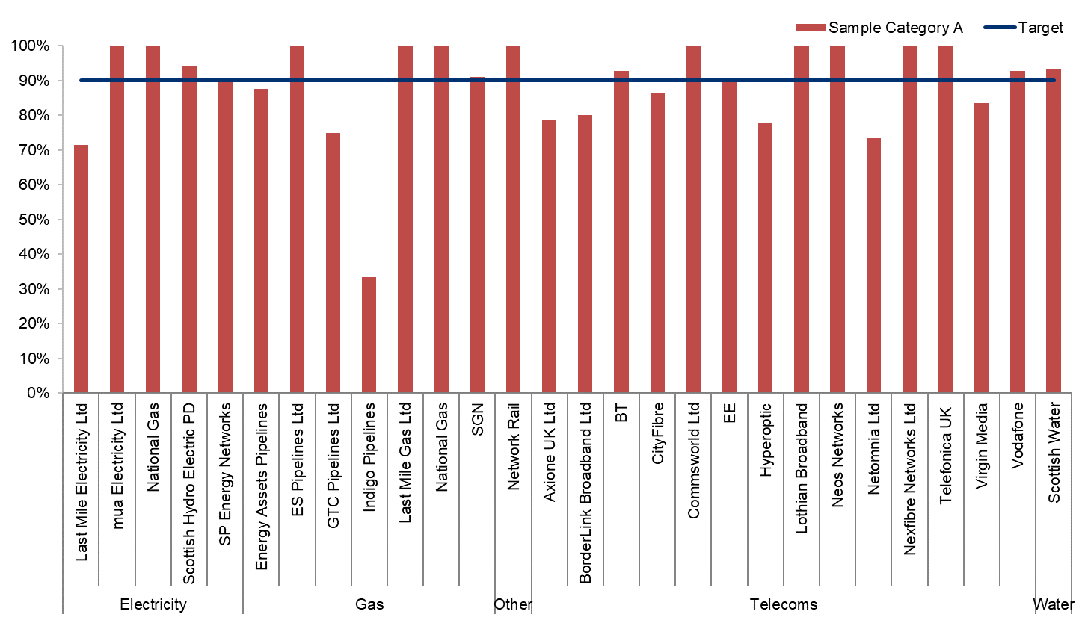
Figure 18 – Category A sample inspection pass rates undertaken by utility companies in 2022/23
(Source: SRWR Quarterly Inspection Report and SRWR Inspections Statistics)

Category B (10% sample) – Undertaken within the six month period following interim or permanent reinstatement.
Inspections check that works are completed to the proper standards. Checking for items, such as edge depression, crowning, etc., in accordance with the SROR.
Type | Organisation | Passed | Inspected | Pass %
Electricity | Energy Asset Networks | 0 | 1 | 0.0%
Electricity | Last Mile Electricity Ltd | 5 | 9 | 55.6%
Electricity | mua Electricity Ltd | 1 | 3 | 33.3%
Electricity | Scottish Hydro Electric Power Distribution plc | 172 | 176 | 97.7%
Electricity | SP Energy Networks | 916 | 965 | 94.9%
Gas | Energy Asset Pipelines | 5 | 9 | 55.6%
Gas | ES Pipelines Ltd | 2 | 2 | 100.0%
Gas | Fulcrum Pipeline Ltd | 3 | 4 | 75.0%
Gas | GTC Pipelines Ltd | 8 | 10 | 80.0%
Gas | SGN | 881 | 915 | 96.3%
Other | Network Rail | 16 | 16 | 100.0%
Telecoms | Axione UK Ltd | 5 | 5 | 100.0%
Telecoms | BorderLink Broadband Ltd | 3 | 3 | 100.0%
Telecoms | Broadway Partners Ltd | 0 | 1 | 0.0%
Telecoms | BT | 1,984 | 2,077 | 95.5%
Telecoms | CityFibre | 825 | 1,040 | 79.3%
Telecoms | Commsworld Ltd | 7 | 7 | 100.0%
Telecoms | EE | 34 | 43 | 79.1%
Telecoms | Hyperoptic Ltd | 19 | 24 | 79.2%
Telecoms | Lothian Broadband | 9 | 9 | 100.0%
Telecoms | Neos Networks | 14 | 15 | 93.3%
Telecoms | Netomnia | 2 | 3 | 66.7%
Telecoms | Telefonica UK | 14 | 17 | 82.4%
Telecoms | Verizon | 2 | 2 | 100.0%
Telecoms | Virgin Media Group | 698 | 758 | 92.1%
Telecoms | Vodafone Ltd | 13 | 16 | 81.3%
Telecoms | Zayo | 1 | 1 | 100.0%
Water | Scottish Water | 2,173 | 2,251 | 96.5%
Table 21 – Category B sample inspection pass rates undertaken by utility companies in 2022/23
(Source: SRWR Quarterly Inspection Report and SRWR Inspections Statistics)

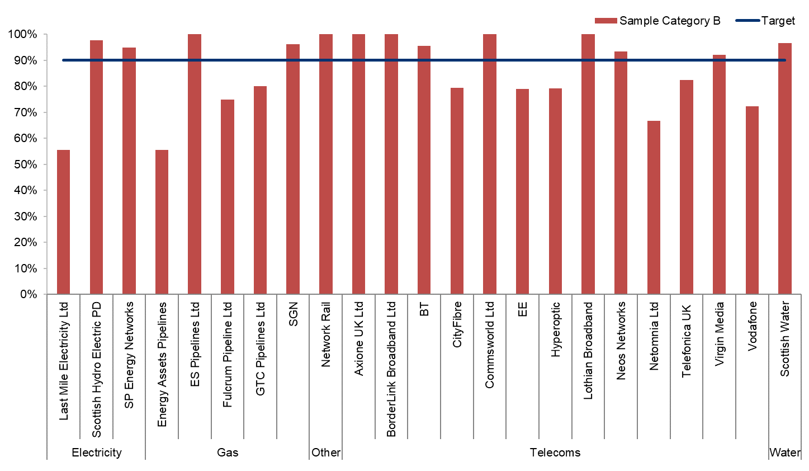
Figure 19 – Category B sample inspection pass rates undertaken by utility companies in 2022/23
(Source: SRWR Quarterly Inspection Report and SRWR Inspections Statistics)

Category C (10% sample) – Undertaken within the three month period preceding the end of the guarantee period.
Inspections again check that works are constructed to the proper standards in accordance with the SROR. Greater focus is given to settlement, cracking and joint failure following trafficking.
Type | Organisation | Passed | Inspected | Pass %
Electricity | Last Mile Electricity Ltd | 8 | 9 | 88.9%
Electricity | Scottish Hydro Electric Power Distribution plc | 171 | 176 | 97.2%
Electricity | SP Energy Networks | 930 | 964 | 96.5%
Gas | Energy Asset Pipelines | 8 | 9 | 88.9%
Gas | ES Pipelines Ltd | 3 | 3 | 100.0%
Gas | Fulcrum Pipeline Ltd | 1 | 3 | 33.3%
Gas | GTC Pipelines Ltd | 10 | 10 | 100.0%
Gas | SGN | 891 | 909 | 98.0%
Other | Network Rail | 20 | 20 | 100.0%
Other | Royal Mail | 12 | 12 | 100.0%
Telecoms | Arqiva | 5 | 6 | 83.3%
Telecoms | Axione UK Ltd | 3 | 4 | 75.0%
Telecoms | Broadway Partners Ltd | 0 | 1 | 0.0%
Telecoms | BT | 2,020 | 2,093 | 96.5%
Telecoms | Commsworld Ltd | 7 | 7 | 100.0%
Telecoms | CityFibre | 882 | 1,129 | 78.1%
Telecoms | Concept Solutions People Ltd | 1 | 1 | 100.0%
Telecoms | EE | 40 | 43 | 93.0%
Telecoms | Hyperoptic Ltd | 22 | 24 | 91.7%
Telecoms | Lothian Broadband | 3 | 5 | 60.0%
Telecoms | Lumen Technologies UK Ltd | 2 | 2 | 100.0%
Telecoms | Neos Networks | 26 | 26 | 100.0%
Telecoms | Sky UK | 0 | 1 | 0.0%
Telecoms | Telefonica UK | 11 | 16 | 68.8%
Telecoms | Verizon | 1 | 1 | 100.0%
Telecoms | Virgin Media Group | 725 | 767 | 94.5%
Telecoms | Vodafone Ltd | 14 | 18 | 77.8%
Telecoms | Zayo | 1 | 1 | 100.0%
Water | Scottish Water | 2,166 | 2,273 | 95.3%
Table 22 – Category C sample inspection pass rates undertaken by utility companies in 2022/23
(Source: SRWR Quarterly Inspection Report and SRWR Inspections Statistics)

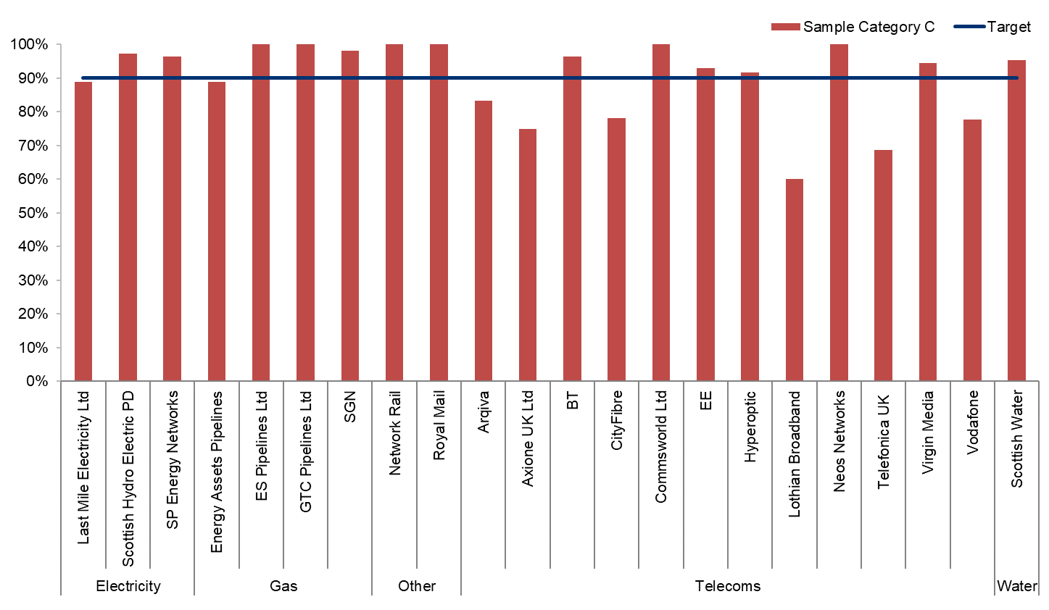
Figure 20 – Category C sample inspection pass rates undertaken by utility companies in 2022/23
(Source: SRWR Quarterly Inspection Report and SRWR Inspections Statistics)

Substandard traffic management from inspection results
This indicator considers the number of substandard traffic management layouts recorded during roads authority inspections of utility company road works.
In addition to sample inspections, roads authorities also carry out inspections at their discretion. These inspections include routine inspections, inspections relating to a previously identified defect, inspections following a third party report and inspections following notification of a defective reinstatement. This report shows the total number of inspection results which failed, showing substandard traffic management as the reason for failure.
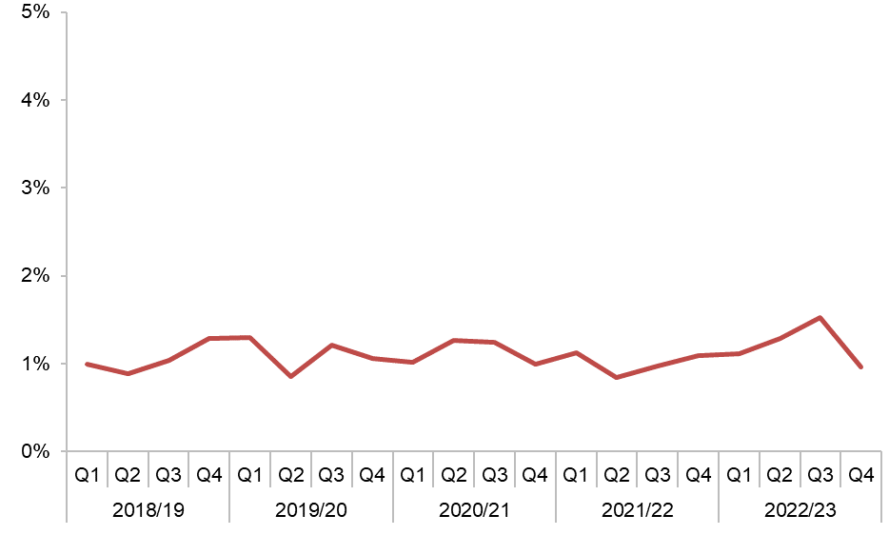
Figure 21 – Substandard traffic management from inspection results
(Source: SRWR Report 19)

Period | Substandard TM
2018/19 Q1 | 257
2018/19 Q2 | 216
2018/19 Q3 | 233
2018/19 Q4 | 316
2019/20 Q1 | 302
2019/20 Q2 | 209
2019/20 Q3 | 273
2019/20 Q4 | 246
2020/21 Q1 | 185
2020/21 Q2 | 297
2020/21 Q3 | 302
2020/21 Q4 | 270
2021/22 Q1 | 294
2021/22 Q2 | 220
2021/22 Q3 | 247
2021/22 Q4 | 311
2022/23 Q1 | 314
2022/23 Q2 | 350
2022/23 Q3 | 407
2022/23 Q4 | 290
Table 23 – Substandard traffic management from inspection results
(Source: SRWR Report 19)

Works registered with missing contact details
Organisations are required to provide contact details of the contractor carrying out road works and details of the person registering the works on the Scottish Road Works Register (SRWR).
Each road works notice recorded in the SRWR must include the originator name, the originator telephone number, the contractor name and the contractor telephone number. At the very latest, these four fields must be populated when works reach the “in progress” phase. For example when an actual start notice is registered for a works.
Contact details entered in the SRWR by roads authorities and utility companies undertaking road works are expected to be accurate. This information is required for co-ordination and co-operation.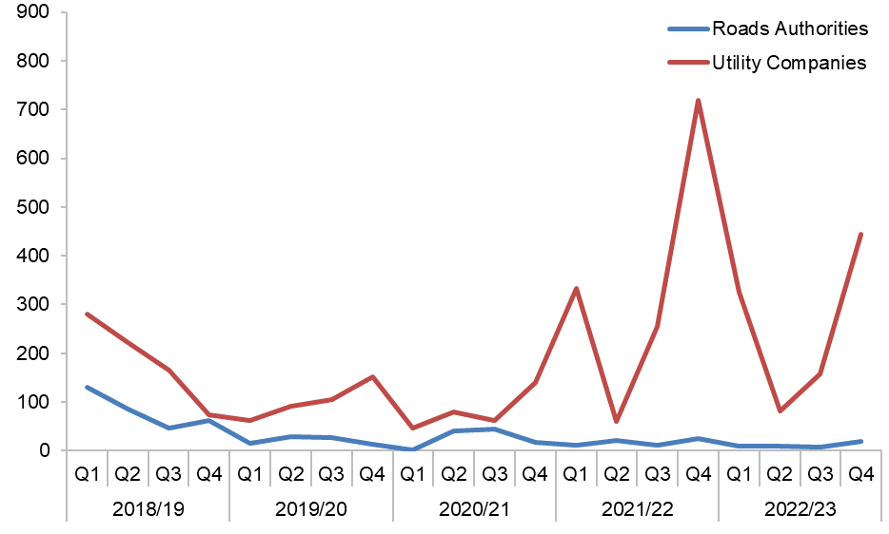
Figure 22 – Roads authorities and utility companies works registered with missing contact details
(Source: SRWR Report 24 and SRWR Report 9a)

Period | Roads Authorities | Utility Companies
2018/19 Q1 | 98 | 281
2018/19 Q2 | 69 | 222
2018/19 Q3 | 39 | 165
2018/19 Q4 | 52 | 74
2019/20 Q1 | 13 | 62
2019/20 Q2 | 23 | 91
2019/20 Q3 | 13 | 106
2019/20 Q4 | 6 | 152
2020/21 Q1 | 2 | 46
2020/21 Q2 | 41 | 80
2020/21 Q3 | 45 | 63
2020/21 Q4 | 17 | 141
2021/22 Q1 | 18 | 334
2021/22 Q2 | 26 | 60
2021/22 Q3 | 13 | 251
2021/22 Q4 | 26 | 720
2022/23 Q1 | 9 | 325
2022/23 Q2 | 9 | 82
2022/23 Q3 | 7 | 158
2022/23 Q4 | 19 | 444
Table 24 – Roads authorities and utility companies works registered with missing contact details
(Source: SRWR Report 24 and SRWR Report 9a)

Misuse of traffic management type “not yet known”
Organisations are required to provide details of traffic management layouts for each of their road works sites. When registering an expected start date, it is not acceptable to record “Not Yet Known” as the traffic management layout.
It is expected that the correct traffic management types are populated in the SRWR for all road works. This information is used for co-ordination and displayed on the Scottish Road Works Online site. Information must be as accurate as possible to highlight the impact and severity of the works.
When placing a 7 day notice (in advance of planned Substantial, Major and Standard Works), a 24 hour notice (in advance of planned Remedial or Minor Works) or a 2 hour notice (for Urgent and Emergency Works) it is not acceptable to describe the traffic management which is planned to be used as “Not Yet Known”. As traffic management types should always be known in advance of works the Commissioner considers it unacceptable for this information to be missing.
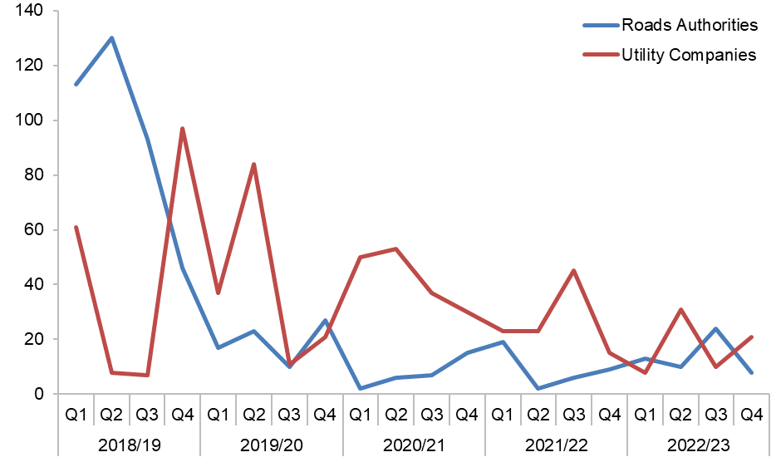
Figure 23 – Roads authorities and utility companies registering works with traffic management type “not yet known”
(Source: SRWR Report 24)

Period | Roads Authorities | Utility Companies
2018/19 Q1 | 113 | 65
2018/19 Q2 | 130 | 8
2018/19 Q3 | 93 | 7
2018/19 Q4 | 48 | 125
2019/20 Q1 | 17 | 38
2019/20 Q2 | 23 | 102
2019/20 Q3 | 8 | 14
2019/20 Q4 | 27 | 22
2020/21 Q1 | 2 | 50
2020/21 Q2 | 6 | 53
2020/21 Q3 | 7 | 37
2020/21 Q4 | 15 | 30
2021/22 Q1 | 19 | 23
2021/22 Q2 | 2 | 23
2021/22 Q3 | 6 | 45
2021/22 Q4 | 9 | 15
2022/23 Q1 | 13 | 8
2022/23 Q2 | 10 | 31
2022/23 Q3 | 24 | 10
2022/23 Q4 | 8 | 21
Table 25 – Roads authorities and utility companies registering works with traffic management type “not yet known”
(Source: SRWR Report 24)

Fixed Penalty Notices (FPNs) issued to utility companies
Fixed Penalty Notices (FPNs) are similar in nature to Parking Penalty Charge Notices. Roads authorities are not required by legislation to issue FPNs. Where they are not issued, generally authorities consider that the potential financial returns would not cover the cost of administration.
However, the benefit is improved utility company compliance with road works legislation which may provide them with time and cost savings elsewhere
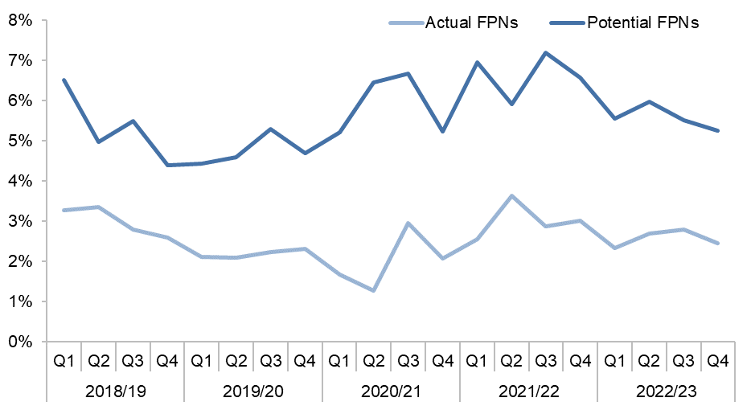
Figure 24 – Actual and potential fixed penalty notices (FPNs) issued to utility companies as a percentage of actual starts
(Source: SRWR Report 1 and SRWR Report 9a)

Period | Actual FPNs % | Potential FPNs %
2018/19 Q1 | 3.3% | 6.5%
2018/19 Q2 | 3.4% | 5.0%
2018/19 Q3 | 2.8% | 5.5%
2018/19 Q4 | 2.6% | 4.4%
2019/20 Q1 | 2.1% | 4.4%
2019/20 Q2 | 2.1% | 4.6%
2019/20 Q3 | 2.2% | 5.3%
2019/20 Q4 | 2.3% | 4.7%
2020/21 Q1 | 1.7% | 5.2%
2020/21 Q2 | 1.3% | 6.5%
2020/21 Q3 | 3.0% | 6.7%
2020/21 Q4 | 2.1% | 5.2%
2021/22 Q1 | 2.6% | 7.0%
2021/22 Q2 | 3.6% | 5.9%
2021/22 Q3 | 2.9% | 7.2%
2021/22 Q4 | 3.0% | 6.6%
2022/23 Q1 | 2.3% | 5.6%
2022/23 Q2 | 2.7% | 6.0%
2022/23 Q3 | 2.8% | 5.5%
2022/23 Q4 | 2.4% | 5.3%
Table 26 – Actual and potential fixed penalty notices (FPNs) issued to utility companies as a percentage of actual starts (Source: SRWR Report 1 and SRWR Report 9a)
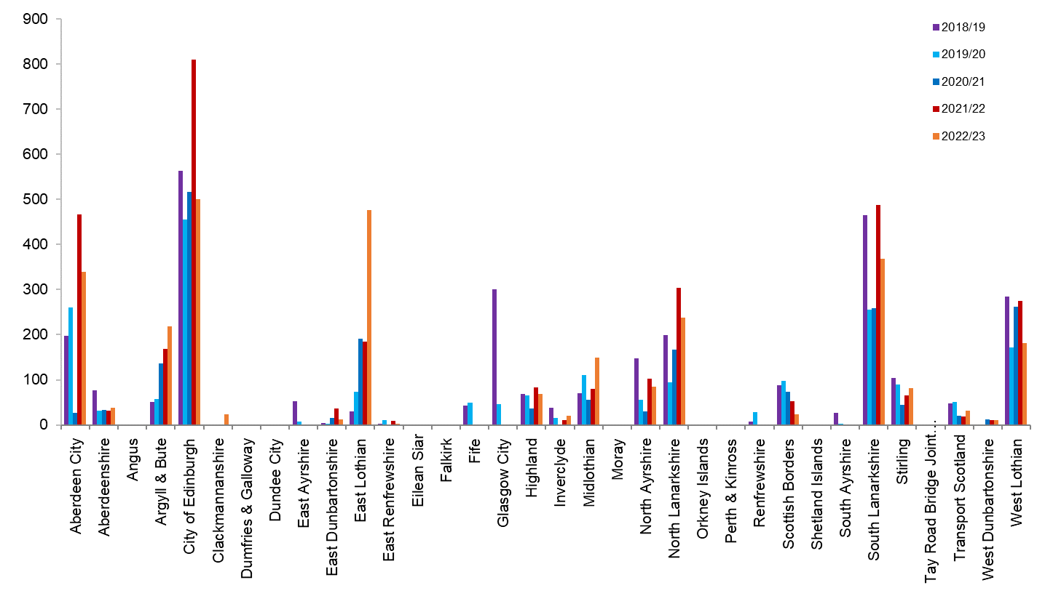
Figure 25 – Fixed penalty notices (FPNs) issued by roads authorities
(Source: SRWR Report 1)

Roads Authority | 2018/19 | 2019/20 | 2020/21 | 2021/22 | 2022/23
Aberdeen City Council | 198 | 260 | 26 | 313 | 295
Aberdeenshire Council | 76 | 32 | 33 | 31 | 38
Angus Council | 0 | 0 | 0 | 0 | 0
Argyll & Bute Council | 51 | 58 | 137 | 169 | 218
City of Edinburgh Council | 563 | 456 | 517 | 796 | 491
Clackmannanshire Council | 0 | 0 | 0 | 0 | 17
Comhairle nan Eilean Siar | 0 | 0 | 0 | 0 | 0
Dumfries & Galloway Council | 0 | 0 | 0 | 0 | 0
Dundee City Council | 0 | 0 | 0 | 0 | 0
East Ayrshire Council | 52 | 8 | 0 | 0 | 0
East Dunbartonshire Council | 4 | 3 | 15 | 37 | 8
East Lothian Council | 30 | 73 | 191 | 182 | 468
East Renfrewshire Council | 2 | 11 | 0 | 9 | 3
Falkirk Council | 0 | 0 | 0 | 0 | 0
Fife Council | 43 | 50 | 0 | 0 | 0
Glasgow City Council | 300 | 46 | 0 | 0 | 1
Highland Council | 69 | 66 | 37 | 83 | 68
Inverclyde Council | 38 | 16 | 0 | 11 | 20
Midlothian Council | 70 | 110 | 55 | 80 | 150
Moray Council | 0 | 0 | 0 | 0 | 0
North Ayrshire Council | 147 | 56 | 30 | 98 | 83
North Lanarkshire Council | 199 | 95 | 167 | 302 | 236
Orkney Islands Council | 0 | 1 | 0 | 0 | 0
Perth & Kinross Council | 0 | 0 | 0 | 0 | 0
Renfrewshire Council | 8 | 29 | 0 | 0 | 0
Scottish Borders Council | 88 | 98 | 73 | 53 | 21
Shetland Islands Council | 0 | 0 | 0 | 0 | 0
South Ayrshire Council | 26 | 3 | 0 | 0 | 0
South Lanarkshire Council | 465 | 255 | 258 | 485 | 366
Stirling Council | 104 | 89 | 44 | 62 | 34
Transport Scotland | 47 | 51 | 21 | 13 | 26
West Dunbartonshire Council | 0 | 0 | 13 | 11 | 10
West Lothian Council | 285 | 171 | 262 | 266 | 164
Table 27 – Fixed penalty notices (FPNs) issued by roads authorities
(Source: SRWR Report 1)

Undue delay (S125) notices issued by roads authorities and received by utility companies
When a utility company unduly delays completion of their road works, a roads authority has the power, under section 125 of the New Roads and Street Works Act 1991 (NRSWA), to serve an undue delay direction on the utility, directing that the works are completed within a specified time.
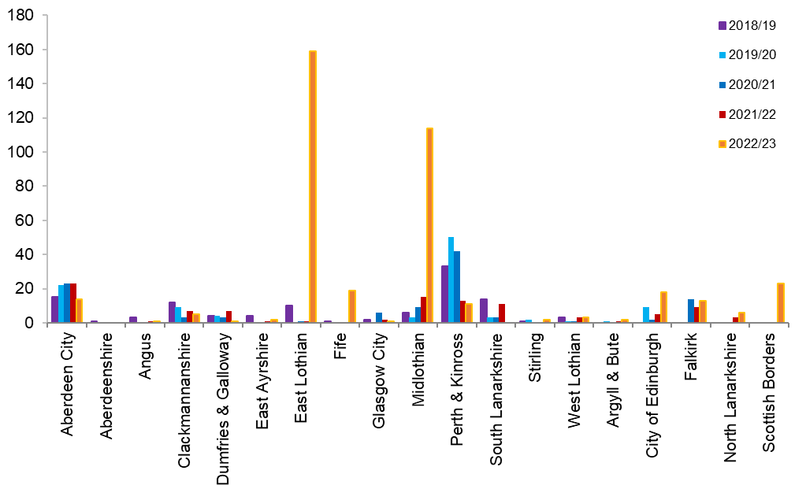
Figure 26 – Undue delay (s125) notices issued by roads authorities
(Source: SRWR Report 17e)

Roads Authority | 2018/19 | 2019/20 | 2020/21 | 2021/22 | 2022/23
Aberdeen City Council | 15 | 22 | 23 | 23 | 14
Aberdeenshire Council | 1 | 0 | 0 | 0 | 0
Angus Council | 3 | 0 | 0 | 1 | 1
Argyll & Bute Council | 0 | 1 | 0 | 1 | 2
City of Edinburgh Council | 0 | 9 | 2 | 5 | 18
Clackmannanshire Council | 12 | 9 | 3 | 7 | 5
Comhairle nan Eilean Siar | 0 | 0 | 0 | 0 | 0
Dumfries & Galloway Council | 4 | 4 | 3 | 7 | 1
Dundee City Council | 0 | 0 | 0 | 0 | 0
East Ayrshire Council | 4 | 0 | 0 | 1 | 2
East Dunbartonshire Council | 0 | 0 | 0 | 0 | 0
East Lothian Council | 10 | 0 | 1 | 1 | 159
East Renfrewshire Council | 0 | 0 | 0 | 0 | 0
Falkirk Council | 0 | 0 | 14 | 9 | 13
Fife Council | 1 | 0 | 0 | 0 | 19
Glasgow City Council | 2 | 0 | 6 | 2 | 1
Highland Council | 0 | 0 | 0 | 0 | 0
Inverclyde Council | 0 | 0 | 0 | 0 | 0
Midlothian Council | 6 | 3 | 9 | 15 | 114
Moray Council | 0 | 0 | 0 | 0 | 0
North Ayrshire Council | 0 | 0 | 0 | 0 | 0
North Lanarkshire Council | 0 | 0 | 0 | 3 | 6
Orkney Islands Council | 0 | 0 | 0 | 0 | 0
Perth & Kinross Council | 33 | 50 | 42 | 13 | 11
Renfrewshire Council | 0 | 0 | 0 | 0 | 0
Scottish Borders Council | 0 | 0 | 0 | 0 | 23
Shetland Islands Council | 0 | 0 | 0 | 0 | 0
South Ayrshire Council | 0 | 0 | 0 | 0 | 0
South Lanarkshire Council | 14 | 3 | 3 | 11 | 0
Stirling Council | 1 | 2 | 0 | 0 | 2
Transport Scotland | 0 | 0 | 0 | 0 | 0
West Dunbartonshire Council | 0 | 0 | 0 | 0 | 0
West Lothian Council | 3 | 1 | 1 | 3 | 3
Table 28 - Undue delay (s125) notices issued by roads authorities
(Source: SRWR Report 17e)

Roads authority works registered per 100km
Prior to enactment of the Transport (Scotland) Act 2005, only utility companies were required to register their qualifying road works in the Scottish Road Works Register (SRWR).
Since 2005, roads authorities have also been required to register their qualifying works, however, their performance remains inconsistent and in need of further scrutiny.
This indicator compares roads authority works registered against others with a similar demographic make-up.
This indicator scrutinises the number of road works registered on the SRWR by council roads authorities, Transport Scotland trunk road operating companies and Transport Scotland trunk road DBFO companies across Scotland.
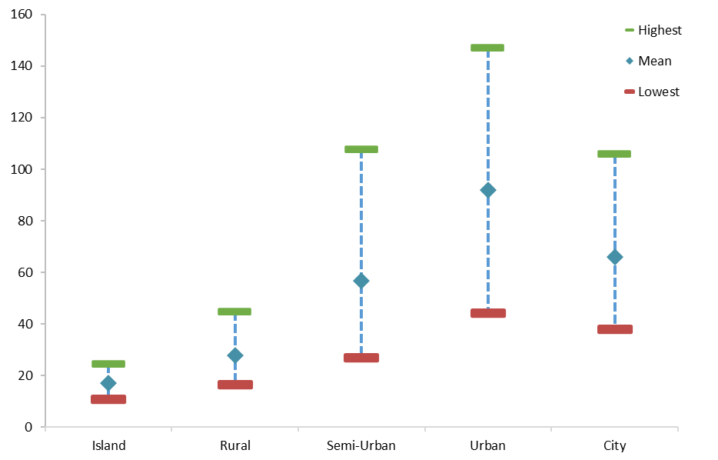
Note: Transport Scotland data has been removed for clarity.
Figure 27 – Works per 100km for authorities in each SCOTS group, showing the high, mean and low values for each group (2022/23).
(Source: SRWR Report Works per 100km)
Road works registered are influenced by many factors such as geographic location, political priorities, population, weather, available resources (numbers of operatives), structural and routine budgets, road network lengths, etc. For example, islands and rural authorities register fewer road works than urban authorities. Consequently, for reporting purposes, authorities and transport Scotland operators are grouped with peer organisations and any view on their performance is relative.
Organisation | 2018/19 | 2019/20 | 2020/21 | 2021/22 | 2022/23
Island Group | 30.8 | 31.0 | 16.6 | 21.0 | 17.0
Rural | 24.9 | 23.9 | 15.1 | 24.9 | 27.7
Semi-urban Group | 63.5 | 55.8 | 39.1 | 54.1 | 56.8
Urban Group | 92.3 | 103.2 | 73.1 | 88.7 | 91.9
City | 74.0 | 65.3 | 52.3 | 75.1 | 66.0
Transport Scotland | 287.0 | 327.1 | 314.0 | 347.0 | 474.2
Table 29 – Mean value of works per 100 km for authorities in each SCOTS group and Transport Scotland
(Source: SRWR Report Works per 100 km)

Contact Details
You can phone us on 0131 244 9936
You can email us at enquiries@roadworks.scot
Our website is https://roadworks.scot
You can contact us by post at:
Scottish Road Works Commissioner
E Spur
Saughton House
Broomhouse Drive
Edinburgh EH11 3XD

Other Formats
The Commissioner is committed to making services, policies and guidance available to everyone. This document may be available in other formats. Please contact us if you wish to discuss this matter.

