CORPORATE PLAN 2023-26

Authorising Context
This Corporate Plan has been produced by the Scottish Road Works Commissioner in fulfilment of his duties as set out in the Transport (Scotland) Act 2005

Contents
Foreword 3
Legal Framework in which the Commissioner Operates 4
Vision of the Scottish Road Works Commissioner 6
Commissioner’s Corporate Outcomes 9
Timetable and Approach 17
Resources 17
Managing our Resources 18
Reporting our Progress 18
Statement of Intent 18
Feedback / Contact Us 19
Accessibility and Inclusion 19

Foreword
Sector wide challenges as a result of the Covid-19 pandemic dominated the latter half of the last Corporate Plan. Whilst the disruption caused by the pandemic is now largely over, events, both at home and abroad, are contributing towards an equally challenging operating environment for undertakers and roads authorities alike. The overwhelmingly positive reaction to the pandemic reassures me greatly that the sector will be well placed to cope and respond to any forthcoming challenges.
Introduction of the Transport (Scotland) Act was, of course, one of many things disrupted over the last 3 years. This has meant that a number of the provisions of the Act anticipated to commence during the last plan still remain to be commenced. Implementation of the Act will require revision and development of secondary legislation, Codes of Practice and other guidance. This will be a key focus for the community over the coming years.
It is considered that the changes introduced as a consequence of the Act will strengthen further Scotland’s enviable reputation for co-ordination and co-operation between undertakers and roads authorities. They will contribute positively towards minimising the impact of works and drive standards higher still.
There will, of course, be a renewed focus on the environment during the lifetime of this plan. The drive towards Net Zero starts now; whilst targets are ambitious, there can be no time to waste. Focus on carbon emissions will be part of almost all sector activities going forwards.
The Corporate Plan is a strategic document, which gives an overview of the direction of the Scottish Road Works Commissioner. It sits above the business plan and performance management reports and informs their content, providing overarching guiding principles for the future of the office.
Whilst we are in a changing and dynamic environment, I am confident that the community’s track record in managing change will make what follows but to be another seamless step in a long tradition of continual improvement.

Kevin Hamilton
Scottish Road Works Commissioner

Legal Framework in which the Commissioner Operates
The Scottish Road Works Commissioner (the Commissioner) is an independent public official established under Section 16 of the Transport (Scotland) Act 2005 and is accountable to the Scottish Ministers and ultimately the Scottish Parliament. The Act states:
[The Commissioner] will oversee improvements to the planning, co-ordination and quality of road works in Scotland.

The Commissioner has powers to impose financial penalties on roads authorities who systematically fail in their duty to co-ordinate and on undertakers who systematically fail to co-operate when undertaking road works.

The Commissioner has powers to appoint staff and has set up a team to assist in the execution of the Commissioner’s duties.

The Commissioner is also “the Keeper” of the Scottish Road Works Register (SRWR). The SRWR is a public register which is used for co-ordination of road works in Scotland. The functionality of this register underpins much of the work carried out by the Commissioner.
The general functions of the 2005 Act are to:
- monitor the carrying out of road works in Scotland;
- promote compliance with the New Roads and Street Works Act 1991;
- promote the pursuit of good practice.
The specific functions of the 2005 Act are to:
- publish an annual report;
- prepare an annual account;
- keep a register to be known as the Scottish Road Works Register.

Accountability
The Commissioner is appointed by the Scottish Ministers and is sponsored by Transport Scotland, an agency of the Scottish Government.
As part of the Commissioner’s accountability, a Corporate Plan detailing the strategic outlook for the office of the Scottish Road Works Commissioner (oSRWC), should be prepared. The Commissioner must also lay an annual report and accounts before Parliament.

New Legislation
The Transport (Scotland) Act 2019 received Royal Assent in November 2019. A number of the Act’s provisions were commenced during the lifetime of the previous Corporate plan. However, as a consequence of the COVID-19 pandemic, a number of provisions remain to be enacted; it is anticipated that these will come into force in the early part of this plan. These include:
- Compliance notices
- Mandatory provision of plant information to Community Apparatus Vault
- Authorised Officers
- Fixed Penalty Notice (FPN) review

Vision of the Scottish Road Works Commissioner
The vision of the Commissioner is to make a positive contribution to Scotland’s road network by improving and monitoring the performance of utility companies and roads authorities when undertaking road works. Through this, environmental impact and inconvenience for people affected by road works should be minimised. The Commissioner also aims to provide a centre of excellence, sharing knowledge and giving assistance to the Scottish road works community. The overarching vision of the Commissioner is –
“To minimise the impacts of road works and support the transition towards Net Zero through improved standards and working practices”
Although the Commissioner is an independent regulator, the work of the office supports the purpose and vision of the Scottish Government as detailed in the National Performance Framework (NPF) to deliver the National Outcomes for Scotland. In addition, the vision of the SRWC aligns with the outcomes of the National Transport Strategy 2 (NTS2) published by Transport Scotland.
The vision of the NTS2 is to create great places by means of a sustainable, inclusive, safe and accessible transport system, helping deliver a healthier, fairer and more prosperous Scotland for communities, businesses and visitors. The Commissioner’s vision “To minimise the impacts of road works and support the transition towards Net Zero through improved standards and working practices” aligns with a number of the outcomes outlined in the NTS2.
Again, aligning with the principles of the NTS2, the Commissioner has worked hard to develop collaboration, engagement and evidence to drive up compliance across the road works community.
The Commissioner’s purpose and vision also supports a number of the United Nations Sustainable Developments Goals (SDG) which are aligned to the National Outcomes, which aim to make Scotland a better place to live and a more prosperous and successful country.
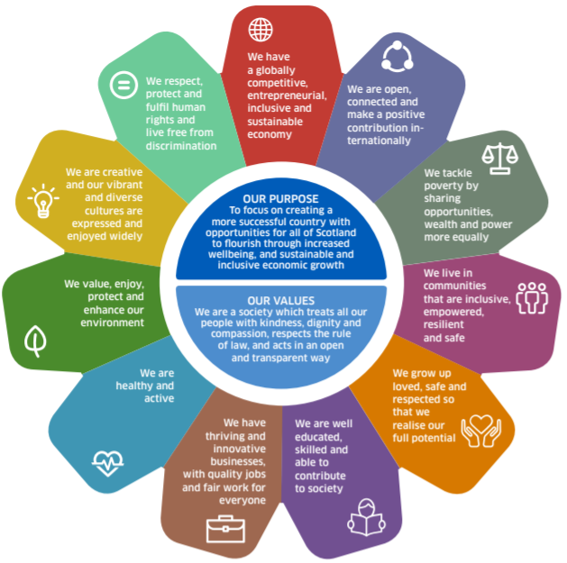
Source: Scottish Government
(https://nationalperformance.gov.scot/sites/default/files/documents/NPF_A2_Poster.pdf)
Implementation of the Sustainable Travel Hierarchy (STH) will also be a key objective during the lifetime of this plan. The Commissioner will seek to embed the principles of the STH in all new policies, procedures and guidance published by the Office.
Whilst better organised, shorter, higher quality road works have a correlation with the outcomes associated with sustainability, the environment and communities, it is recognised that road works, by their very nature, have negative environmental and social impacts. The Commissioner will work to support organisations to reduce the number of works carried out, with a particular focus on those involving excavation.

The Commissioner also recognises the global climate emergency and is committed to playing his part in Scotland’s national endeavour to end our contribution to climate change within a generation. To ensure the Commissioner contributes to public sector leadership in this effort, we adopt the following minimum targets and dates:

- Achieve net zero emissions across our direct Scope 1 emissions, indirect Scope 2 and Scope 3 emissions including water, waste, business travel, upstream leased assets, purchased goods and services and capital goods by 2045.
- Where a business need identifies a requirement for the Commissioner to hire/lease vehicles, petrol and diesel cars will not be selected from 2025.;
- Minimise the distance our staff travel by car, both for business travel and commuting;
- Ensure that our investment decisions, including procurement, are aligned with Scotland’s net zero targets and support the move to a circular economy;
- Ensure adaptation to the impacts of climate change alongside our efforts to reduce our emissions as far as we can, as fast as we can.

Commissioner’s Corporate Outcomes
The cornerstones of the Commissioner’s work are four core Corporate Outcomes, which were developed initially to meet the duties conferred by the Transport (Scotland) Act 2005. These outcomes are still the foundations of the overarching vision for the Commissioner and his Corporate Plan 2023-2026, albeit the Transport (Scotland) Act 2019 extends and strengthens these duties and powers.
The Transport (Scotland) Act 2005 was created to amend and strengthen the provisions of the earlier New Roads and Street Works Act 1991. As well as creating the post of Scottish Road Works Commissioner and confirming the posts responsibilities as legal ‘keeper’ of the Scottish Road Works Register, the act made clear the responsibility for roads authorities to co-ordinate works on their network, and for undertakers to co-operate with them under the provisions of the 1991 Act.
The Transport (Scotland) Act 2005 changed the enforcement regime of offences under the New Roads and Street Works Act 1991 and strengthened requirements for the training of persons carrying out, supervising and administrating road works.
The aim of the Act is to improve the quality and co-ordination of road works across Scotland. The Commissioner monitors the national road works performance and encourages improvement by promoting good practice and ensuring that all parties comply with relevant legislation.
This Corporate Plan takes the strategic requirements for the post of Scottish Road Works Commissioner under the Transport (Scotland) Act 2005 into the following four corporate outcomes and describes their delivery and monitoring:

- Monitor the carrying out of road works in Scotland;

- Compliance with road works legislation;

- Promotion of good practice;

- Effective operation of the Commissioner’s office.

Notwithstanding the above, the Transport (Scotland) Act 2019 goes a further step, strengthening the position of the Commissioner and increasing their powers to include the introduction of authorised officers to monitor road works and take enforcement action if required.
It is expected that the remaining provisions of the 2019 Act will be commenced during the early stages of the life of this plan. This plan is mindful of changes that may occur over this period but rooted in the delivery of the core strategic outcomes of the Commissioner already conferred in legislation.

Corporate Outcome 1

Monitor the Carrying Out of Road Works in Scotland

Why is this a priority?
A key function of the Commissioner is monitoring the carrying out of road works in Scotland. While day to day co-ordination of road works is undertaken at a local level by roads authorities requiring the full co-operation of the utility companies, the Commissioner takes a strategic overview of these mechanisms. Better co-ordination serves to improve efficiency while reducing disruption to the travelling public. Better planned and co-ordinated works help maintain the integrity of the road network for the benefit of all road users.
This outcome supports the achievement of, and contributes to the following National Outcomes:
- People live in communities that are inclusive, empowered, resilient and safe
- People have a globally competitive, entrepreneurial, inclusive and sustainable economy
- People value, enjoy, protect and enhance their environment
- People are healthy and active
- People respect, protect and fulfil human rights and live free from discrimination

How we will deliver on this priority
This corporate outcome is delivered by in house monitoring of the organisations undertaking road works in Scotland. This will include both desktop analysis and on-site monitoring. The outcome is driven by each of these key monitoring tools:
- Annual Performance Reviews using information taken from the Scottish Road Works Register;
- Monitoring of complaints from both the Scottish road works community and the wider public;
- Monitoring the results of inspections carried out by roads authorities on works;
- Technical Standards Monitoring programme;
- Analysis of the results of the Coring Programme carried out by the Scottish road works community;
- Commitment to on-going community engagement.

It is likely that, during the life of this plan, the Commissioner will appoint authorised officers in line with the provisions in the Transport (Scotland) Act 2019. Whilst details of how officers will operate are yet to be confirmed, it is intended that they will operate in accordance with a code of conduct. This will be developed in the early stage of the plan and will outline how, why and when interventions will be made.

How will we monitor this priority
The Commissioner will monitor and report on:
- Roads Authority Performance;
- Undertaker Performance;
- Technical Standards Monitoring programme;
- Community Engagement.

Corporate Outcome 2

Compliance with Road Works Legislation

Why is this a priority?
Failure to meet expected performance levels can indicate that road works are not being co-ordinated effectively, undertaken efficiently and carried out in accordance with specified technical standards. Such instances are generally identified through the Commissioner’s monitoring programme but can also be highlighted as a consequence of investigation of complaints by members of the public.
This outcome supports the achievement of, and contributes to the following national outcomes:
- People live in communities that are inclusive, empowered, resilient and safe
- People have a globally competitive, entrepreneurial, inclusive and sustainable economy
- People value, enjoy, protect and enhance their environment
- People are healthy and active
- People respect, protect and fulfil human rights and live free from discrimination

How we will deliver on this priority
This outcome is achieved through utilising information gathered through various sources, including the Commissioner’s monitoring programme and investigations following reports from members of the public. Information is analysed and, where failings are identified, steps are taken to bring organisations back into compliance with legislation.
This approach drives improvements in compliance with legislation, with its emphasis on co-operation and coordination, ultimately delivering a better, safer environment for all.

How will we monitor this priority
The Commissioner will monitor and report on:
- Performance Reviews (including Interim Performance Reviews);
- Commissioner Penalties imposed;
- Compliance notices issued (once powers become available)

Corporate Outcome 3
Promotion of Good Practice

Why is this a priority?
While many of the key milestones required of both undertakers and roads authorities are set in legislation, the fundamental key to the practical application of overarching policy and legislation is the promotion of good practice. The Commissioner has an essential role in both promoting the legislative obligations of those organisations undertaking road works in Scotland and ensuring compliance with the required standards. In the ongoing challenging financial climate which has increased the, focus on efficiency, setting practical and achievable best practice guidance is essential within the road works community. The Commissioner will continue to promote good practice as widely and openly as possible.
This outcome supports the achievement of and contributes to the following national outcomes:
- People live in communities that are inclusive, empowered, resilient and safe
- People have a globally competitive, entrepreneurial, inclusive and sustainable economy
- People value, enjoy, protect and enhance their environment
- People are healthy and active
- People respect, protect and fulfil human rights and live free from discrimination
- People are well educated, skilled and able to contribute to society
- People are open, connected and make a positive contribution internationally

How we will deliver on this priority
This outcome will be delivered through:
- Annual Best Practice Seminars;
- Circulation of Informative Newsletters;
- Circulation of Information Bulletins;
- An area for community news on the Commissioner’s website;
- Regulation;
- Direct communication with the overall community;
- Leading the review of the Specification for the Reinstatement of Openings in Roads (SROR);
- Data collection, publication and information sharing.

How will we monitor this priority
The Commissioner will monitor and report on:
- Attendance at Scottish and UK Working Groups;
- Document publications;
- Technical standards programme;
- Seminars and events, including UK wide events;
- Appropriate corporate events
- Feedback from stakeholders and the Scottish road works community;
- Relevant publications;
- Relevant events;
- Publicity;
- Organisations assisted;
- Meetings attended;

Corporate Outcome 4

Effective Operation of the Office

Why is this a priority?
The Scottish Road Works Commissioner is a Public Body accountable to Scottish Ministers for their actions. The office exists to support the Commissioner and therefore needs to ensure that it meets its own service standards.
This Commissioner outcome supports the achievement of, and contributes to the following national outcomes:
- People grow up loved, safe and respected so that they realise their full potential
- People live in communities that are inclusive, empowered, resilient and safe
- People have a globally competitive, entrepreneurial, inclusive and sustainable economy
- People are well educated, skilled and able to contribute to society
- People respect, protect and fulfil human rights and live free from discrimination
- People tackle poverty by sharing opportunities, wealth and power more equally

How we will deliver on this priority

This outcome will be delivered by:
- Development and implementation of robust processes;
- Implementation of management best practice;
- Publishing an annual report, detailing the activities of the Commissioner during the preceding year.

Key steps in the delivery of this outcome are to:

- Review and improve governance arrangements, ensuring they are robust and transparent;
- Support governance arrangements with operational policies which are fit for purpose;
- Maintain and develop networks with key strategic stakeholders and partners;
- Investigate and develop shared service opportunities with partners and similar bodies;
- Progress a best value regime;
- Pursue efficiency savings for the Commissioner as set by Scottish Government;
- Monitor service standards and ensure these are in keeping with the expectations of users.

How will we monitor this priority
The Commissioner will monitor and report on:
- Adoption and adaption of Scottish Government policies;
- Freedom of Information (Scotland) Act and Environmental Information (Scotland) Regulations request and response statistics;
- General enquiry statistics;
- Compliance with the Commissioners and Scottish Government financial procedures, policies and controls;
- Improvement of communications with our key stakeholders;
- Audit Scotland reports.

Timetable and Approach
The Commissioner’s Corporate Plan will be implemented on 1 April 2023. The Commissioner’s Business Plan, which details business objectives and activities, will facilitate delivery of the overall corporate outcomes outlined in this document.
The business plan is published on the Commissioner’s website at the following address:
https://roadworks.scot/publications/corporate-business-plans

Resources
The Scottish Road Works Commissioner is appointed by the Scottish Ministers and has the power to appoint his own staff. The SRWC is funded via Grant in Aid from the Scottish Government, and he is also the keeper of the SRWR which is funded through legislation, however managed by the SRWC.
As referred to previously, legislation to allow the Commissioner to appoint authorised officers should be commenced during the lifetime of the plan. Subject to adequate financial resources being made available, it is intended to create a new role and carry out recruitment. It is not certain at this stage how many posts will be created as this will be completely dependent on the funding granted; without additional funding it will not be possible to recruit at all.

Staffing Structure
The staffing structure of the office of the Scottish Road Works Commissioner at present is shown below:
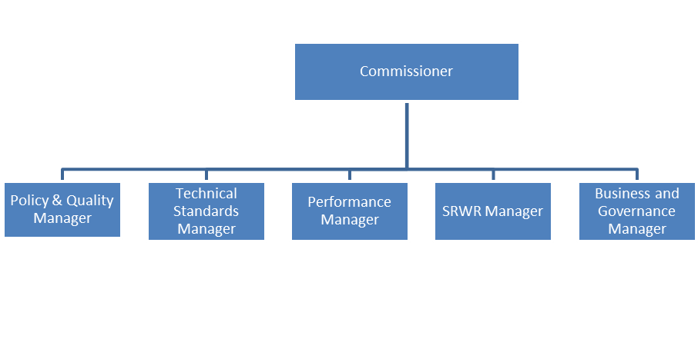

Managing our Resources
As a public body aligned to Scottish Government working practices, the Commissioner is committed to the efficient management of resources. In order to achieve this, the Commissioner takes a streamlined approach to the work of the office, ensuring that the activities undertaken are specific, realistic and measurable as detailed in the annual business plan. The Commissioner publishes an annual report and accounts every year in line with the responsibilities of an Accountable Officer of public funds.

Reporting our Progress
The Commissioner is required to report progress on objectives and achievements in autumn each year. This is carried out by means of the publication of the Annual Report and Accounts. These documents are laid before Parliament.
The Commissioner shall prepare an annual Business Plan. This will contain the previous year’s operational objectives and will report upon progress to achieve these. This will also include identified Key Performance Indicators (KPIs).
The Commissioner shall also prepare an annual road works monitoring report. This will report on the performance of individual organisations and sectors against a suite of metrics.
The reports are published on the Commissioner’s website at:
roadworks.scot/publications

Statement of Intent
The Scottish Road Works Commissioner will:
- Show appropriate governance over the work of the oSRWC;
- Treat individuals with equality, dignity and respect;
- Commit to the principles of Fair Work First;
- Act with integrity when complying with the Commissioner’s policies and procedures;
- Regulate effectively and independently; and
- Demonstrate best value in financial undertakings.

Feedback / Contact Us
The Scottish Road Works Commissioner is committed to providing a quality service for the road works community and the people of Scotland. To assist and improve this process, the Commissioner would be pleased to receive feedback and your views on the planning of the service. Alternatively, if you have any comments or complaints about our service please let us know.
All feedback received will be used to inform future plans
 You can phone us on 0131 244 9936
 You can email us at enquiries@roadworks.scot
 You can contact us by post at
Scottish Road Works Commissioner
E Spur
Saughton House
Broomhouse Drive
Edinburgh
EH11 3XD

Accessibility and Inclusion

This document may be available in other formats, please contact us if you wish to discuss this matter.

