Gazetteer Conventions for Street Polygons
Document Version | 0.5 (Draft)
Date | March 2015
Contents
1. Introduction 4
1.1. Purpose 4
1.2. Background 4
1.3. Business Requirements 5
1.4. Project Streams 5
1.5. Elementary Level of Capture 6
1.6. Base Mapping 7
1.7. Conventions 9
2. Glossary 10
3. Gazetteer model 11
4. Local Street Gazetteer Conventions 12
4.1 Purpose 12
4.2 Content 12
4.3 Street attributes 13
4.4 USRN 16
4.5 Record type 16
4.6 Responsible authority 18
4.7 State 18
4.8 Date 18
4.9 Identifier 18
4.10 Locality and town 20
4.11 Administrative area 21
4.12 Language 21
4.13 Extremity points 22
4.14 Street lifecycle 24
4.15 Cross-references 27
4.16 ESU ID 29
4.17 ESU lifecycle 29
4.18 Street Polygon Examples 30
4.19 ESP Geometry 31
4.20 ESP feature type 32
4.21 Road status 32
4.22 Adoption date 33
4.23 ESP ID 33
4.24 ESP lifecycle 33
5. Geometry 34
5.1 Method 34
5.2 ESP Hierarchy 38
5.3 Junction Types 38
6. Junction Layouts 39
6.1 T Junctions 39
6.2 Cross Roads 43
6.3 Offset Junctions 45
6.4 Roundabouts 50
6.5 Dual Carriageway Cross Overs 56

Introduction

Purpose
This document outlines proposed conventions for capture and maintenance of a “Polygonised” representation of Scottish Street Gazetteers presently maintained in linear network format. The document also presents the full set of street conventions to make it simpler to review the corresponding rules required for handling street polygons.
The aim of these conventions is to ensure that gazetteer data are maintained to a consistent standard across Scotland and are usable regionally and nationally.

Background
The collection of data to form a Street Gazetteer has been in place for a long time; however the recent maturity of the Addressing Products has brought the position of data collected for the Street Work Purposes into focus.
Although the Local Authorities collect Street Information for their Corporate Address Gazetteer (Local Land and Property Gazetteer), this is not always the same data as is held in their Street Works system. The purpose of the Street Gazetteer in the CAG is simply a mechanism to attach a property to. The Street Gazetteer for Street works (SWR) is used extensively within council for a number of purposes.
For the purposes of a CAG, the Street Gazetteer needs to provide a start and end coordinate for a street. This is known as a Level 1 Gazetteer. This is enough for the CAG to attach a property to a Street. For the purposes of a Street Work Gazetteer, the street needs to have shape that matches the road that the Street is modelling. This is known as a Level 3 Gazetteer. This is a more useful format of the Gazetteer than the Level 1 as the street can be visualised looking like the Road.
There are a number of business requirements which could benefit from the accurate representation of roads and the availability of key attribute data. Current street gazetteers use linear geometry to represent roads, which has limited benefits. A more useful approach would be to represent roads as polygons and associate roads attributes with these polygons to generate information based on area.

Business Requirements
The main business requirements driving this project are:
- Statutory List of Public Roads (LoPR). To improve the understanding and accuracy of the data held within the LoPR by adding a spatial element to it. It is currently possible to derive an LOPR from LSG and ASD, however a polygon dataset is required to accurately present adoption extents.

- To create a graphical representation of roads data for internal and external use e.g. public website. This will aid access to the data, improve the accuracy and also make it easier to update and amend as necessary.

- To ensure that a standard is applied to the creation of this data so that it can be used nationally.

- For SCOTS asset management project the LoPR data will represent one of the biggest assets in the country and will be used within each authority as a major part of the Council’s Roads Asset Management System.

- There are many other potential uses for a detailed street polygon dataset including e.g. street cleansing operations, waste management, grounds maintenance, accurate recording of surface types, maintenance planning and costing.

- Representing existing linear ESUs surface area is a useful attribute for asset management.

Project Streams
Initially the project included two streams:-
- Identification and documentation of the business requirements for holding street polygon data.
- Identification and documentation of the conventions for capturing, editing and maintaining street polygons.
Two groups were initiated to meet the objectives of these streams
- A small technical group (5 members) elected from a meeting of 15 local authorities who have already captured street polygons, are in the process of capturing street polygons or have shown a desire to capture street polygons.
- A business case group made up of interested stakeholders to produce a business requirements document supporting the requirements and advantages of capturing street data as polygons.

Elementary Level of Capture
It should be noted that the scope of the project is to create conventions detailing the method and methodology of capturing a polygonised representation of the existing linear street gazetteers. Therefore in order to get maximum benefit from the capture of street polygons, it is necessary to integrate them into the existing street gazetteer structure.
A key decision has been made regarding whether polygons should be linked to USRNs (Unique Street Reference Number) or ESUs (Elementary Street Unit, see 4.13). The method proposed links polygons to ESUs and as a consequence of their hierarchical geometry uniquely linked to the corresponding USRNs. Current GIS functionality can be used to ensure that polygons representing individual ESUs (ESPs) can be ‘aggregated’ to represent the geometry of their parent USRNs in polygon format.
Street polygons are referred to as Elementary Street Polygons and are handled in a similar manner to ESUs. Many of the conventions for ESUs have been adopted for ESPs
Linking ESPs uniquely to ESUs will allow access to USRN attribution via the existing ESU cross references. i.e. An attribute of an ESP will be the ESUID of the corresponding ESU. This link would allow ESU based attributes to be associated with ESPs which can therefore make USRN attribution accessible.
It is the case that it is possible for an ESU to be linked to more than one ESP . See example in 6.3.1
Polygons provide a better visual representation of streets than centreline geometry does and it is required that key attributes of a street are displayed graphically. These include road status and road class. It is normally not good practice to store a data item twice but road status is included as an ESP attribute. This is held in the Associated Street Data Type 51 record but ASD is not available to all street gazetteers and if status does not apply to whole road, the definition is imprecise. Capture Status
Scotland’s local authorities are at various stages of data capture for street polygons at present.
- Authorities who have captured street polygons covering the extent of their local authority boundary that represent a polygonised version of their linear street gazetteer with polygons ‘split’ at ESUs. Although these have been captured in the absence of any centrally defined standards.
- Authorities who have captured a polygonised version of the statutory ‘List of Public Roads’ (LoPR) i.e. graphical representation of road adoptions, stopping ups and in some cases private roads. In most cases these polygons have not been ‘split’ at ESU level. Although these have been captured in the absence of any centrally defined standards
- Authorities who have already commenced or have plans to capture a polygonised street dataset
- Authorities who have neither captured polygons nor have any plans to.
These conventions set out to create a set of rules and recommendations enabling the consistent capture of street polygons for those authorities who have not yet commenced capturing this data i.e. a set of directives for data capture starting ‘from scratch’. Consequently the conventions outline the rules for those authorities who have began or completed data capture to amend and edit existing data to create national consistency.
It should be noted that to ensure consistent capture of street polygon datasets representing linear street gazetteer geometry it is necessary that there is consistency in the capture and maintenance of this linear geometry e.g. some authorities do not create separate ESUs at changes in maintenance responsibility while others do. The document therefore includes existing conventions for local street gazetteer
These conventions do not intend to recommend changes to existing conventions for linear street gazetteers; rather the intention is to adhere to these in order to create consistent corresponding polygons. There are though exceptions to this caused by the differing nature of the polygon geometry which will be highlighted and explained later in this document.

Base Mapping

OS MasterMap will be used as a common source of street polygon data, although other mapping products, including paper maps can be used as reference and investigation. At present all Local Authorities receive OS MasterMap Topography Layer as part of the One Scotland Mapping Agreement and currently no other large scale polygonised dataset exists.
OS MasterMap Topography Layer has been developed in response to the need for a national topographic dataset that offers customers a more sophisticated type of data that represented the world in a more realistic way and was more aligned to the increasing use and functionality of GIS and spatial database technology within organisations. Many customers use geographic products as a basis to derive their own data, which can be time consuming and inefficient where features in the data are amalgamations of more than one real-world feature or even parts of real-world features. Where the feature represents a real-world feature that has an ‘area’, such as a building or a parcel of land, the feature is represented in the data as a polygon. OS MasterMap Topography Layer is used extensively by businesses and organisations that need to relate their activities and/or their assets to the physical environment. Many organisations need to derive their own GI from OS MasterMap Topography Layer. They use the individual features that Ordnance Survey provides to form the building blocks for their own sets of GI. Many local- and central-government organisations use it this way. Once they have the physical feature or group of features they are interested in, they can attach their own attribution to that already provided with the product. When this kind of data association takes place, it can lead to efficiencies in storing and using data. It can also enable data to be shared more easily between and within organisations.

Street polygons will be derived from OS MasterMap Topography Layer by extracting the roads, tracks and paths features. To date all authorities who have captured or have commenced capture have used this method. This is then edited to represent the geometrical extents of polygons. Care should be taken in rural areas when using this method as the OSMM geometry does not always accurately reflect the layout of the carriageway and verges in these areas. In this case the polygons will require to be captured using whatever extra information is available from other sources or by making assumptions as to road widths.
It should be noted that the roads, tracks and paths polygon features layers do not presently geometrically match the footprint of previous polygon datasets which have been captured in all cases e.g. list of public roads. The existing OSMM polygons also represent junctions contrary to the rules of existing street gazetteer conventions. These factors signify a considerable amount of editing to OSMM features to truly represent polygon extents of existing linear street geometry.
OS currently take the information from the OneScotland Gazetteer and process this with other information into their AddressBase product. It is envisaged that a similar procedure may be possible with local authority street polygon datasets being made available to OS to enhance or expand the existing MasterMap suite of products. This may include OS, in conjunction with stakeholders, developing ‘batch’ process’ to automate a percentage of the data capture process to reproduce geometry of existing street polygon data using existing OSMM polygons. The percentage of the total coverage that will be suitable for such batch process is as yet unknown; although during the production of conventions it has become apparent that this may become challenging at ‘complex’ junctions and roundabouts.
All OS MasterMap products contain a field holding TOIDs. Every feature has a unique common reference (a TOID) which enables the layers to be used together i.e. each polygon, line. Point or annotation has an identifier that uniquely identifies it. There is therefore the issue that if there is a requirement to ‘split’ OSMM polygons to represent street gazetteer geometry the TOID reference will no longer be unique.
Attributes of street polygon datasets will match those of existing street gazetteers apart from those which are not relevant to polygon data e.g. length, start, end. The unique identifier linking both datasets will be ESUID.

Conventions

Three categories of convention are presented in this document, which indicate the requirements of the OneScotland Gazetteer and also indicate best practice to support widespread local use of the gazetteer

Category | Explanation
Mandatory | Compliance with this convention is compulsory for street polygons. Non-compliance with this convention may result in local records being rejected from any future national combined polygon dataset.
Recommended | Compliance with this convention is recommended for street polygons. Non-compliance with this convention will result in local records being accepted into any future national combined polygon dataset but a warning may be issued.
Guidance | Compliance with this convention is not compulsory for street polygons but conventions encourage best practice.

Glossary
ASD | Associated Street Data
BLPU | Basic Land and Property Unit
CAG | Corporate Address Gazetteer (popular name for a local property gazetteer)
ESU | Elementary Street Unit
ESUID | Elementary Street Unit ID
ESP | Elementary Street Polygon
ESPID | Elementary Street Polygon ID
GIS | Geographic Information System
LoPR | List of Public Roads
LPI | Land and Property Identifier
LSG | Local Street Gazetteer
NLPG | National Land and Property Gazetteer
NSG | National Street Gazetteer
OSG | One Scotland Gazetteer
OSMM | Ordnance Survey MasterMap
PAO | Primary Addressable Object
SAO | Secondary Addressable Object
SDTF | Scottish Data Transfer Format
SNN | Street Naming and Numbering
SRWR | Scottish Road Works Register
TOID | OS MasterMap Topographic Identifier
UPRN | Unique Property Reference Number
USRN | Unique Street Reference Number

Gazetteer model
The following diagram shows the relationships between the different entity classes that make up street gazetteers.
Street
Street
Reinstatement
(52)
Street
Special
Designation
(53)
Street
(11)
Street
X Ref
(12)
ESU Coord
(12)
Elementary
Street
Unit (13)
Street
Descriptor
(15)
Elementary
Street
Polygon (A)
ESP
Vertex (B)
Street
Reinstatement
(52)
Street
Special
Designation
(53)
Street
(11)
Street
X Ref
(12)
ESU Coord
(14)
Elementary
Street
Unit (13)
Street
Descriptor
(15)
Elementary
Street
Polygon (A)
ESP
Vertex (B)
Street
Maintenance
Responsibility
(51)

Local Street Gazetteer Conventions

Purpose
This section presents conventions for Scottish street gazetteers. Conventions are excluded for Public Rights of Way (not applicable in Scotland) and Associated Street Data (see Ref. Doc. 8)
In Scotland, Local Street Gazetteers (LSG) are created and maintained by local authorities. They cover all streets in the authority’s geographic area regardless of maintenance responsibility - for instance, some streets are maintained by the Scottish Government not local authorities. LSGs have two primary users, whose requirements have influenced these conventions:
To comply with the New Roads & Street Works Act, the Scottish Road Works Register (SRWR) holds a copy of 32 LSGs plus associated street data (ASD). This is an electronic register that records street works carried out by local authorities and utilities.
To comply with BS7666 requirements, property gazetteers are dependent on LSGs to provide a property record’s street, locality, town, and administrative area information.

Content
There are three categories of content requirement:
Content Requirement | Explanation
Mandatory | These streets must be included in local street gazetteers. Error notifications can be issued by the SRWR if one of these street types is found missing.
Recommended | It is recommended that these streets are recorded in local street gazetteers. Warning notifications can be issued by the SRWR if one of these street types is found missing.
Guidance | These streets may or may not be recorded in local street gazetteers, according to local requirements. There are no current national requirements for these streets.

To meet the requirements of the New Roads & Street Works Act, each Roads Authority must register public roads and prospective public roads. It is also recommended that Roads Authorities should register all private roads with a public right of passage. Where such private roads are named, they will need to be included to meet property gazetteer addressing requirements. The following table seeks to clarify content with specific examples.
Street Category | Notes and examples | Content Requirement
Classified | A, B, C or M roads | Mandatory
Unclassified | U roads | Mandatory
Prospective public | e.g. Development site roads that have been built in accordance with a valid road construction consent but have not yet been adopted | Mandatory
Private | Maintained by private owner(s) but with a public right of passage | Recommended
Cycle track /  Footpath | Where not part of a street. Note that footways and cycle ways adjacent to streets are taken to be part of the parent street. | Mandatory (if on statutory list of public roads)  Recommended (if private)
Service | Side roads etc. | Mandatory
Roundabout |  | Mandatory
Slip |  | Mandatory
Indoor | Where required locally for a useful address | Guidance
Private access | Where access is provided to more than one property. Note that a drive to a single property is not a street (see BS7666-1:2006 section 3.7). A private access differs from a private road in that it can be ‘closed’ to the public if desired by the owner. | Guidance
Proposed |  | Guidance

Street attributes
BS7666:2006 specifies mandatory (M), optional (O), and conditional (C) attributes for Streets. Both England and Wales (NLPG) and Scotland have extended BS7666:2006 with some additional Street attributes.
The tables below clarify whether there is an obligation to populate each attribute according to BS7666:2006, the NLPG, and in Scotland. The tables are structured according to SDTF and cover the geometry and relationship between a street and an elementary street unit (a subset of a street).
BS67666 attribute | SDTF field (11) | BS7666 | NLPG | Scotland
USRN | USRN | M | M | M
Record type | RECORD_TYPE | M | M | M
Responsible authority | CUSTODIAN_CODE | M | M | M
State | STATE | O | O | O
Current state date | STATE_DATE | O | C | C
Street classification | STREET_CLASSIFICATION | O | O | N/A
Entry date | ENTRY_DATE | M | M | M
Update date | LAST_UPDATE_DATE | M | M | M
Start date | START_DATE | M | M | M
End date | END_DATE | O | C | C
Extremity point 1 | START_X  START_Y | M | M | M
Extremity point 2 | END_X  END_Y | M | M | M
External cross-reference |  | O | N/A | N/A

BS67666 attribute | SDTF field (15) | BS7666 | NLPG | Scotland
Identifier | DESCRIPTOR | M | M | M
Locality | LOCALITY | C | C | C
Town | TOWN | C | C | C
Administrative area | ADMINISTRATIVE_AREA | C | M | M
Language | LANGUAGE | O | M | M

Attribute | SDTF field (12) | BS7666 | NLPG | Scotland
Cross reference type | XREF_TYPE | N/A | M | M
Cross reference | XREF_ID | N/A | M | M

BS67666 attribute | SDTF field (13) | BS7666 | NLPG | Scotland
ESU ID | ESUID | M | M | M
Update date | LAST_UPDATE_DATE | M | M | M
End date | END_DATE | O | C | C
Extremity point 1 | START_X  START_Y | M | M | M
Extremity point 2 | END_X  END_Y | M | M | M
Entry date | ENTRY_DATE | M | M | M
Start date | START_DATE | M | M | M
State | N/A | O | N/A | N/A
Current state date | N/A | O | N/A | N/A
Street classification | N/A | O | N/A | N/A
Description | N/A | O | N/A | N/A
External cross-reference | N/A | O | N/A | N/A

BS67666 attribute | SDTF field (14) | BS7666 | NLPG | Scotland
Coordinated point | X_COORDINATE  Y_COORDINATE | O | M | C

USRN
The Unique Street Reference Number (USRN) is the primary key of a street record.
ID | Convention | Category
 | A USRN is within the range allocated by the UK Government to the authority that originally created the street. See Appendix A. | Mandatory
 | Each USRN is unique within the UK and is not re-used. | Mandatory
 | The USRN for a street is never changed apart from the Lifecycle changes described in the Street Lifecycle section. | Mandatory

Record type
According to BS7666-1:2006 section 6.7.2, there are four record types, which identify the type of street reference:
Record type | Street reference type | Examples
1 | Designated street name | Formally named by a Local Authority’s Street Naming and Numbering Service, e.g. High Street or Tower Roundabout
2 | Described street | A9 from High Street to A72  Cycle track from B341 to Main Road
3 | Numbered street | Nationally allocated numbers (A, B, M roads), e.g. B818  Locally allocated numbers, e.g. U693
4 | Unofficial street name | Not formally named by the Local Authority but in common use, e.g. Old Perth Road:  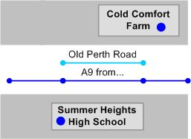  Formally named by the Local Authority but not separated from the main carriageway, e.g. Market Place:  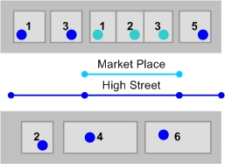
ID | Convention |  | Category
 | A USRN has a record type of :  1, 2, 3 or 4.  Note that record type 9 is not used in Scotland. |  | Mandatory
 | A record type 3 exists for:  every road of classification M, A, or B  every road where the Roads Authority has allocated a number |  | Mandatory

Responsible authority
The responsible authority code identifies the authority that is currently responsible for the gazetteer record. Note that this may not be the authority currently responsible for maintaining the road.

ID | Convention | Category
 | A responsible authority code is allocated to each authority by the UK Government. See Appendix A. | Mandatory

State
Currently, State is used in Scotland to flag streets that are under construction. Other State codes may be introduced in the future.
ID | Convention | Category
 | State is populated with:  0 or null = no state  1 = prospective or under construction  2 = open  4 = permanently closed | Mandatory

Date
ID | Convention | Category
 | Current state date is populated if state is 1 | Mandatory
 | Current state date is not before entry date. | Mandatory
 | Last update date must be the same as or after the entry date | Mandatory
 | Street end date must be the same as or after street start date | Mandatory

Identifier
A street’s Descriptive Identifier is made up of the following BS7666-1:2006 elements: Identifier Language, Locality, Town, and Administrative Area. Identifier is the street name, number, or description.

ID | Convention | Category
 | Descriptive identifiers (combination of Identifier, Locality, Town, and Administrative Area) are unique within Britain. | Mandatory
 | The identifier of a street with a record type 1 matches the official Street Naming and Numbering record, where this exists.  Note that punctuation is discouraged (see Formatting in the General section) | Mandatory
 | The identifier of a street with a record type 2 provides sufficient information to uniquely identify the street.  The identifier either describes the end points or the general location and may include key words such as: from, to, adjacent to, next to, between, rear, alongside, passing across, joining, via, with branch to. | Guidance
 | If a street with a record type 2 has been allocated a road number, the identifier starts with the road number. | Recommended
 | If the identifier of a street with a record type 2 includes a road number for a C class, unclassified or other road, a ‘Z’ prefix is not inserted before the road number. | Recommended
 | The identifier of a street with a record type 3 does not exceed 12 characters | Recommended
 | The identifier of a street with a record type 3 is:  the nationally allocated classification number starting with A, B, or M  the local Roads Authority allocated number prefixed with an additional ‘Z’ (see BS7666-1:2006 6.6.5.3) | Mandatory
 | The identifier of a street for a C class road begins with ‘ZC’ | Mandatory
 | The identifier of a street for an unclassified class road starts with a ‘ZU’ | Guidance
 | In the identifier for A-class trunk roads, the suffix ‘T’ is added without a space or brackets, e.g. A9T | Mandatory
 | If a street with a record type 3 runs through multiple authorities, the authority name is not included in the identifier. The authority can be identified via administrative area or responsible authority. | Mandatory

Locality and town
The purpose of the locality and town attributes is to provide a spatial reference for a street to identify it uniquely and to form a useful property address. These fields are not mandatory in Scotland (a difference from England and Wales, where town is mandated) but are strongly encouraged wherever possible - especially for Type 2 streets - to help SRWR users easily locate streets and for property gazetteer users to locate addresses.
Locality and town may be used flexibly as ‘area 1’ and ‘area 2’ to represent a wide variety of geographic areas that will be meaningful to gazetteer users. Localities and towns may evolve as property development occurs and these changes should be reflected in the Street Gazetteer as necessary.
The following examples aim to clarify the types of area likely to be found in each field. Note that some types of area may appear as either a locality or a town or depending on the local geographical context (e.g. Glens).
A Locality represents a lower level geographic area.
Examples:
Suburbs (Cornton)
Small settlements and surrounds (Blairdaff)
Small rural areas (Glen Ogil)
Industrial estates (Springkerse Industrial Estate)
Where the PAO/SAO is needed for other address elements, the following can also be held as a locality:
Rural estates (Keir Estate)
Shopping centres (Thistles Centre)
Educational campuses (Stirling University)
Caravan parks (Dunnikier Caravan Park)
If required for a useful address, a town is added to the street gazetteer to represent a higher level geographic area that may contain one or more lower level geographic areas (localities).
Examples:
Cities (Stirling)
Islands (Isle of Mull)
Large settlements and surrounds (Hamilton)
Large rural areas (Glen Clova)

ID | Convention | Category
 | Locality is populated for all street records where it will aid street or property addressing, except for streets with a record type 3 that cross multiple localities. | Recommended
 | Town is populated for all street records, except for streets with a record type 3 that cross multiple towns. | Mandatory
 | Locality is not populated unless town is also populated. | Mandatory
 | Authorities liaise to represent locality and town consistently across and within authority boundaries. | Recommended
 | Locality or town do not contain modifier words such as ‘by’ or ‘near’. | Recommended
 | The same description is not used as a locality and a town within the same record. | Mandatory

Administrative area
The administrative area is the name of the local authority area in which the street is located.
ID | Convention | Category
 | Administrative area is populated for all street records. | Mandatory
 | Administrative area does not contain the word ‘Council’ so that, if required locally, authorities can easily use this field in the address, e.g.  Clackmannanshire not Clackmannanshire Council | Mandatory

Language
See Language in the LPI section.

Extremity points
A street’s location is described through Extremity Points (start and end x y coordinates). A street can be subdivided into Elementary Street Units (ESUs). These features usually start and end at junctions but also allow authorities to store different names for sections of the same street (e.g. part of the B818 may be officially named High Street).
A street record can be represented according to one of three levels, which reflect the geographic accuracy of the street. A street gazetteer can hold a mix of levels and a record’s level can change from 1 through 3 as better geographic information becomes available.
Level | Explanation | Example
1 | Street has a start and end point but is not broken down into ESUs.
2 | Street is divided into ESUs with start and end points at each junction.
3 | Street is enhanced by intermediate points within ESUs that represent the true shape of the street.

ID | Convention | Category
 | To facilitate map-based viewing in the SRWR, a new street record is entered with Level 2 or 3 geometry, even if this is initially approximate and needs to be revised later. | Recommended
 | An ESU does not contain branches. It must not extend across:  A junction  A point where there is a change in the maintenance responsibility  Where the street name or number changes  An authority boundary  A town or locality boundary | Mandatory
 | ESUs are connected where roads that are open to vehicles join and also where roads that are open to vehicles join those that are closed or restricted to vehicles e.g.  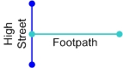 | Recommended
 | An ESU should not be broken except at the locations described above. | Recommended
 | For dual carriageways (or roads separated by multiple central islands), ESUs are created for each carriageway. However, separate USRNs are only created for each carriageway if they have different names. | Recommended
 | For service roads that share a name with the parent street, ESUs are created for the service road. However, separate USRNs are created for each road if they have different names.  Note that if a service road is officially named, properties accessed from the service road use that name as their street name. | Recommended
 | Slip roads have the same USRN as the adjoining street sharing the maintenance responsibility (e.g. part of a trunk road if both are under the same trunk road operator), unless there is a requirement for the slip road to be separately identified. | Recommended
 | Where roundabouts (other than mini roundabouts) do not form part of a named road or have an official name, they have their own Type 2 USRN. | Recommended

Street lifecycle
ID | Convention | Category
 | When a new street is being constructed:  a new street is added to the street gazetteer as soon as it is needed by the property gazetteer. This is usually before or shortly after Street Naming and Numbering has assigned a new street name:  The entry date and start date are populated | Mandatory
 | When a major new road scheme is to be constructed:  It may be appropriate to add new streets to the street gazetteer to show the location and layout of the new scheme.  Streets are given descriptions indicating when the scheme would be finished e.g. New road from A to B opening Spring 2011  The entry date and start date are populated. In this case start date is the date when approval was given or construction started. It should be on or before the present day.  The State field is set to 1 (prospective or under construction).  The ESUs would be attached to the existing road network when the scheme was completed or in stages as construction progressed. The new ESUs would the replace old and the state field would be set to 2. | Guidance
 | When a street’s descriptive identifier changes due to error or official renaming, or a street’s geometry changes:  a new USRN is not created. Instead, the affected street fields are edited and update date changed., e.g.  If a street has been renamed, a type 4 record may be created for the old name. | Mandatory
 | If a street needs to be extended:  the ESU geometry is changed for one or more existing streets and extremity points updated. A new USRN is not required, e.g.  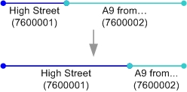 | Mandatory
 | When a street no longer exists:  the end date is populated  if the street record was created in error or the street never existed, the record can be deleted from the gazetteer. If a legitimate record, it remains in the gazetteer with an end date. | Mandatory
 | When a street is split:  two new USRNs are created (even if one of the streets retains its name)  the old USRN is closed (end date populated), e.g.  If a street is split for a town or locality, the preference is to split at a:  Street junction  Physical feature that can be easily recognized by SRWR users, such as a bridge, river, or access to a property  Note that Type 2 descriptions should be actively maintained if there are changes to the name of the referenced physical feature. | Mandatory
 | When two or more streets are merged:  one new USRN is created (even if one of the original names is retained for the new street)  the old USRNs are closed (end date populated), e.g. | Mandatory

Cross-references
There are three types of cross-references in street gazetteers that are used to link sections of a street, as described below:
XREFType | Use | Example
1 | Used in ‘Level 1’ street gazetteers to link a USRN to another USRN. | A single stretch of road may include a number of different road types, e.g.  a designated street name (High Street)  a numbered road (A38)  an unofficial name (Market Place)
2 | Used in ‘Level 2 or 3’ street gazetteers to link an individual ESU to a USRN. | Using the same example above but, this time, Market Place forms only part of High Street.

ID | Convention | Category
 | Cross reference type is populated with:  1 (Street)  2 (ESU) | Mandatory
 | All Street records are cross-referenced to their constituent ESUs | Mandatory
 | A record type 3 is cross-referenced to one or more record types 1 or 2 | Mandatory
 | A record type 4 is cross-referenced to one or more record types 1 or 2 | Mandatory
 | An ESU can not be cross-referenced to more than one open Street of the same record type for types 1, 2 or 3 (e.g. can not reference two type 1’s).  However, an ESU can be cross referenced to more than one record type 4. | Mandatory

ESU ID
ID | Convention | Category
 | The ESU ID is unique within Scotland and is never re-used. | Mandatory
 | To easily create a unique, 14 digit number, the ESU ID can be derived from a grid reference, such as the original mid-point of the ESU. However, the ESU ID does not then change if the mid-point changes. | Guidance

ESU lifecycle
ID | Convention | Category
 | When a new ESU is added, a new ESU ID is created | Mandatory
 | When an ESU is changed, the ESU ID does not change | Mandatory
 | If an ESU needs to be extended, the ESU ID does not change | Mandatory
 | When an ESU no longer exists, the ESU end date is populated. The old ESU ID is not re-used. | Mandatory
 | When an ESU is split, the old ESU is closed and two new ESUs are created. The old ESU ID is not re-used. | Mandatory
 | When two or more ESUs are merged, the old ESUs are closed and one new ESU is created. The old ESU IDs are not re-used. | Mandatory

Street Polygon Examples
The following examples illustrate how carriageways and footways should be split into polygons at junctions, crossroads and roundabouts. Where the polygons are split will depend on:
(a) The identifier(s) of each section of road. Each section will have:

Polygon Attribute Fields
Street Details | Attribute
ESPID |  | M
ESUID |  | M
Record_Type | Type 1 / Type 2 / Type 3 / Type 4 | R
Descriptor |  | M
Start Date |  | M
End Date |  | R
Entry Date |  | M
Last Updated |  | M
State | Under Construction / Unknown / Other | M
Class | Open to Vehicles / Restricted Access / Pedestrian / Pedestrian and Cycle Track | M
Hierarchy | Strategic / Main / Secondary/Prestige/Primary etc. | R
Speed Limit | 10 / 15 / 20 / 30 / 40 / 50 / 60 / 70 | O
Urban / Rural | Urban / Rural | R
Clipped ESU Length | XXX.X (m) | O
Average Width | XX.X (m) | O
Area | XXX.X (m) | O
Dual Carriageway | Y / N | O
Route Number | Numerical Value | O
Classification | A / B / C / U | O
Feature_Type | See 4.20.1 | M

Maintenance Responsibility
Adopted Date | Move in table above | R
Road Status | Public / PMR / Private | M

ESP Geometry

ID | Convention | Category
 | ESPs must not overlap. An exception to this is the case of roads with a vertical displacement e.g. Multi level junctions, flyovers, underpasses etc. In these cases only the geometrical representation will overlap and not the physical extent. | Mandatory
 | An ESP must not extend across:  A point where there is a change in the maintenance responsibility  Where the street name or number changes  An authority boundary  A town or locality boundary | Mandatory
 | An ESP should not be broken except at the locations described above and exceptions made which will be explained later in this document | Recommended

ESP feature type
The feature type identifies the type of area defined by the polygon.
ID | Convention | Category
 | An ESP has a feature type of:  1 (carriageway)  2 (footway)  3 (footpath)  4 (verge)  5 (service strip)  6 (swale)  7 (cycle track)  8 (visibility splays)  9 (section 51 permissions)  10 (central reservation – landscaping hard or soft) | Mandatory

Road status
The road status identifies the maintenance responsibility of a feature.
ID | Convention | Category
 | An ESP has a road status of:  1 (public road)  2 (prospective public road)  3 (private road)  4 (trunk) | Mandatory

Adoption date
The adoption date is the date on which the local authority became responsible for maintenance of the feature.
ID | Convention | Category
 | Adoption date is not before start date.  Start date is the date when approval was given or construction started. It should be on or before the present day. | Mandatory

ESP ID
ID | Convention | Category
 | The ESP ID is unique within Scotland and is never re-used. | Mandatory
 | To easily create a unique digit number, the ESP ID will be  similar to USRN allocation where authorities are allocated a range authority code (same as USRN) Allocate by sequential numbering | Mandatory

ESP lifecycle
ID | Convention | Category
 | When a new ESP is added, a new ESP ID is created. | Mandatory
 | When an ESP is changed, the ESP ID does not change. | Mandatory
 | If an ESP needs to be extended, the ESP ID does not change. | Mandatory
 | When an ESP no longer exists, the ESP end date is populated. The old ESP ID is not re-used. | Mandatory
 | When an ESP is split, the old ESP is closed and two new ESPs are created. The old ESP ID is not re-used. | Mandatory
 | When two or more ESPs are merged, the old ESPs are closed and one new ESP is created. The old ESP IDs are not re-used. | Mandatory

Geometry

Method

This section will cover the method and rules relating to the creation of street polygon geometry by editing existing OS MasterMap geometry to create a polygonised representation (ESP) of linear (ESU) geometry.
In general, in the case of junctions, OSMM derived polygons will be ‘cut’ perpendicular to the carriageway edge intersecting the end/start point of the corresponding ESUs. (This is usually the centre point of the OSMM ‘junction box’) The resulting split parts of the OSMM junction box will each then be merged with the adjacent road polygons (depending on hierarchy) to create a continuous polygon representing the desired ESP (matching the linear extent of the ESU).
This cut should continue across any adjacent features e.g. Footway / Verge etc. Perpendicular to the feature edge. There may be exceptions to the angle of this split at roundabouts and complex junctions which will be covered later.
The following diagrams illustrate the conversion of OSMM existing geometry to represent ‘street polygons’. For this example it is assumed each of the three roads involved are of the same hierarchical importance.

Text Description | Diagram 1
Diagram 1 shows existing OSMM geometry

Text Description | Diagram 2
Diagram 2 shows existing OSMM geometry with corresponding ESU geometry (shown in red)

Text Description | Diagram 3
Diagram 3 shows existing the required street polygon representation according to rules which will be described in this document

Text Description | Diagram 4
Polygons A, B, C and D representing the geometry of the original OSMM polygons should be merged to create a ‘single’ polygon as shown Diagram 5

Text Description | Diagram 5
Merged single polygon

Text Description | Diagram 6
To begin to create the required street polygon representation illustrated in the previous diagram 3 :- Cut polygon A in line with kerb line of the road running east to west to create polygon D
Text Description | Diagram 7
Split polygon A by drawing a line perpendicular to the split between A and D which intersects the junction of the ESUs (shown in red) and continues through the northern footway of A. This will create road polygons A and C with corresponding footways a and c.

Text Description | Diagram 8
Split the footway polygons adjacent to D and south of A and C by drawing a line continuous of the ‘back’ of the footways a1 and c1 to create footways d and d1.

ESP Hierarchy
This process for converting OSMM geometry to represent ESPs has been shown for a relatively simple junction layout. This document will attempt to illustrate a series of further examples and the rules applied to converting OSMM polygon into ESPs which represent the extents of corresponding ESUs.
Although this document attempts to set out definitive rules for ‘simple junctions’ which can then be applied to all junctions including ‘multi’ junctions and complex locations; it is recognised that there will undoubtedly be exceptions where rules governing ‘simple’ junction cannot easily be applied. An example of this would be roundabouts or ‘offset junctions’ where it becomes necessary to assign multiple carriageway sections (ESPs) to a single ESUID. In most cases specific ESPs will be assigned with the ESUID of the ESU which intersects or is contained by that ESP. If it is decided that in specific circumstances an ESP contains or is intersected by multiple ESUs then the ESP will be allocated the numerically lowest ESUID of these ESUs. (Illustrated later within document)
The splitting of OSMM polygons to represent ESPs will be governed by a hierarchical order where preference is given to the ‘higher rated’ carriageway and associated features. The order in which prioritisation will be assigned is:-
- Road Hierarchy
- Classification
- Local Knowledge

Junction Types
The following diagrammatical examples and corresponding text illustrate the method of splitting OSMM polygons at road junctions based on the rules described in the previous paragraphs
Examples split into the following categories:-
- Regular Junctions
- Cross Roads
- ‘Offset’ Junctions (irregular junctions and junctions where roads meet at obtuse and acute angles)
- Roundabouts
- Dual and Multi Carriageways
To elaborate the representation of ESU / ESP extents and geometry; each example will contain two diagrams:
- Diagram showing resultant street polygons after splitting / merging OSMM polygons with ESUs shown in their linear form and extent with start / end points.
- Diagram showing resultant street polygons after splitting / merging OSMM polygons only.

Junction Layouts

T Junctions

Simple T Junction
Text Description |  | Diagram 1
The split extends from the centre point of the line splitting the road adjoining from the south passing through the intersection of the corresponding ESUs, perpendicular across all feature classes ; in this case the opposite footway  The carriageway of the private road adjoining from the south is cut in line (as if a continuation of) with the rear kerb line of the main distributor which has a higher hierarchical importance.  The adjacent footways are cut following the rear kerb on the red road (in this case ‘main distributor’) as it has a higher hierarchical importance. |  | 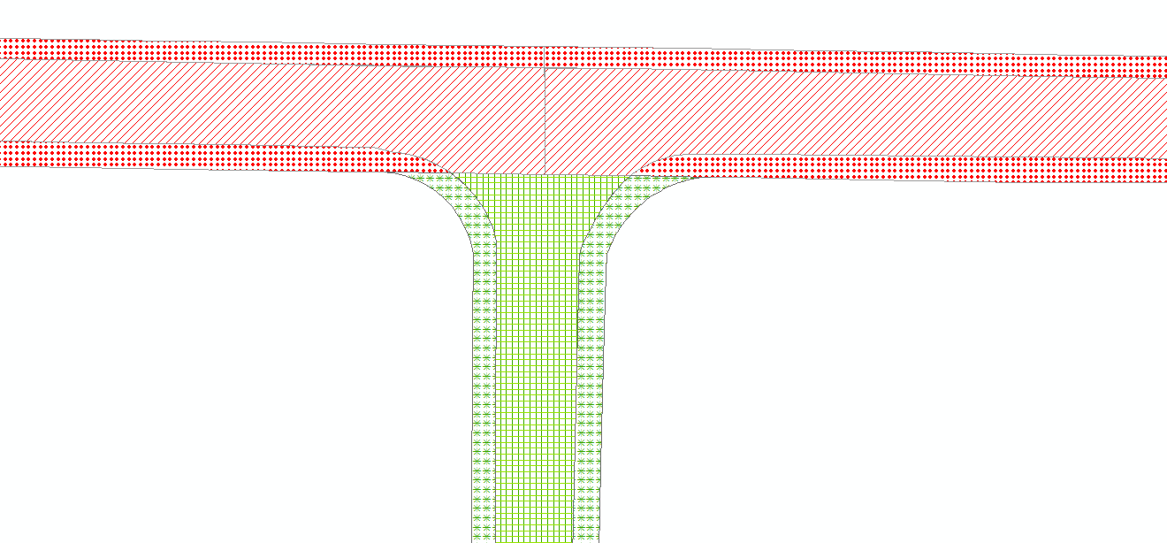
Legend |  | Diagram 2 ESU geometry shown
Red Road  Public  Main Distributor  A Class | Green Road  Private  Local Access  Unclassified | 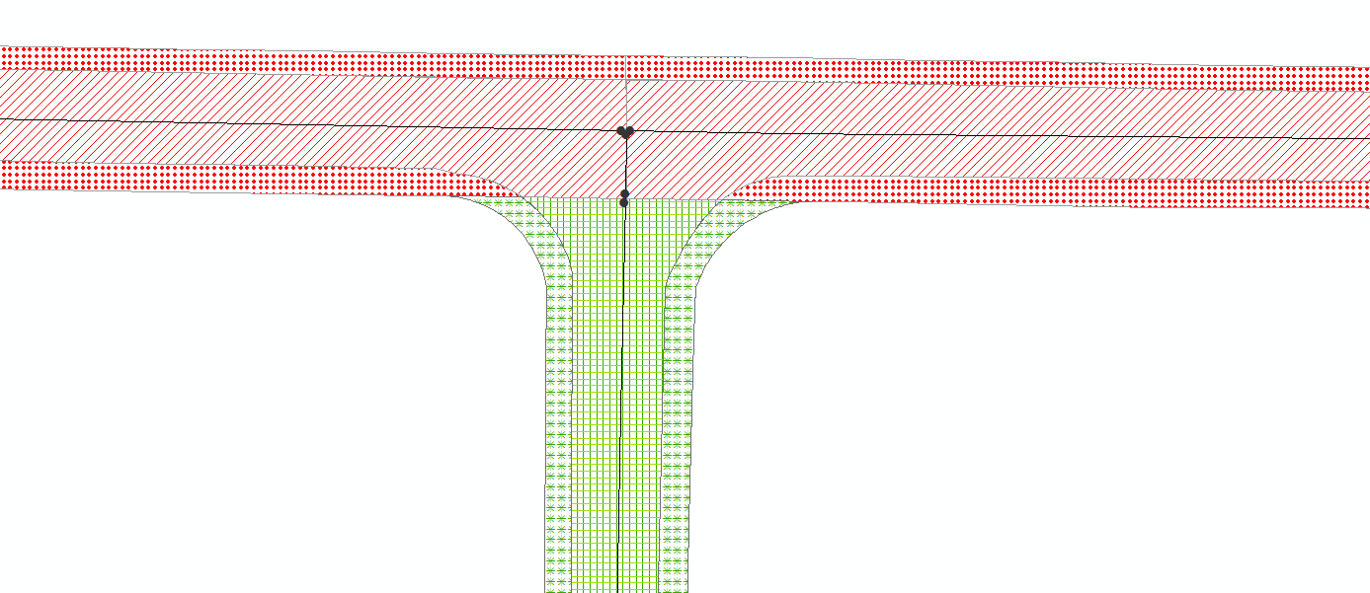

T Junction with Maintenance Split in Junction

Text Description |  | Diagram 1
The split extends from the centre point of the line splitting the road adjoining from the south passing through the intersection of the corresponding ESUs, perpendicular across all feature classes ; in this case the opposite footway
An additional split is required across the features to accommodate the extent of the private road in line with the rear of the blue footway (unless adoption documentation show the extents as being elsewhere) across the private road (green road) passing through the intersection of the corresponding ESUs.
The footway of the private road is cut at the end of the public road, at the start of the private section.

Legend |  | Diagram 2 ESU geometry shown
Red Road  Public  Local Access  Unclassified | Blue Road  Public  Local Access  Unclassified | 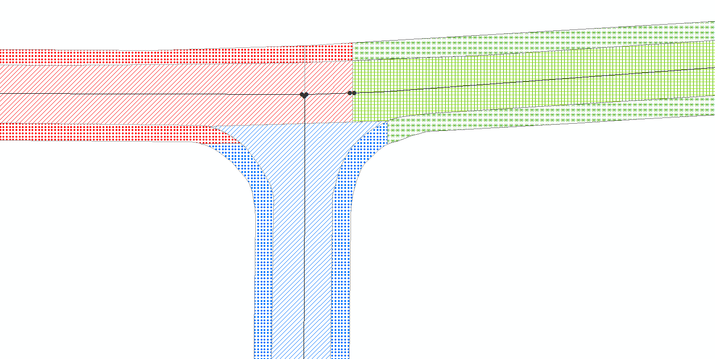
Green Road
Private
Local Access
Unclassified

T Junction Change of Maintenance Split at Junction

Text Description |  | Diagram 1
The split extends from the centre point of the line splitting the road adjoining from the south passing through the intersection of the corresponding ESUs, perpendicular across all feature classes ; in this case the opposite footway  The carriageway of the adjoining private road is cut in line with the heel kerb across the private road as in most cases there is maintenance responsibility for the total footway adjacent to the public road.  The footways are cut across the heel kerbs on the public roads as they have a greater hierarchical importance than the private road. |  | 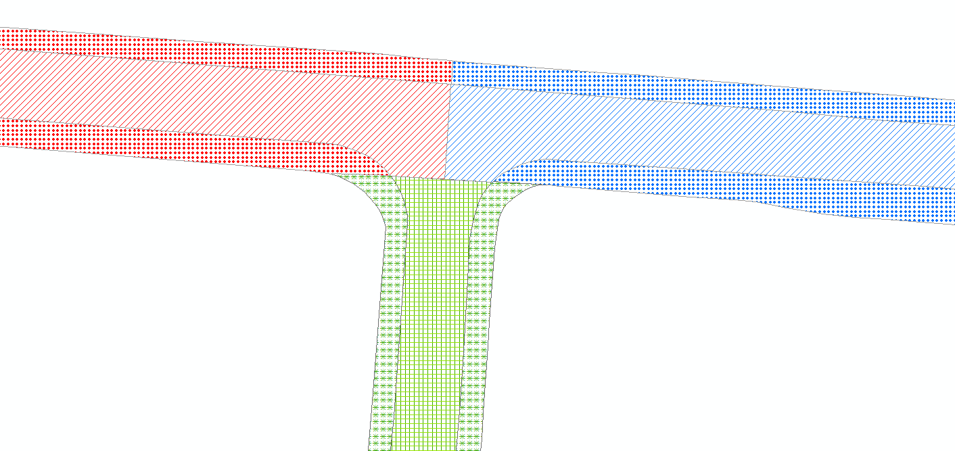
Legend |  | Diagram 2 ESU geometry shown
Red Road  Public  Local Access  Unclassified | Blue Road  Public  Local Access  Unclassified | 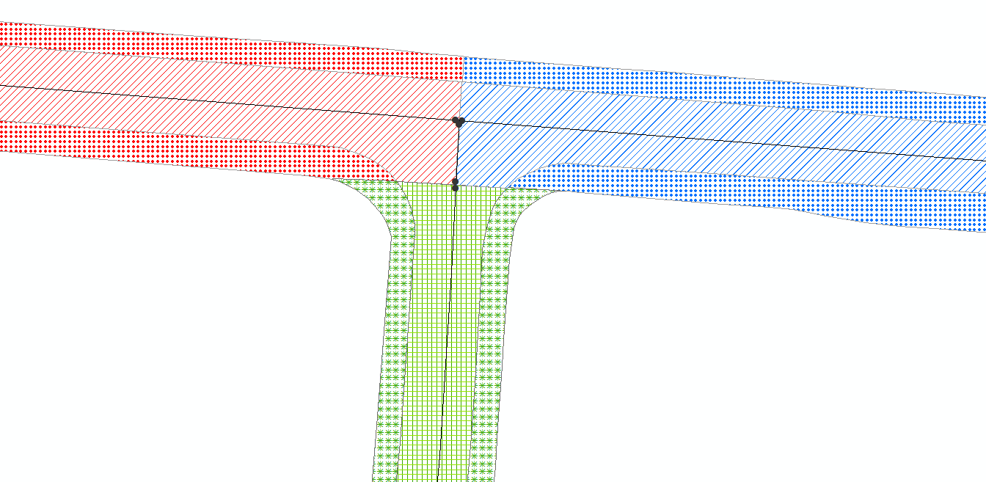
Green Road
Private
Local Access
Unclassified

T Junction Displaying Hierarchy Geometry
Text Description |  | Diagram 1
The split extends from the centre point of the line splitting the road adjoining from the south passing through the intersection of the corresponding ESUs, perpendicular across all feature classes ; in this case the opposite footway  The carriageway of the adjoining road is cut in line with the front of the kerbs of the secondary distributors as they have greater hierarchical importance than the local access road; usually at the road markings.  The footways are cut across the heel kerbs of the greater hierarchical importance; in this case the secondary distributors |  | 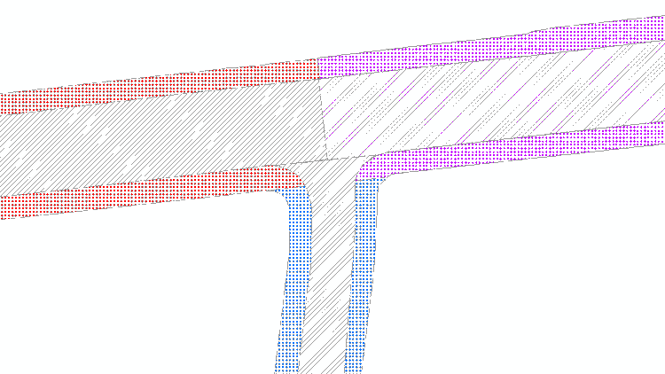
Legend |  | Diagram 2 ESU geometry shown
Red Road  Public  Secondary Dist.  C Class | Purple Road  Public  Secondary Dist.  C Class | 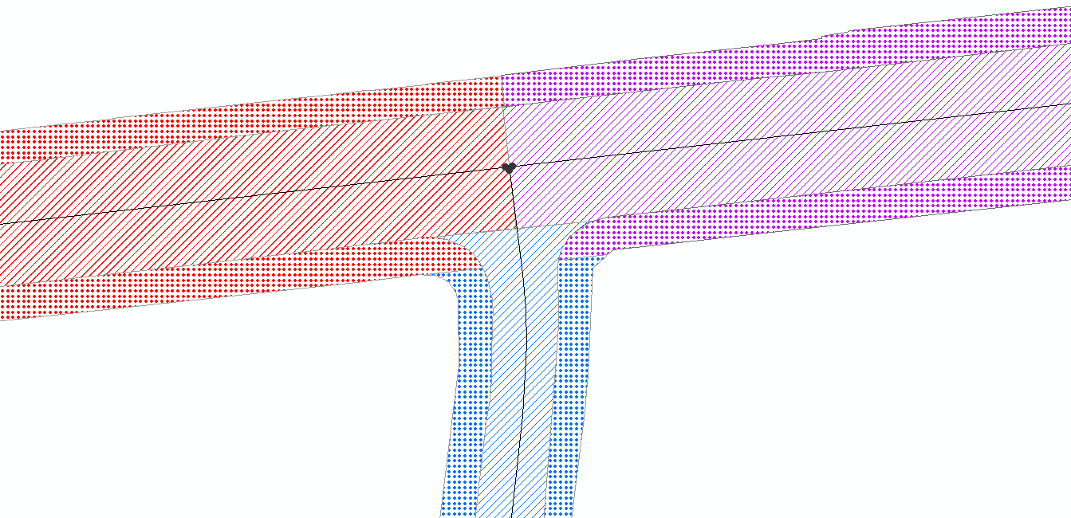
Blue Road
Public
Local Access
C Class

Cross Roads

Simple Crossroads

Text Description |  | Diagram 1
The split extends from the centre points of the lines splitting the roads adjoining from the south and north passing through the intersection of the corresponding ESUs.  The footways are cut across the heel kerbs of the greater hierarchical importance; in this case the main distributors |  | 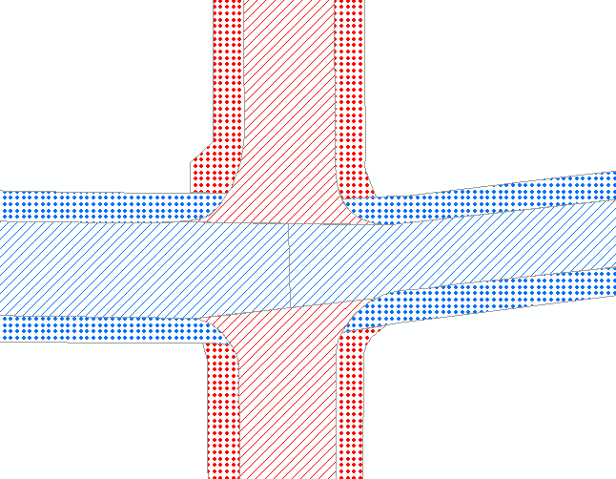
Legend |  | Diagram 2 ESU geometry shown
Blue Road  Public  Main Dist.  A Class | Red Road  Public  Secondary Dist.  B Class | 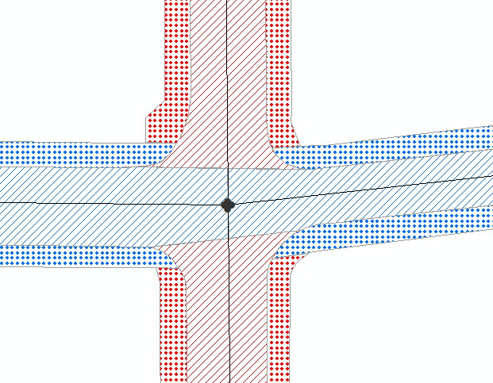

Crossroads with Change of Maintenance Split at Junction

Text Description |  | Diagram 1
The horizontal split extends from the centre points of the lines splitting the roads adjoining from the east and west passing through the intersection of the corresponding ESUs.  The vertical split between the carriageway of the adjoining road from the west is cut in line with the front of the kerbs of the main distributors as they have greater hierarchical importance than the local access road; usually at the road markings.  An additional split is required across the features to accommodate the extent of the private road perpendicular from the intersection of the corresponding ESUs of the private and public roads passing through corresponding adjacent features; in this case the north and south footways representing the adoption record. |  |  | 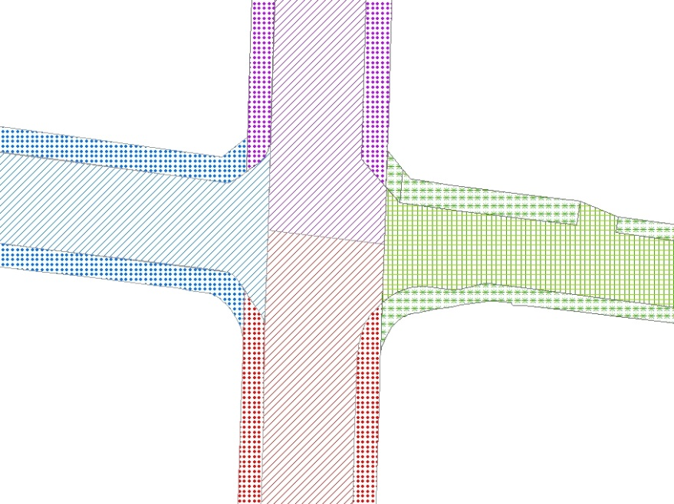
Legend |  | Diagram 2 ESU geometry shown
Blue Road  Public  Local Access  Unclassified | Purple Road  Public  Main Dist.  A Class | 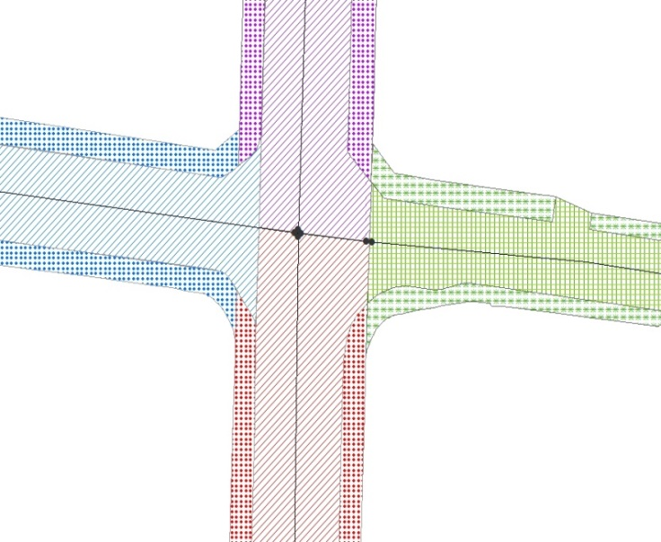
Green Road  Private  Local Access  Unclassified | Red Road  Public  Main Dist.  B Class

Offset Junctions

Multi Offset Junction

Text Description |  | Diagram 1
Offset junctions will be governed by the same rules applied to the relatively simple junctions covered in the previous examples.  The junction between the purple and black roads is treated as a T junction between similar roads as is the junction of the red and blue road.  The geometry of the corresponding ESU of the black and blue roads coupled with the split of the blue road resulting from the junction with the red road creates smaller polygon on the blue road.  The procedure to deal with this scenario is highlighted below in diagram 2.29  The ‘irregular’ shaped footways / verges are associated with adjacent blue road |  | 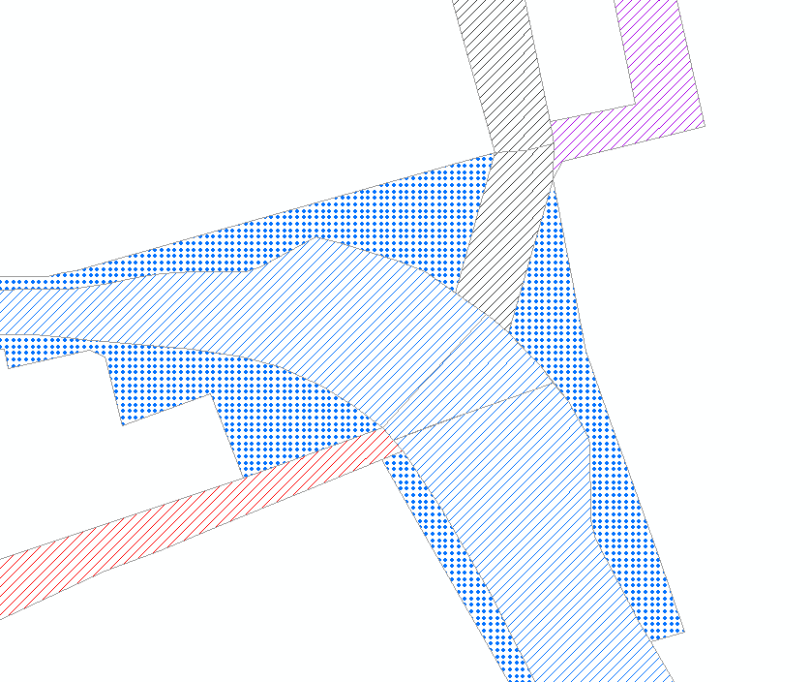
Legend |  | Diagram 2 ESU geometry shown
Blue Road  Public  Local Access  B Class | Black Road  Public  Local Access  C Class | 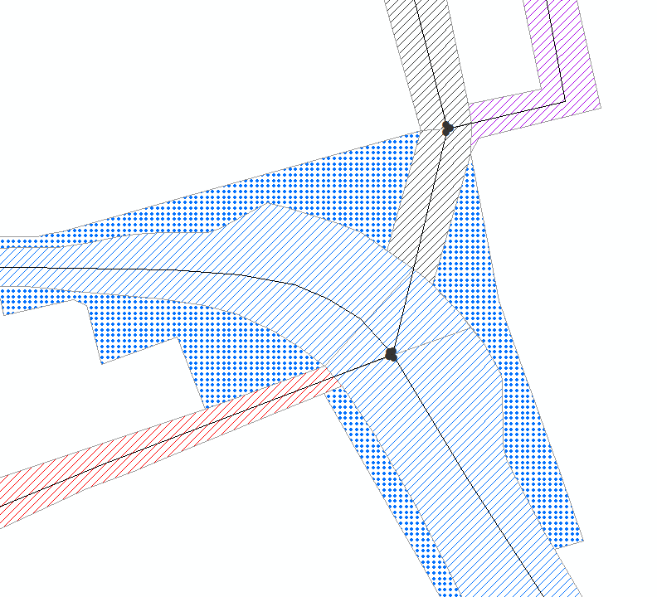
Purple Road  Public  Local Access  Unclassified | Red Road  Public  Local Access  Unclassified

Situations such as that described in 2.29 will be treated as follows. Applying the rule of cutting across a road perpendicularly from the centre point of the adjoining carriageway to the intersection of the corresponding ESUs results in an additional polygon that doesn’t have a unique ESU, i.e. the ESU relating to the blue polygon would have more than one polygon.
This illustrates well the situations that result in an ESU having many polygons associated with it. This is more predominate with roundabouts.
In these instances the polygon should be associated with the ESU that enters the polygon from the road it is associated with, i.e. it should be assigned to the ESU highlighted below as the polygon is part of the blue road, and not the ESU coming from the north which relates to the green road.

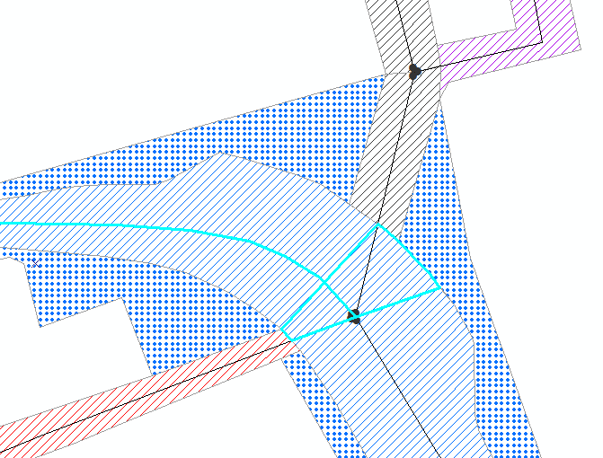 FIG 2.29

Offset Junction with Island

Text Description |  | Diagram 1
The junction between the green and red roads is treated as a T junction between similar roads.  The intersection of blue and red roads is treated by drawing a line continuous of the northern kerb of the red road at the intersections of blue roads either side of the triangular island. Lines are then drawn perpendicular to the split between the blue roads and the red road starting at the centre point of the split passing through the intersection of the corresponding ESUs to create ESPs on the red road. This split will also cut any adjacent features, in this case the south footway of the red road, perpendicularly.  The split on the blue road approach to the island from the north is created by drawing a line perpendicular to either side of the corresponding ESU also splitting adjacent features perpendicularly.  The procedure for splitting the island is explained below in diagram 2.29.1 |  | 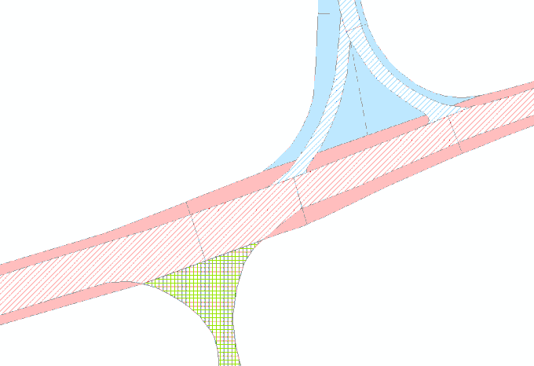
Legend |  | Diagram 2 ESU geometry shown
Blue Road  Public  Local Access  Unclassified | Green Road  Private  Local Access  Unclassified | 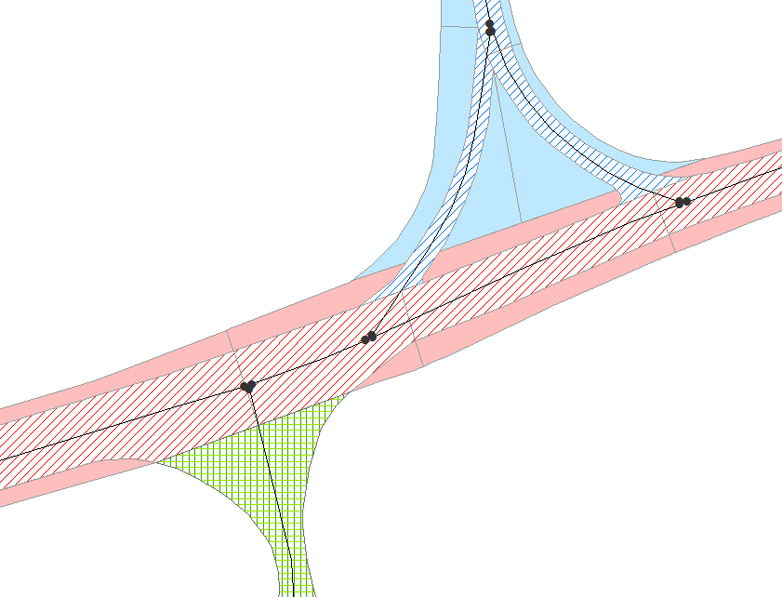
Red Road
Public
Local Access
B Class

Using this method explained above and the rules governing the previous examples will result in the necessity to divide islands into multiple sections enabling it to be accurately allocated to the relevant road / ESUs. This ruling maintains the consistency of the convention to allow rules governing simple junctions to be applied to any junction. In this example the island must be split into 3 parts each assigned to 3 different ESUs. The southern part of the island is split using a line continuous of the heel kerb of the footway associated with the red road due to its hierarchical importance. The remainder of the island is split by creating a line from the midpoint of the line dividing the southern footway to the apex of the island to the north. In the event that island is a more ‘irregular’ shape a line would be drawn perpendicular from the midpoint of the line dividing the southern footway northwards to split the remainder of the island in two.

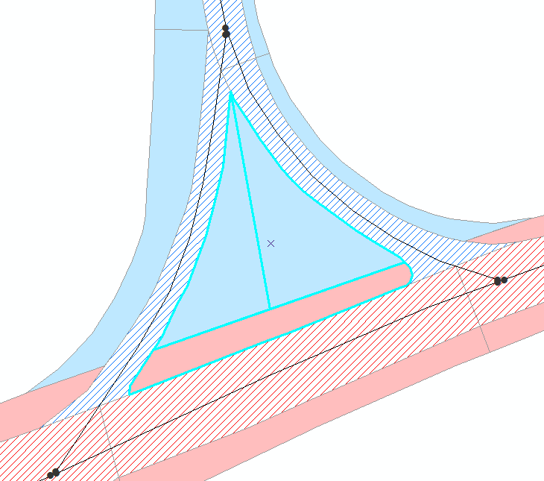
Fig. 2.29.1

This method will also be used to create polygons for central reserves. The central reserve will be split along its geometrical centreline with each resultant half being allocated to the ESU on the side it is located.

Acute Angle Junction

Text Description |  | Diagram 1
In the case where two roads meet at an acute angle it is treated very similar to a T junction between similar roads.  Where the green private road meets the red public road is governed by the rules of a typical T junction.  A split is between the blue road and the red road from the heel kerb blue road, due to its greater hierarchical importance, following the curvature of the blue road via the intersection of the corresponding ESUs until it intersects with the kerb of the red road. A further line is then drawn from this ESU intersection perpendicular with the red south footway intersecting corresponding features.  The split on the blue road approach to the junction from the west is created by drawing a line perpendicular to either side of the corresponding ESU also splitting adjacent features perpendicularly. |  | 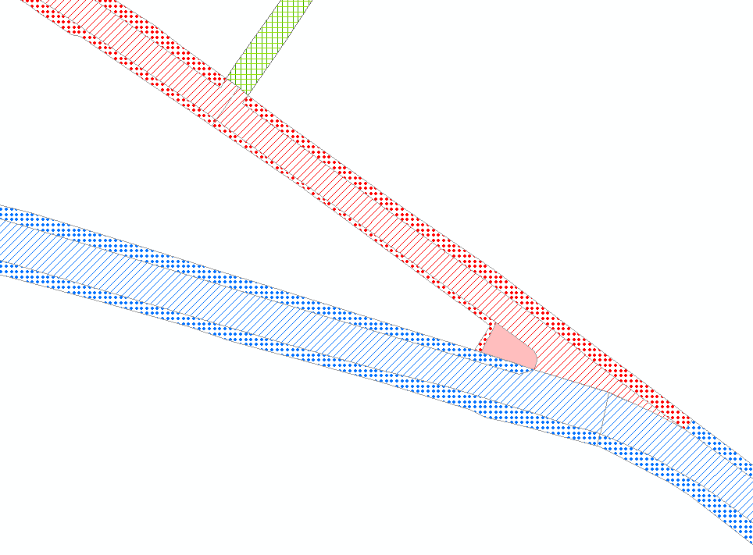
Legend |  | Diagram 2 ESU geometry shown
Blue Road  Public  Strategic  A Class | Red Road  Public  Secondary Dist  B Class | 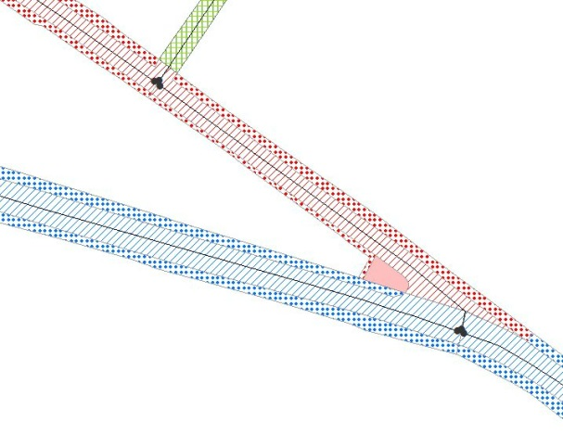
Green Road
Private
Local Access
Unclassified

Roundabouts
This is a draft document and therefore rules are subject to discussion. In the case of roundabouts several options will be put forward for discussion prior to the document being finalised.

Option 1
Option 1: Applying the general rule applied to T junctions and Crossroads fully to create polygon geometry matching corresponding ESUs. This would result in following the line of the corresponding ESUs of approach roads then continuing this split perpendicular to the ESU of the roundabout and intersecting the central roundabout.
The general view is that although this option applies the rules of ‘simple’ junctions to a more complicated situation it results in a very complicated solution which results in multiple polygons. From a cartographic point of view this option is not ideal. The advantage of this solution is that ESPs are unique to corresponding ESUs.
Text Description |  | Diagram 1
Applying the general rule applied to T junctions and Crossroads fully to create polygon geometry matching corresponding ESUs.  The approach roads are treated as T junction involving dual carriageways as discussed in previous examples with the purple local access road being treated as a normal T junction. The cut then continues this split perpendicular to the ESU of the roundabout and intersecting the central roundabout Approach islands are also split by applying previous rules.  The cut at these junctions are made using a line parallel to the roundabout ESUs at the kerb line of adjacent features and islands.  Features adjacent to the roundabout are attached to the nearest ‘roundabout’ ESP. |  | 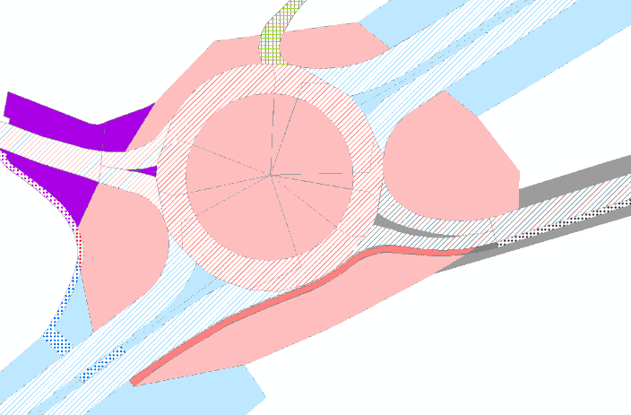
Legend |  | Diagram 2 ESU geometry shown
Blue & Red Road  Public  Strategic  A Class | Purple Road  Public  Local Access  Unclassified | 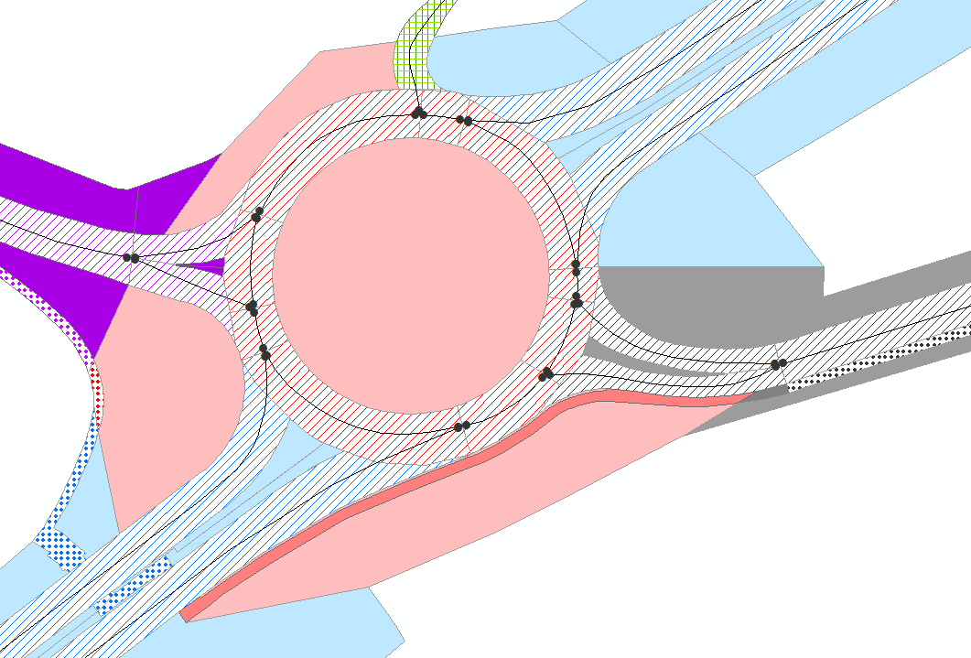
Black Road  Public  Local Access  C Class | Green Road  Private  Local Access  Unclassified

Option 2
Applying the general rule applied to T junctions and Crossroads to create polygon geometry matching corresponding ESUs is applied. Although in this case an exception is made to allow the split in the inner ring of the roundabout to be created by a line perpendicular to the ‘roundabout’ ESU. Also the central feature of the roundabout is attributed to the lowest numbered ESU of the roundabout.
The general view is that although this option does not adhere strictly to the general rules governing simple junctions it creates a simpler and more manageable solution. From a cartographic point of view this option is more pleasing.
Text Description |  | Diagram 1
In this option the approach roads are treated as T junction involving dual carriageways as discussed in previous examples with the purple local access road being treated as a normal T junction. Approach islands are also split by applying previous rules.  The main difference from Option 1 is that the cut across the roundabout id drawn perpendicular to the ‘roundabout’ ESUs as opposed to following the line of the approaching ESUs on the outer ring of the roundabout.  In this example the central feature of the roundabout is attributed to the lowest numbered ESU of the roundabout.  Approach islands are also split by applying previous rules.  The cut at these junctions are made using a line parallel to the roundabout ESUs at the kerb line of adjacent features and islands.  Features adjacent to the roundabout are attached to the nearest ‘roundabout’ ESP. |  | 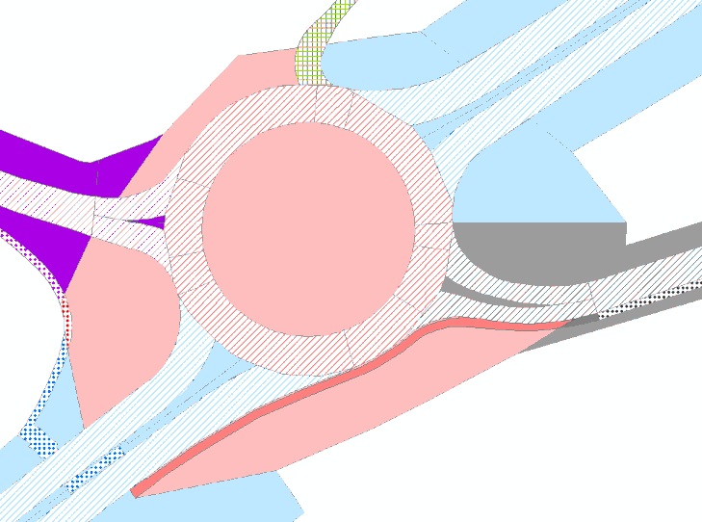
Legend |  | Diagram 2 ESU geometry shown
Blue & Red Road  Public  Strategic  A Class | Purple Road  Public  Local Access  Unclassified | 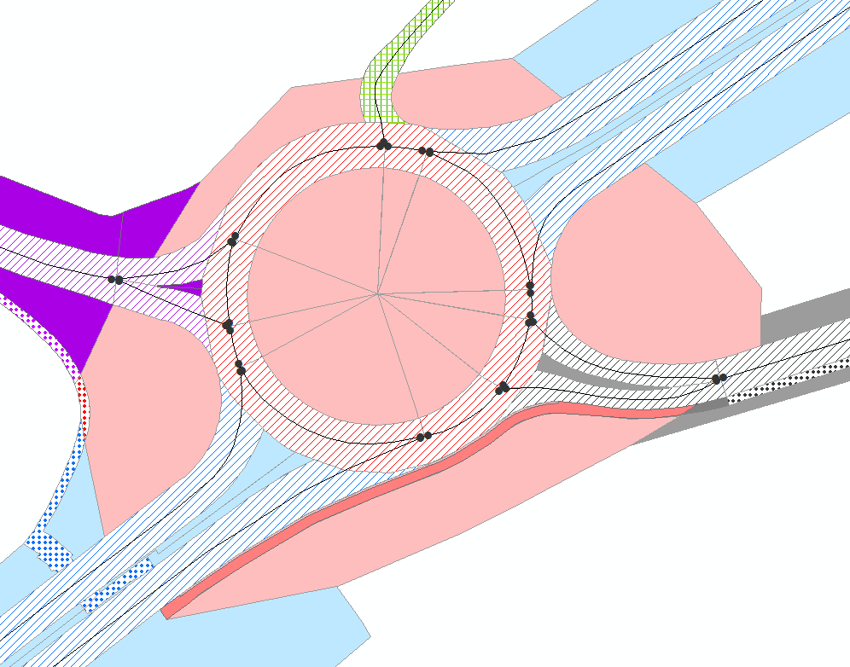
Black Road  Public  Local Access  C Class | Green Road  Private  Local Access  Unclassified

Option 3

Option 3 The general rule applied to T junctions and Crossroads to create polygon geometry matching corresponding ESUs is not fully applied. In this option a line is drawn perpendicular from the point where the ESU of the approach roads intersect with the split between these roads and the roundabout. This result is that not all ESUs having a corresponding ESPs.
The general view is that although this option does not adhere strictly to the general rules governing simple junctions it creates a simpler and more manageable solution than option 1. From a cartographic point of view this option is the most pleasing. The disadvantage is that not all ESUs having a corresponding ESPs. This solution may involve amending present ESU geometry to match ESP geometry which is not in the scope of this convention.

Text Description |  | Diagram 1
In this option the general rule applied to T junctions and Crossroads to create polygon geometry matching corresponding ESUs is not fully applied. In this option a line is drawn perpendicular from the point where the ESU of the approach roads intersect with the split between these roads and the roundabout. This result is that not all ESUs having a corresponding ESPs  T junction involving dual carriageways treated as discussed in previous examples with the purple local access road being treated as a normal T junction. Approach islands are also split by applying previous rules.  The main difference from Option 2 is that there is cut across the roundabout where the continuous curve of approach ESUs meet the roundabout ESUs.  In this example the central feature of the roundabout is attributed to the lowest numbered ESU of the roundabout.  Approach islands are also split by applying previous rules.  The cut at these junctions are made using a line parallel to the roundabout ESUs at the kerb line of adjacent features and islands.  Features adjacent to the roundabout are attached to the nearest ‘roundabout’ ESP. |  | 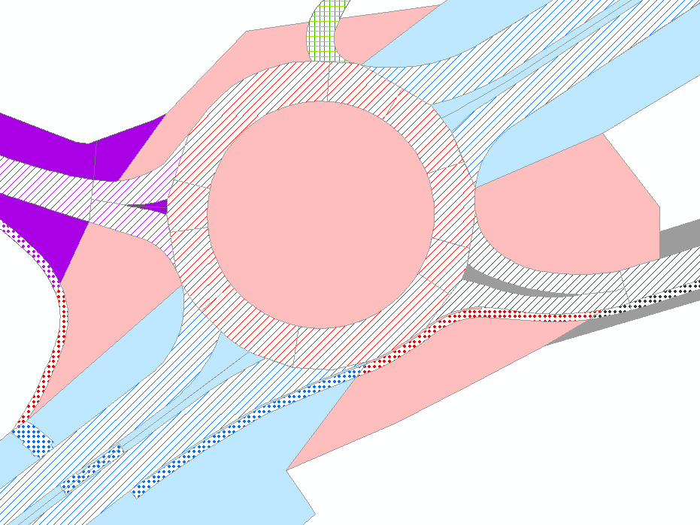
Legend |  | Diagram 2 ESU geometry shown
Blue & Red Road  Public  Strategic  A Class | Purple Road  Public  Local Access  Unclassified | 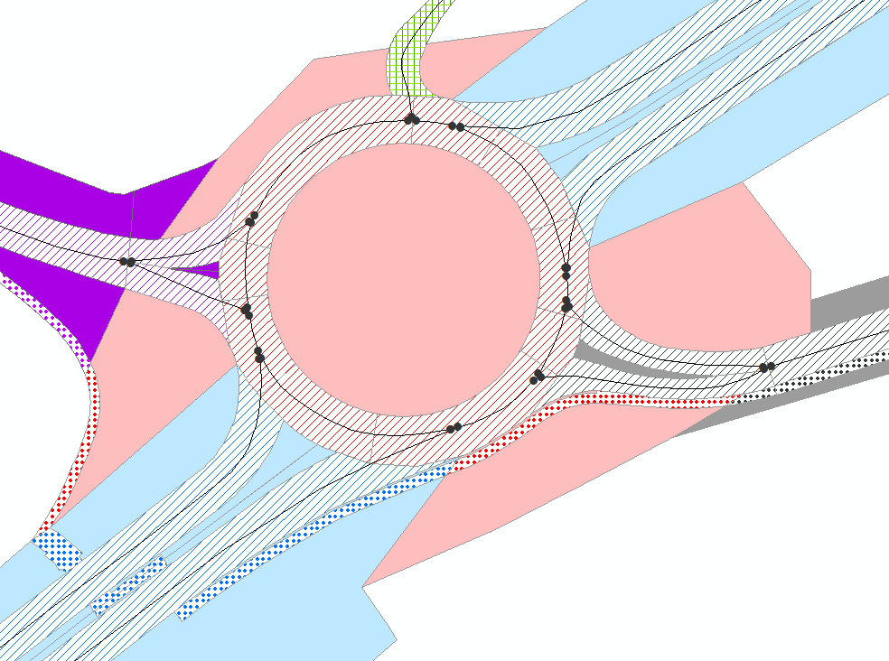
Black Road  Public  Local Access  C Class | Green Road  Private  Local Access  Unclassified

There may be another viable option where the constituent ESU making up the roundabout are represented by one continuous polygon.

Roundabout ESU Assignment
The proposal (Option 3) would result in the polygonisation shown below in Fig. 2.29.4. Note: the roundabout is elevated and has a dual carriage running below. Also the maintenance responsibility for the verge to the east and west of the roundabout change just before the junction creating a narrow strip.
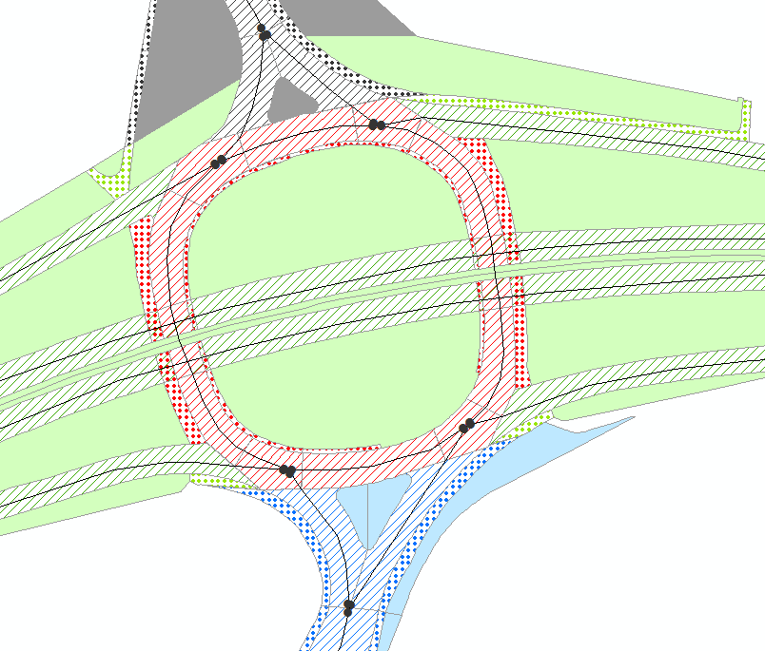
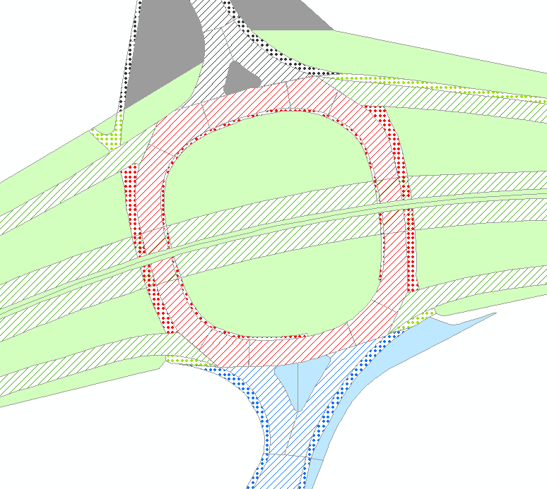
Fig. 2.29.4

This scenario results in areas created between junctions on the roundabout that don’t have their own unique ESUs i.e. They are shared by and intersected by the geometry of more than one ESU. These areas can be seen highlighted in blue in Fig. 2.29.4.1. Such areas should be assigned to the ESU of the road they of which they are a constituent part of (in this case red road roundabout). Due to the fact it is a roundabout, there could be one of two ESUs to choose from, and in this case the lowest numbered ESU should be selected.
The verge within this roundabout, between slips could be assigned to either the roundabout or the carriageway going over / under the roundabout. This would be user preference as it may be best to allocate to the road they are maintained from etc.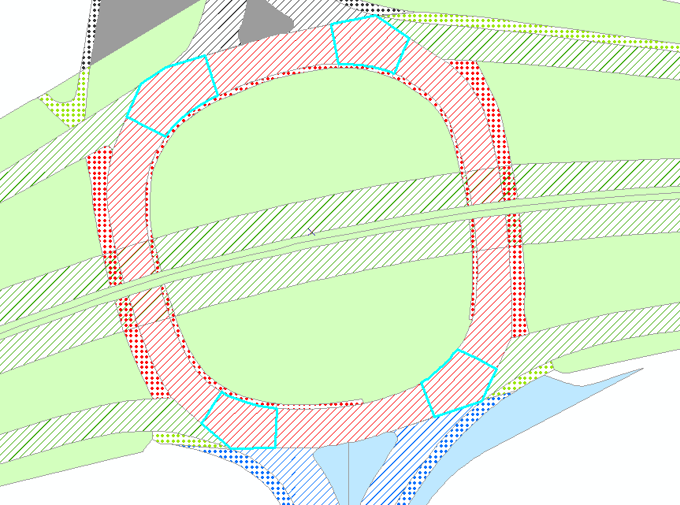
Fig. 2.29.4.1

Dual Carriageway Cross Overs
Centre reserves have to be split down the middles as well so that each side can be assigned to the neighbouring ESU ID

Option 1 (Cross Over Acceleration / Deceleration lanes separate entities)
It is necessary to discuss these scenarios further with Transport Scotland before a decision is made as this will generally only affect trunk roads.
Text Description |  | Diagram 1
 |  | 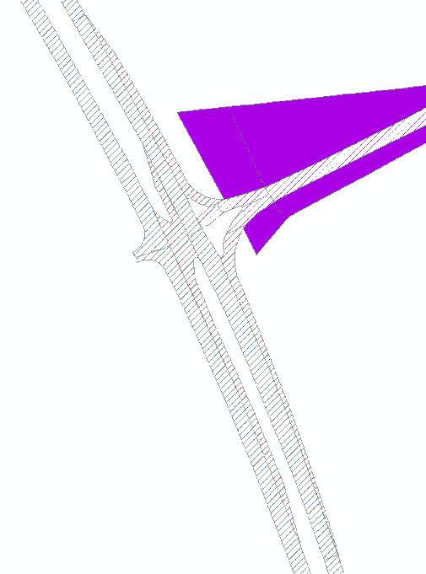
Legend |  | Diagram 2 ESU geometry shown
Blue & Red Road  Public  TRUNK  A Class | Purple Road  Public  Local Access  A Class | 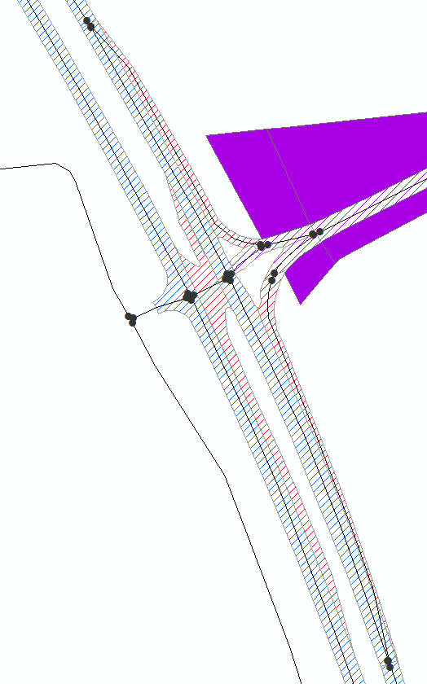
The acceleration / deceleration lanes at the junction side of the main carriageway will be separated to create a separate polygon as they have their own ESUs and consequently ESP’s.
Some questions to be answered by Transport Scotland:-
What do you do with the acceleration and deceleration lanes that are in the middle as part of the cross over element?
Assign it all to the ESU that crosses the junction?
If you do that how much of the deceleration lanes to you include with the middle section? All or should some be part of the main carriageway?

Option 2(Cross Over Acceleration / Deceleration lanes part of main carriageway)
Text Description |  | Diagram 1
 |  | 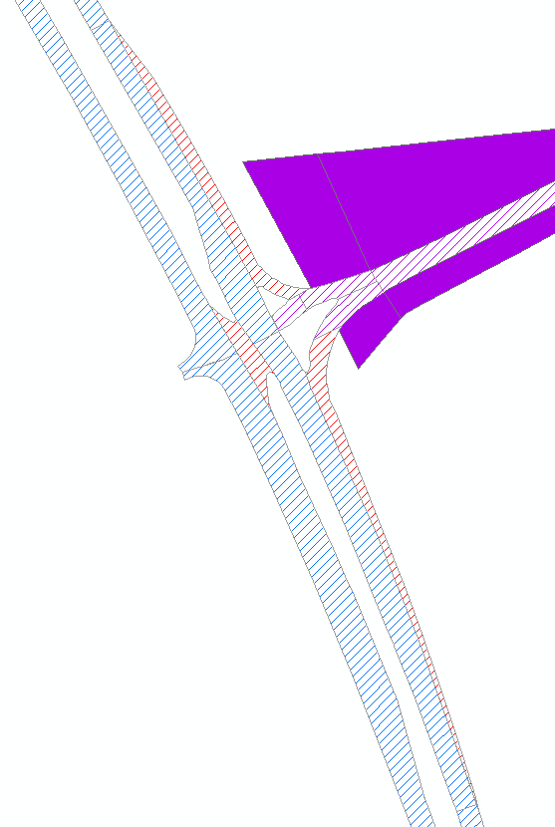
Legend |  | Diagram 2 ESU geometry shown
Blue & Red Road  Public  TRUNK  A Class | Green Road  Public  Local Access  A Class | 